20191227

ttaylor@xxxxxxxxxxxxxxxxx

317 515 5530

This document describes the (suggested) tools to create the doc part of the ISV portal.

xxxxxxxxxxxxxxxxxxxxxxxx

**TOC**

Ch0. Suggested tools 3

(ch4) Doc site tools summary (free) 20191227 3

(ch4b) Doc site tools summary (not free) 20191227 4

(ch4c) Doc (static) site deployment (serving) tools 4

Requirements? 5

Ch4. Doc site tools (SIMPLE/FREE) 10

4.1 docusaurus.io V1 (facebook/react) 20191227 10

4.1b docusaurus v2 24

4.2 Jekyll 20191016 25

4.3 dapperdox.io 20191218 42

4.4 Emberjs (angularjs?) 20191218 43

4.5 Redoc.ly 20191210,0924 48

4.6 slate (linux, ruby) 61

4.7 sphinx (cant get it working) 20191216 65

4.8 hugo (complicated installation) (see 4b.3 aerobatic) 67

Ch4b. Doc site tools (not so simple / not free) 68

4b.0 notes…. 68

4b.1 Postman 20191001 (SOAP+REST) ** ($18/month-user, + calls) 69

4b.2 readme.io 20190927 (REST) ** ($400/month white label) 79

4b.3 Gatsby 20190924 ($99 or 200 / month??) 86

4b.4 speca.io (REST) 20191014 * ($50/month custom domain, sso, support) 94

4b.5 Innovasys 20191002 (SOAP+REST) ** (can we add postman button?) 100

Ch4c. Doc (static) site deployment (serving) tools 105

4c.1 Cloud Cannon (works with jekyll) 20190926 106

4c.2 Aerobatic (Jekyll, Hugo) (AWS) 20191017,1029 124

4c.3 Netlify (deploy tool) 20191030 135

4c.4 Amazon amplify ??? 146

Ch4d. other 147

# Ch0. Suggested tools

TERRY: I spent a few weeks researching, testing etc. below are my suggestions.

## (ch4) Doc site tools summary (free) 20191227

|  |  |  |
| --- | --- | --- |
| **Doc site Tool (url)** | **Plus** | **Minus** |
| 4.1b docusaurus v2 | ?? | ?? |
| 4.1 docusaurus.io | * Easy to use (well designed/ good docs) * From facebook (react) * Can use github * Hosting Static HTML Pages on ZEIT Now, GitHub Pages * Automating Deployments Using Continuous Integration (CircleCI 2.0, Travis CI, ZEIT Now, Netlify, Render, GitHub Enterprise) | * markdown * no swagger ? |
| 4.2 Jekyll ([jekyllrb.com](https://jekyllrb.com/)) | * highly customizeable * Source in github, autoupdated | * do a lot of things by hand. need to know a bit of javascript, and the file structure gets a bit complicated * no user logins (solved with ccannon) * must run the jekyll server, complicated ruby installation (solved with ccannon) |
| 4.3 dapperdox.io | * Easy to use (if you are not changing the scripts) * Designed for api | * Only swagger… must point at swagger file? * Very sparse documentation… confusing * Very complex script based… basically dapper extracts everthing out of swagger file and scripts build the web content.. 35 (!) script files |
| 4.4 ember ([emberjs.com](https://emberjs.com/)) | * Easy to get up and running (localhost, heroku) | * complex angularjs setup (?).. seems that maintaining text might be complex * Does API? |
| 4.5 Redoc.ly | * Easy to implement (?? If you don’t want to change anything) | * Need swagger input file ?? * How do you format ?? * Very bad sparse documentation * Seems “too open source”.. its like an internal tool that redoc.ly has spun to be a semi-product… but their real business is doing custom sites. |
| 4.6 slate ([github.com/slatedocs/slate](https://github.com/slatedocs/slate)) | * Api-focused with multi-language tabs * free | * linux * seems not a finished product, but a basis used by other to create their own custom sites. * no access control (??) etc |
| 4.7 sphinx (sphinx-doc.org/en/master/) |  | * cant get it to work…. |
| 4.8 hugo ([gohugo.io/](https://gohugo.io/)) |  | * Complicated installation * In showcase I saw nothing about APIs * Just a few sponsors (that use it).. seems like a spinoff |

## (ch4b) Doc site tools summary (not free) 20191227

|  |  |  |  |
| --- | --- | --- | --- |
| **Doc site Tool (url)** | **$/mo** | **Plus** | **Minus** |
| 4b.1 Postman ([getpostman.com](https://www.getpostman.com/)) | 18 | * Industry Standard tool * Custom url * Does SOAP * Same tool used for API executor… the Postman button is included | * not sure how much you can customize the output * no user logins (I think), no access control |
| 4b.2 Readme.io ([readme.com](https://readme.com/)) | 400 | * Automates so much. Makes it easy to created content and manage. * User logins, blogs, etc. | * Expensive (very) |
| 4b.3 gatsby (gatsbyjs.org) | 99/ 200 | * React-based | * Too complex * Not provide the formatting required for api ??? (I don’t see the tabs for languages in their customer sites) |
| 4b.4 speca.io | 50 | * Well-designed tool, focusing on apis * sso (saml, openid connect) * Custom domain * $50 a month includes support | * Looks like still under development. A new tool. speca.io/speca/speca-io-features-showcase does not show the multi-language feature. |
| 4b.5 innovasys.com |  | * full-featured tool * Does SOAP * chm | * More like a doc generator, not a website generator * No user logins? |

## (ch4c) Doc (static) site deployment (serving) tools

TERRY: these tools take the static site and  
1. make deployment easy  
2. add functionality (password protect, logins, etc)

|  |  |  |
| --- | --- | --- |
| **Deploy Tool** | **Plus** | **Minus** |
| 4c.1 [cloudcannon.com](https://cloudcannon.com/) (Jekyll only) | * very full-featured, well done * logins, access control |  |
| 4c.2 aerobatic.com | * very full-featured, well done * SSL, logins, Auth0, client IP ranges, etc. sophisticated access control * Great quick starts |  |
| 4c.3 netlify.com | * very full-featured, well done .. I need to research more | * Business version $500+/month |
| 4c.4 amazon amplify |  |  |

## Requirements?

This sums up my recommendations (based on limited experience). Note:

1. big companies do custom in-house development, but xxxxxxxxxxxx needs something simple and cheap.
2. we need SOAP, and many tools are REST.

### 0. Restrict access? (east to maintain and/or hosting)

Login? Token?

### 1. in-page request execution? (NO)

Seemed like this was req early on… but I don’t think so now…

##### The following is paypal example (paypal.com/apex) would take a lot of work to do this

TERRY: “explorer” actually refers to the “executor”. If you just click on “APIs” that’s the same as clicking on “REST APIs”.

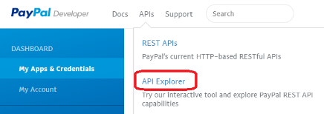

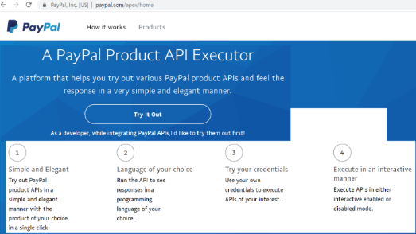

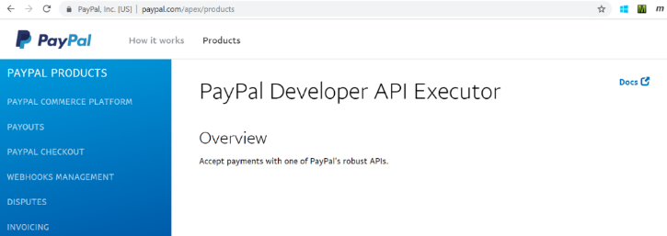

Paypal checkout

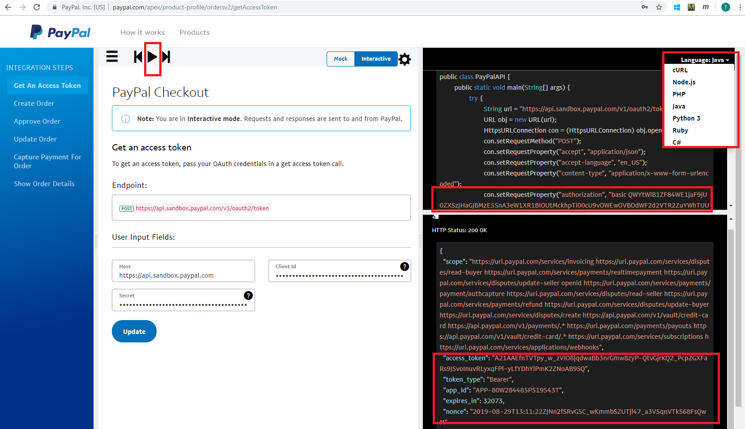

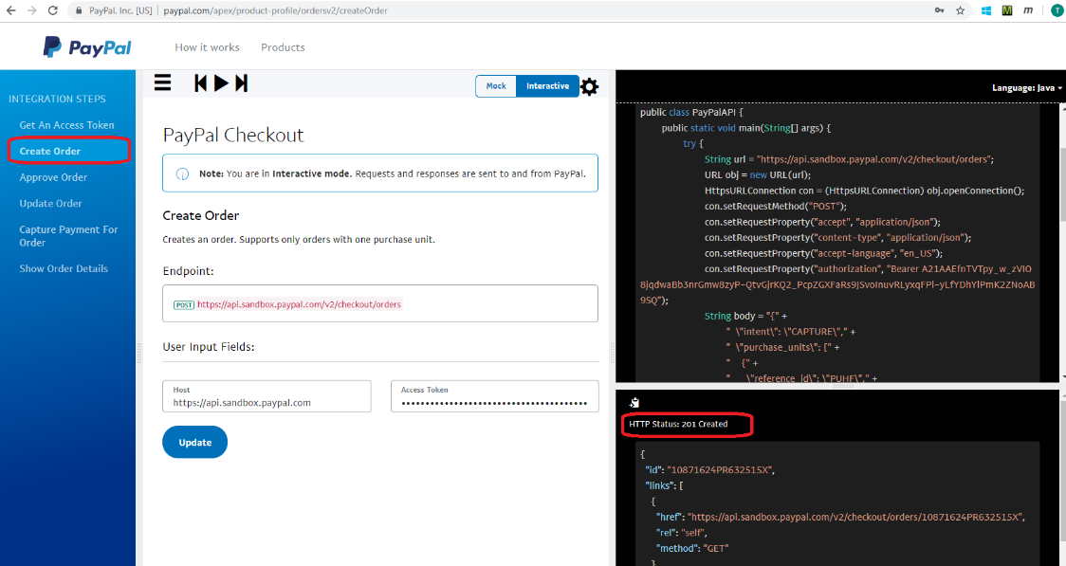

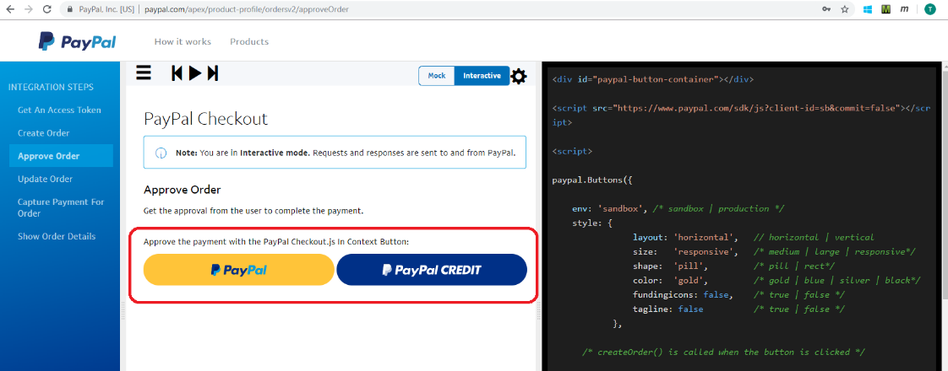

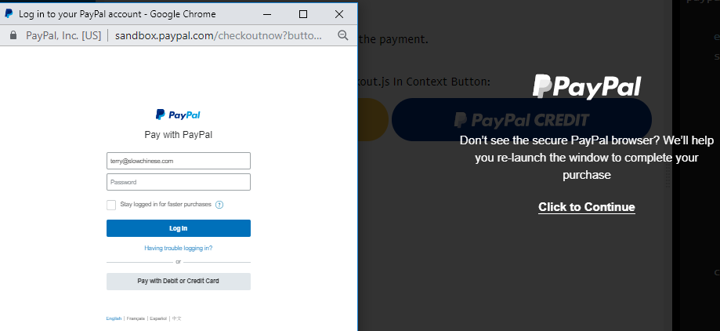

TERRY: I had trouble logging in… so stopped at this point… but you get the idea…

### 2. SOAP??

##### Example of SOAP in Postman

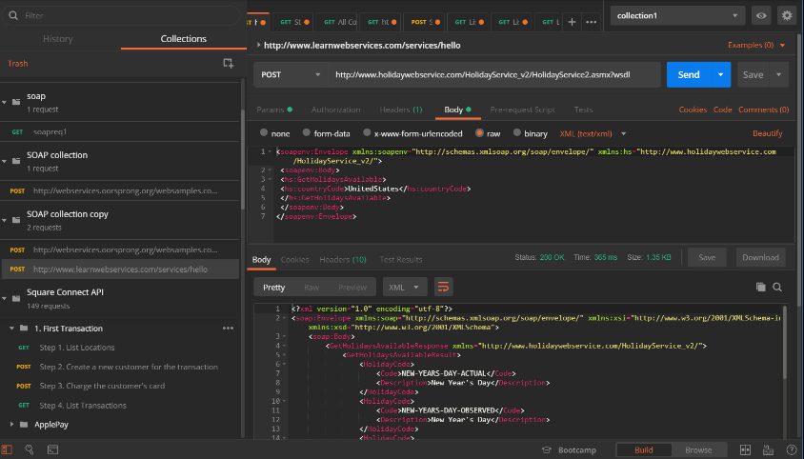

##### Sabre postman docs in github

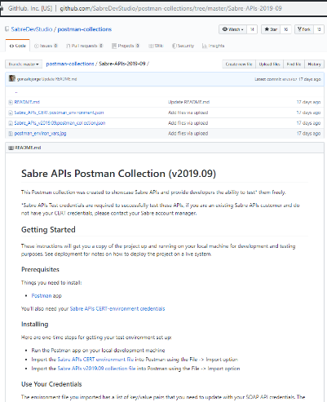

##### marketo

<https://developers.marketo.com/soap-api/leads/getmultipleleads/>

basicallly

1. Request table of fields
2. Request xml
3. Response xml
4. Sample code – php, java…

##### salesforce

<https://developer.salesforce.com/docs/atlas.en-us.api.meta/api/sforce_api_quickstart_intro.htm>

### 3. low cost (YES) jekyll, slate, redocly, gatsby (finix), sphinx

xxx

### 4. easy to maintain (NO??) readme.io, innovasys

More expensive are easier to maintain

#### 4b. hosting? (cc, aerobatic, netlify)

xxx

#### 4c. whitelable (YES, must have xxxxxxxxxxxxxxxx branding)

xxx

# Ch4. Doc site tools (SIMPLE/FREE)

## 4.1 docusaurus.io V1 (facebook/react) 20191227

SEE ___docusaurus_vxx_20xxxxxx.docx

## 4.1b docusaurus v2

SEE ___docusaurus_vxx_20xxxxxx.docx

## 4.2 Jekyll 20191016

Uses cloudcannon for deployment… see 4b.1.

<meta name="description" content="Get started with Bootstrap, the world’s most popular framework for building responsive, mobile-first sites, with BootstrapCDN and a template starter page.">

<meta name="author" content="Mark Otto, Jacob Thornton, and Bootstrap contributors">

<meta name="generator" content="Jekyll v3.7.0">

<title>Introduction · Bootstrap</title>

#### C# .NET Client consuming a ServiceNow SOAP Web Service 20191015

<https://www.youtube.com/watch?v=UQ0lqGkVMJU>

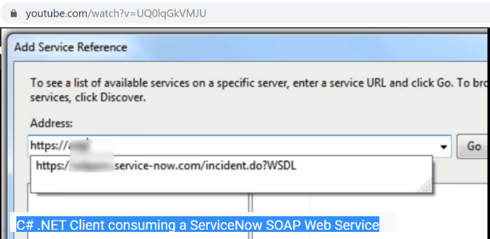

### 4.1.1 jekyll basics 20191016

Terry: the most important thing is to understand how jekyll runs, and to make sure that the finally product is something that we could use for the portal.

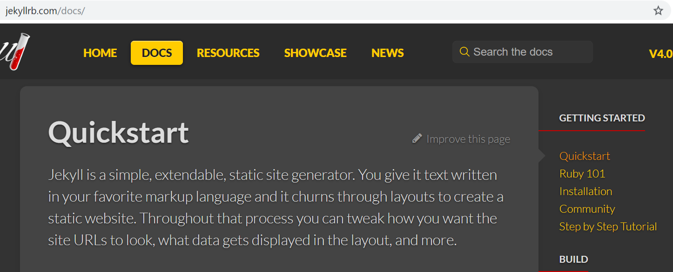

#### Getting started

##### Quickstart

<https://jekyllrb.com/docs/>

Jekyll is a simple, extendable, static site generator. You give it text written in your favorite markup language and it churns through layouts to create a static website. Throughout that process you can tweak how you want the site URLs to look, what data gets displayed in the layout, and more.

1. Install a full [Ruby development environment](https://jekyllrb.com/docs/installation/)
2. Install Jekyll and [bundler](https://jekyllrb.com/docs/ruby-101/#bundler) [gems](https://jekyllrb.com/docs/ruby-101/#gems)
3. gem install jekyll bundler
4. Create a new Jekyll site at ./myblog
5. jekyll new myblog
6. Change into your new directory
7. cd myblog
8. Build the site and make it available on a local server
9. bundle exec jekyll serve
10. Now browse to [http://localhost:4000](http://localhost:4000/)

If you encounter any unexpected errors during the above, please refer to the [troubleshooting](https://jekyllrb.com/docs/troubleshooting/#configuration-problems) page or the already-mentioned [requirements](https://jekyllrb.com/docs/installation/#requirements) page, as you might be missing development headers or other prerequisites.

##### Ruby 101

<https://jekyllrb.com/docs/ruby-101/>

Jekyll is written in Ruby. If you’re new to Ruby, this page is to help you get up to speed with some of the terminology.

###### Gems

A gem is code you can include in Ruby projects. It allows you to package up functionality and share it across other projects or with other people. Gems can perform functionality such as:

* Converting a Ruby object to JSON
* Pagination
* Interacting with APIs such as GitHub
* Jekyll itself is a gem as well as many Jekyll plugins including [jekyll-feed](https://github.com/jekyll/jekyll-feed), [jekyll-seo-tag](https://github.com/jekyll/jekyll-seo-tag) and [jekyll-archives](https://github.com/jekyll/jekyll-archives).

###### Gemfile

A Gemfile is a list of gems required for your site. For a simple Jekyll site it might look something like this:

source "https://rubygems.org"

gem "jekyll"

group :jekyll_plugins do

gem "jekyll-feed"

gem "jekyll-seo-tag"

end

###### Bundler

Bundler installs the gems in your Gemfile. It’s not a requirement for you to use a Gemfile and bundler however it’s highly recommended as it ensures you’re running the same version of Jekyll and Jekyll plugins across different environments.

gem install bundler installs [Bundler](https://rubygems.org/gems/bundler). You only need to install it once — not every time you create a new Jekyll project. Here are some additional details:

If you’re using a Gemfile you would first run bundle install to install the gems, then bundle exec jekyll serve to build your site. This guarantees you’re using the gem versions set in the Gemfile. If you’re not using a Gemfile you can just run jekyll serve.

For more information about how to use Bundler in your Jekyll project, this [tutorial](https://jekyllrb.com/tutorials/using-jekyll-with-bundler/) should provide answers to the most common questions and explain how to get up and running quickly.

##### Installaton, step by step tutorial

<https://jekyllrb.com/docs/installation/windows/>

<https://jekyllrb.com/docs/step-by-step/01-setup/>

#### build

#### content

#### site structure

<https://jekyllrb.com/docs/structure/>

#### guides

#### Ccannon tutorial

<https://learn.cloudcannon.com/jekyll/running-jekyll/>

To run Jekyll on a site, we’ll navigate to the site’s directory in the command line, then run one of these commands.

##### Serve

jekyll serve

Does a build of the site to _site and runs a local development server at [http://localhost:4000](http://localhost:4000/) by default. Any changes we make to a site (except edits to _config.yml) trigger the site to rebuild and the development server to refresh. This command is typically used while you’re developing a site as it automatically builds and serves your site locally after a change.

##### Build

jekyll build

This builds the site to _site. From here we would typically copy the contents of _site to a hosting provider.

##### Runtime flags

There’s a number of runtime flags we can pass these commands to adjust how the site is built. For example if we wanted the build to include all of our draft blog posts we could run jekyll like this:

jekyll build --drafts

Below is a full list of the run time parameters available. Many of these can be added to your _config.yml if you want them to run every time, check the [configuration documentation](https://jekyllrb.com/docs/configuration/) for more information.

TERRY: see link for flag details.

#### Ccannon cheat sheet

<https://learn.cloudcannon.com/jekyll-cheat-sheet/>

### 4.1.1b structure of source for [tangerine-lemon.cloudvent.net/](https://tangerine-lemon.cloudvent.net/) 20191016

TERRY: this is a great template for us to us. In this section I describe how its set up (ccannon docs do not explain this clearly anywhere). I think this is more or less correct.

xxxxxxxxxxxxxxxxxxxxxxxx

#### 1) _layouts/default.html (describes main page)

This defines the main page:

* Header (with SEO, etc)
* Body header
* Body body
  + {% include sidebar.html %}
  + Div class=”main” {{content}} TERRY: I think this looks in config.yml for the center, right content.
* Event listener script

#### 2) _includes/sidebar.html (sidebar)

Has sidebar text.

#### 3) index.html (script that defines content: h3, description, h6 params, left/right blocks)

* h3
* description
* h6 params
* left/right blocks

#### 4) _config.yml (defines collections)

collections are the content that the script puts in.

collections:

documentation:

title: Documentation

position_number: 1

api:

title: APIs

position_number: 2

plugins:

- jekyll-sitemap

- jekyll-seo-tag

NOTE: from what I can guess, “documentation” and “api” above refer to dir names (+ “_”).

#### 5) _documentation/getting_started,authentication,errors.md

xxxxxxxxxxxxxxxxxxxx

These define the text for sidebar section “Documentation”

* getting_started.md
* authentication.md
* errors.md

#### 6) _api/books_add.md, …

xxxxxxxxxxxxxxxxxxxxx

Describes content (left/right) and code for sidebar section “APIs”.

### 4.1.1c works on ccannon 20191015

I updated with todays date on git. Updated automatically.

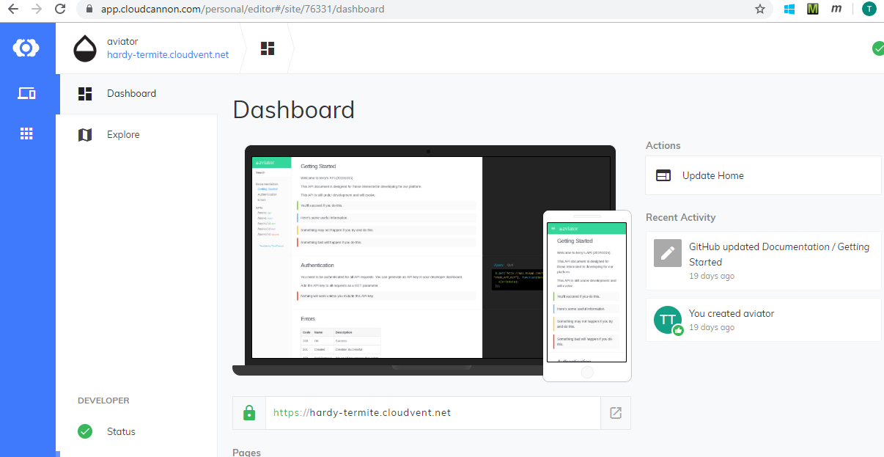

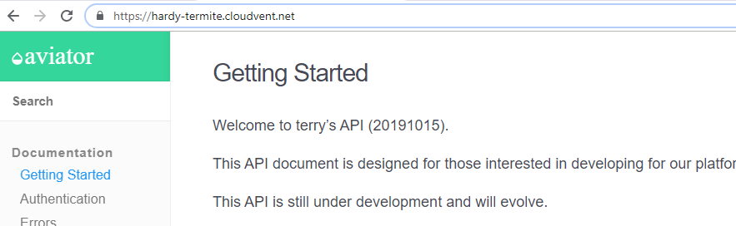

### 4.1.1d git local 20191015

<https://rogerdudler.github.io/git-guide/>

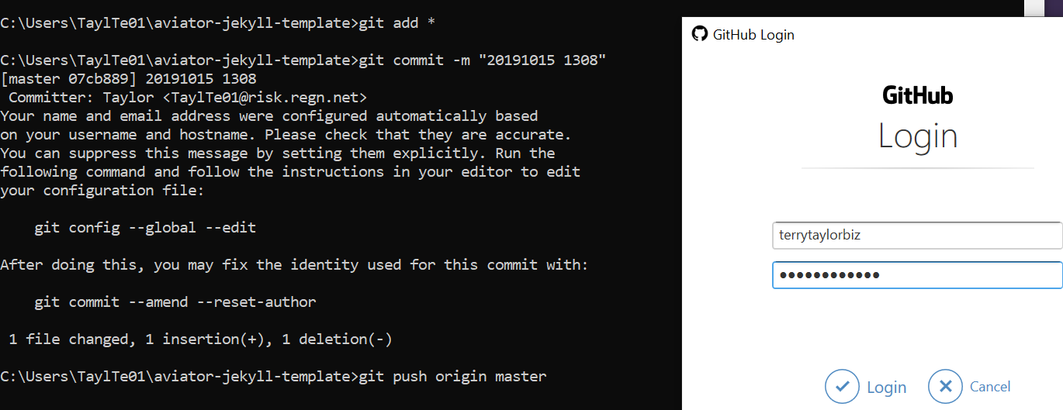

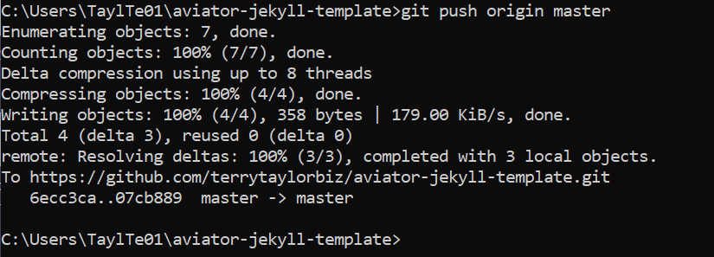

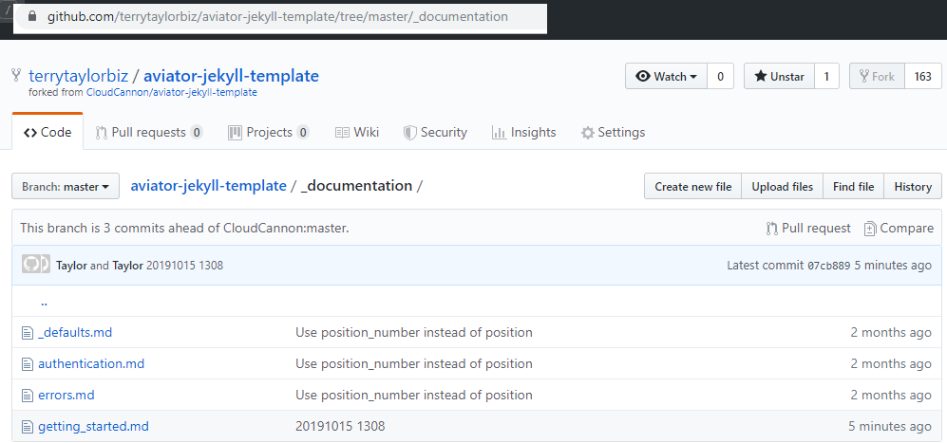

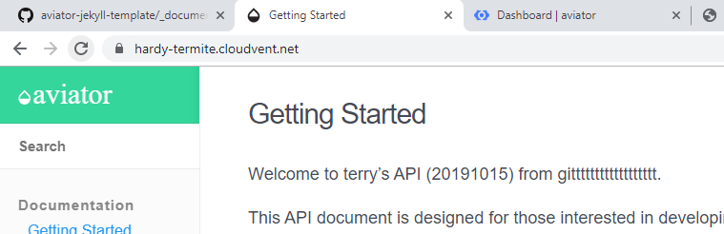

### 4.1.1e error trying to serve aviator on local pc 20191015

I tried many things… even copying to the directory that was working.. apparently, ccannon put some stuff in that is causing problems… not figured out yet.

Maybe this: <https://stackoverflow.com/questions/19061774/cannot-load-such-file-bundler-setup-loaderror>

Maybe this… <https://stackoverflow.com/questions/26560725/bundler-setup-loaderror/26560950>

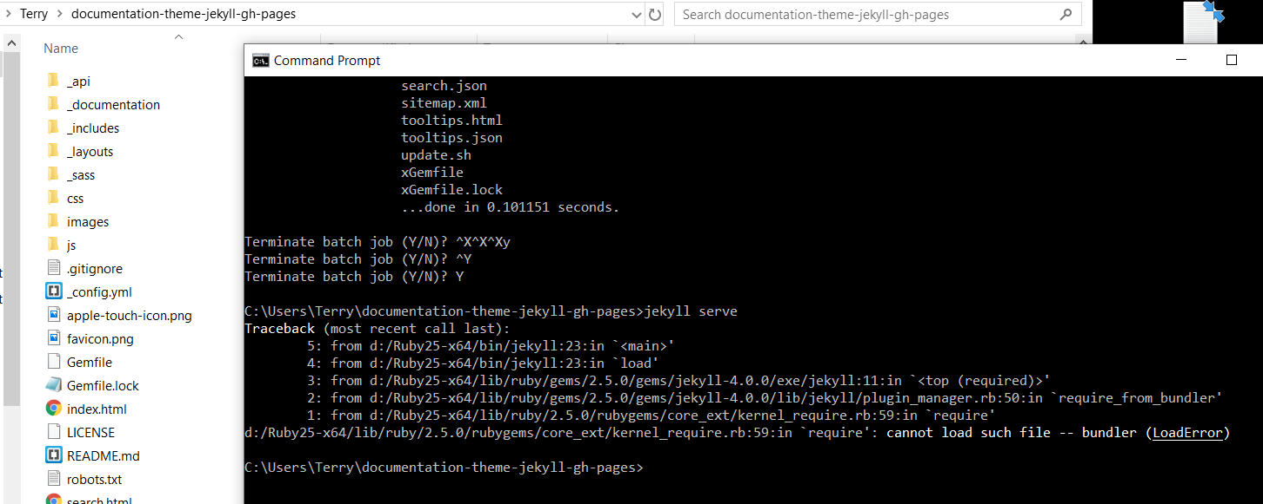

I could serve up doc theme in the aviator dir and worked fine.

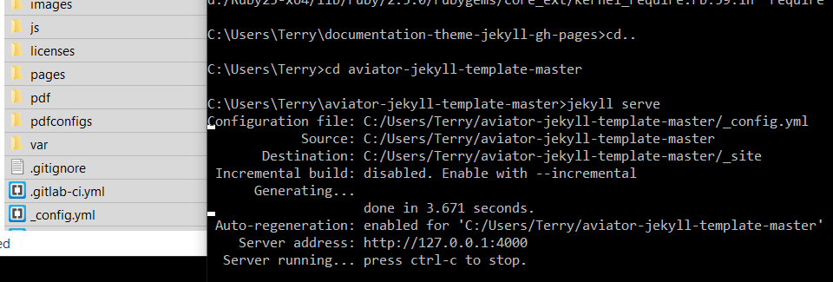

### 4.1.2 Terry example: Stepbystep doc theme IRBWriting (install ruby, jekyll, bundler…)

<https://idratherbewriting.com/documentation-theme-jekyll/>

Follow these instructions to build the theme.

#### 1. Download the theme

First, download or clone the theme from the [Github repo](https://github.com/tomjoht/documentation-theme-jekyll). Most likely you won’t be pulling in updates once you start customizing the theme, so downloading the theme (instead of cloning it) probably makes the most sense. In Github, click the **Clone or download** button, and then click **Download ZIP**.

#### 2. Install Jekyll

If you’ve never installed or run a Jekyll site locally on your computer, follow these instructions to install Jekyll:

* [Install Jekyll on Mac](https://idratherbewriting.com/documentation-theme-jekyll/mydoc_install_jekyll_on_mac.html)
* [Install Jekyll on Windows](https://idratherbewriting.com/documentation-theme-jekyll/mydoc_install_jekyll_on_windows.html)

+++++++++++++++++++++++++++++++++++++

##### Install Ruby and Ruby Development Kit

First you must install Ruby because Jekyll is a Ruby-based program and needs Ruby to run.

1. Go to [RubyInstaller for Windows](http://rubyinstaller.org/downloads/).
2. Under **RubyInstallers**, download and install one of the Ruby installers under the **WITH DEVKIT** list (usually the recommended/highlighted option).
3. Double-click the downloaded file and proceed through the wizard to install it. Run the ridk install step on the last stage of the installation wizard.
4. Open a new command prompt window or Git Bash session.

##### Install the Jekyll gem

At this point you should have Ruby and Rubygem on your machine.

Now use gem to install Jekyll:

gem install jekyll

You can now use Jekyll to create new Jekyll sites following the quick-start instructions on [Jekyllrb.com](https://jekyllrb.com/).

##### Installing dependencies through Bundler

Some Jekyll themes will require certain Ruby gem dependencies. These dependencies are stored in something called a Gemfile, which is packaged with the Jekyll theme. You can install these dependencies through Bundler. (Although you don’t need to install Bundler for this Documentation theme, it’s a good idea to do so.)

[Bundler](https://bundler.io/) is a package manager for RubyGems. You can use it to get all the gems (or Ruby plugins) that you need for your Jekyll project.

You install Bundler by using the gem command with RubyGems:

##### Install Bundler

1. Browse to the directory where you downloaded the Documentation theme for Jekyll.
2. Delete or rename the existing Gemfile and Gemfile.lock files.
3. Install Bundler: gem install bundler
4. Initialize Bundler: bundle init

This will create a new Gemfile. Terry this is probably where error caused.

1. Open the Gemfile in a text editor.

Typically you can open files from the Command Prompt by just typing the filename, but because Gemfile doesn’t have a file extension, no program will automatically open it. You may need to use your File Explorer and browse to the directory, and then open the Gemfile in a text editor such as Notepad.

1. Remove the existing contents. Then paste in the following:

source "[https://rubygems.org](https://rubygems.org/)"

gem 'wdm'

gem 'jekyll'

The [wdm gem](https://rubygems.org/gems/wdm/versions/0.1.1) allows for the polling of the directory and rebuilding of the Jekyll site when you make changes. This gem is needed for Windows users, not Mac users.

1. Save and close the file.
2. Type bundle install.

Bundle retrieves all the needed gems and gem dependencies and downloads them to your computer. At this time, Bundle also takes a snapshot of all the gems used in your project and creates a Gemfile.lock file to store this information.

##### Git Clients for Windows

Although you can use the default command prompt with Windows, it’s recommended that you use [Git Bash](https://git-for-windows.github.io/) instead. The Git Bash client will allow you to run shell scripts and execute other Unix commands.

##### Serve the Jekyll Documentation theme

1. Browse to the directory where you downloaded the Documentation theme for Jekyll.
2. Type jekyll serve
3. Go to the preview address in the browser. (Make sure you include the / at the end.)

Unfortunately, the Command Prompt doesn’t allow you to easily copy and paste the URL, so you’ll have to type it manually.

##### Resolving Github Metadata errors

After making an edit, Jekyll auto-rebuilds the site. If you have the Gemfile in the theme with the github-pages gem, you may see the following error:

GitHub Metadata: No GitHub API authentication could be found. Some fields may be missing or have incorrect data.

If so, you will need to take some additional steps to resolve it. (Note that this error only appears if you have the github-pages gem in your gemfile.) The resolution involves adding a Github token and a cert file.

See this post on [Knight Codes](http://knightcodes.com/miscellaneous/2016/09/13/fix-github-metadata-error.html) for instructions on how to fix the error. You basically generate a personal token on Github and set it as a system variable. You also download a certification file and set it as a system variable. This resolves the issue.

+++++++++++++++++++++++++++++++++++++

#### 3. Install Bundler

In case you haven’t installed Bundler, install it:

gem install bundler

You’ll want [Bundler](https://bundler.io/) to make sure all the Ruby gems needed work well with your project. Bundler sorts out dependencies and installs missing gems or matches up gems with the right versions based on gem dependencies.

#### 4. Option 1: Build the Theme (without the github-pages gem)

Use this option if you’re not planning to publish your Jekyll site using [Github Pages](https://pages.github.com/).

Bundler’s Gemfile specifies how project dependencies are managed. Although this project includes a Gemfile, this theme doesn’t have any dependencies beyond core Jekyll. The Gemfile is used to list gems needed for publishing on Github Pages. **If you’re not planning to have Github Pages build your Jekyll project, delete these two files from the theme’s root directory:**

* Gemfile
* Gemfile.lock

If you’ve never run Jekyll on your computer (you can check with jekyll --version), you may need to install the jekyll gem:

gem install jekyll

Now run jekyll serve (first change directories (cd) to where you downloaded the project):

jekyll serve

#### 4. Option 2: Build the Theme (with the github-pages gem)

If you are in fact publishing on Github Pages, leave the Gemfile and Gemfile.lock files in the theme.The Gemfile tells Jekyll to use the github-pages gem. **However, note that you cannot use the normal jekyll serve command with this gem due to dependency conflicts between the latest version of Jekyll and Github Pages** (which are noted [briefly here](https://help.github.com/articles/setting-up-your-github-pages-site-locally-with-jekyll/)).

You need Bundler to resolve these dependency conflicts. Use Bundler to install all the needed Ruby gems:

bundle update

Then always use this command to build Jekyll:

bundle exec jekyll serve

If you want to shorten this long command, you can put this code in a file such as jekyll.sh (on a Mac) and then simply type . jekyll.sh to build Jekyll.

#### 5. Running the site in Docker

You can also use Docker to directly build and run the site on your local machine. Just clone the repo and run the following from your working dir:

docker-compose build --no-cache && docker-compose up

The site should now be running at <http://localhost:4000/>.

This is perhaps the easiest way to see how your site would actually look.

#### 6. TERRY RESULTS 20190925 (no git)

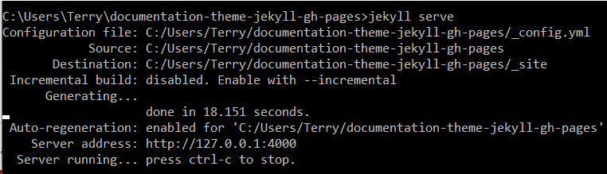

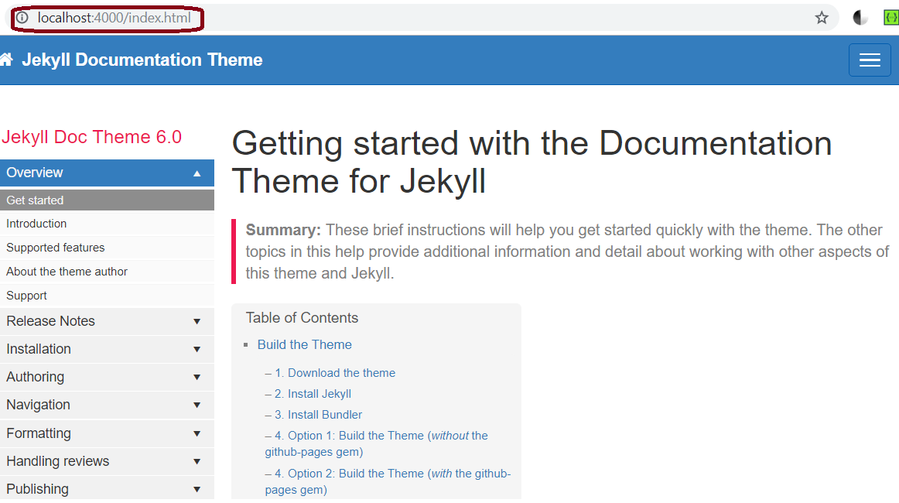

#### 7. Terry results (tried with git.. failed) 20190926

This failed … but I tried using CloudCannon (next section).. that worked, does all this complex Git stuff for you. That’s how you want to do it.

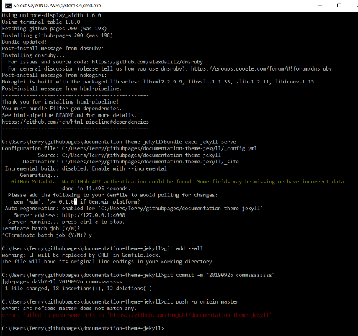

### 4.1.3 overview

<https://idratherbewriting.com/learnapidoc/pubapis_static_site_generators.html#jekyll>

is a Ruby-based [static site generator](https://idratherbewriting.com/learnapidoc/pubapis_static_site_generators.html#jekyll), meaning it uses Ruby as the underlying programming language to compile the website. This site and my [blog](https://idratherbewriting.com/) use Jekyll, and I used Jekyll for the documentation at my past two jobs. For example, all the docs [here](https://developer.amazon.com/appstore/documentation) use Jekyll. With Jekyll, you can publish a fully functional tech comm website that includes content re-use, conditional filtering, variables, PDF output, and everything else you might need as a technical writer.

#### themes

<https://github.com/topics/jekyll-theme>

##### The Jekyll Aviator theme

My Jekyll documentation theme is just one possibility for a Jekyll site. (Most people who use it end up heavily customizing it for their needs.) You could also use this [Aviator API documentation theme](https://github.com/CloudCannon/Aviator-Jekyll-Theme), which has some API templating built-in, or you could choose from many other Jekyll themes. I also wrote a tutorial for [creating your own Jekyll theme](https://jekyllrb.com/tutorials/convert-site-to-jekyll/), likely using your company’s site as the template.

<https://github.com/CloudCannon/Aviator-Jekyll-Theme>

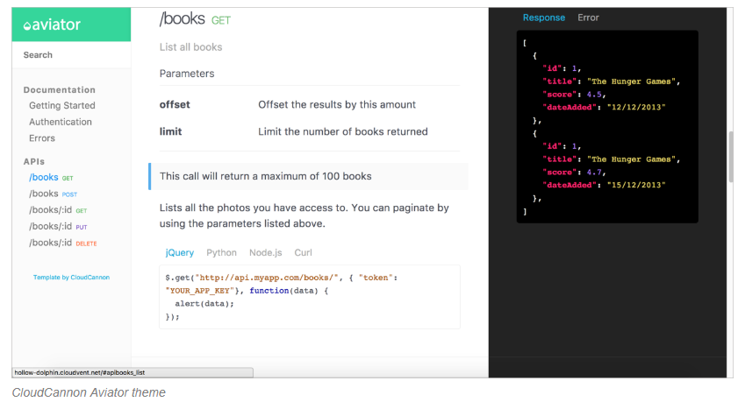

#### [GitHub Pages](https://pages.github.com/)

provides a free hosting and deployment option for Jekyll projects. If you upload a Jekyll project to a GitHub repository, you can indicate that it’s a Jekyll project in your GitHub repo’s Settings, and GitHub will automatically build it when you commit to your repo. This feature — building Jekyll projects directly from your GitHub repo — is referred to as GitHub Pages.

In your GitHub repo, click **Settings** and scroll down to **GitHub Pages**. This section is where you activate GitHub Pages for your project.

[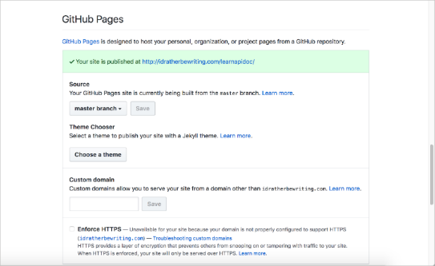](https://pages.github.com/)

Every GitHub repository is potentially a Jekyll project that you can auto-build when you commit to it.

The tight integration of Jekyll with GitHub makes for a compelling argument to use a Jekyll-GitHub solution. For the most part, GitHub is the dominant platform for open source projects. If you’re already using GitHub, it makes sense to choose a static site generator that integrates into the same platform to build your docs.

GitHub Pages is free but does have some limitations in scope:

* GitHub Pages source repositories have a recommended limit of 1GB.
* Published GitHub Pages sites may be no larger than 1 GB.
* GitHub Pages sites have a soft bandwidth limit of 100GB per month.
* GitHub Pages sites have a soft limit of 10 builds per hour. (See [Usage Limits](https://help.github.com/articles/what-is-github-pages/))

Unlike with other hosting and deployment platforms, GitHub Pages doesn’t offer a commercial version that expands these limits. You can learn more about [GitHub Pages here](https://help.github.com/categories/github-pages-basics/).

I build this site and [my blog](https://idratherbewriting.com/) using Jekyll and GitHub Pages. They are actually separate Jekyll projects and repos. My blog is in a GitHub repo called [tomjoht.github.io](https://github.com/tomjoht/tomjoht.github.io), named after my GitHub username but published using a custom domain [idratherbewriting.com](http://idratherbewriting.com/). (Without the custom domain, it would be available at [http://tomjoht.github.com](http://tomjoht.github.com/).) The API doc site is in a repo called [learnapidoc](https://github.com/tomjoht/learnapidoc). It’s available by default at <https://idratherbewriting.com/learnapidoc>. They seem like the same site, but they are really separate projects in separate repos. The fact that each repo in addition to the primary repository (tomjoht.github.io) appears as a subdirectory to the primary domain ([idratherbewriting.com](http://idratherbewriting.com/)) is pretty cool.

#### Convert html site to jekyll

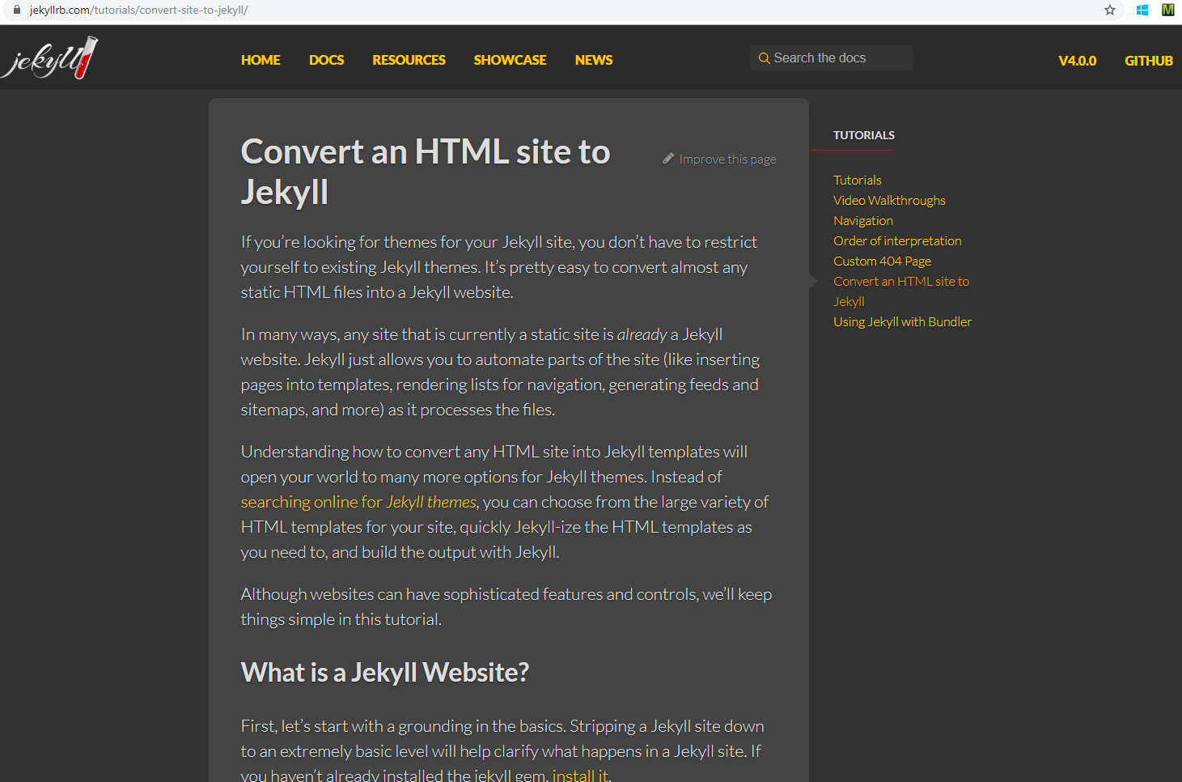

## 4.3 dapperdox.io 20191218

“DapperDox was created by API documentation authors for one purpose: to improve the quality and usability of the API documentation they were providing for other developers.

They needed the flexibility to structure and style the pages the way they wanted; to be able to author readable guides and have them form part of a cohesive set of documentation along with the API specifications; to allow relevent documentation to be injected right into the rendered specification page, just where it was needed.

DapperDox is the result. Simply point DapperDox at your OpenAPI Swagger specifications, add some documentation and DapperDox does the rest.”



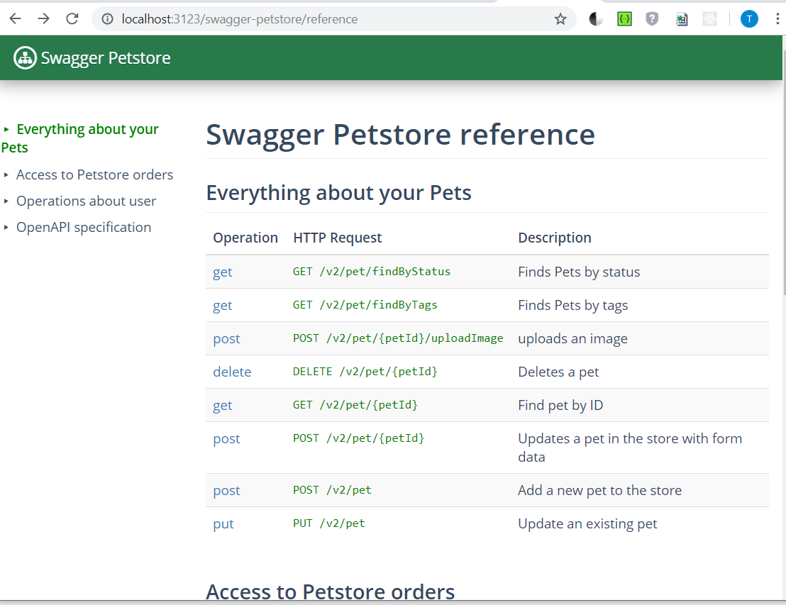

## 4.4 Emberjs (angularjs?) 20191218

seems like not able to create API style stuff.

<https://emberjs.com/ember-users>

quick start

<https://guides.emberjs.com/release/getting-started/quick-start/>

<http://builtwithember.io/>

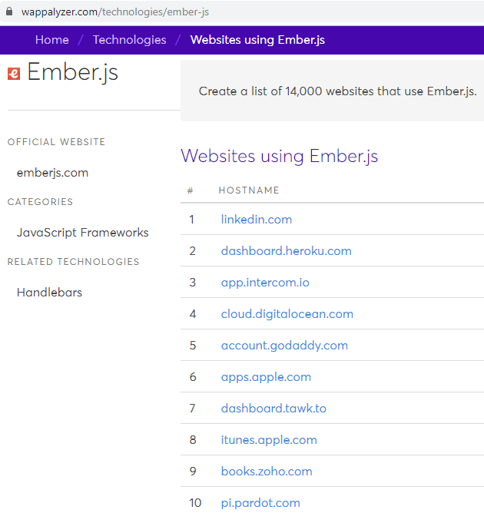

### localhost



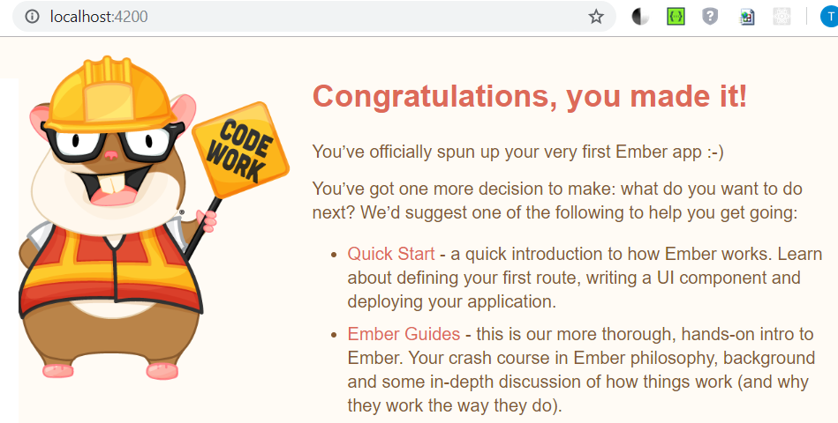

### Heroku 20191217

(for api key, see next page)

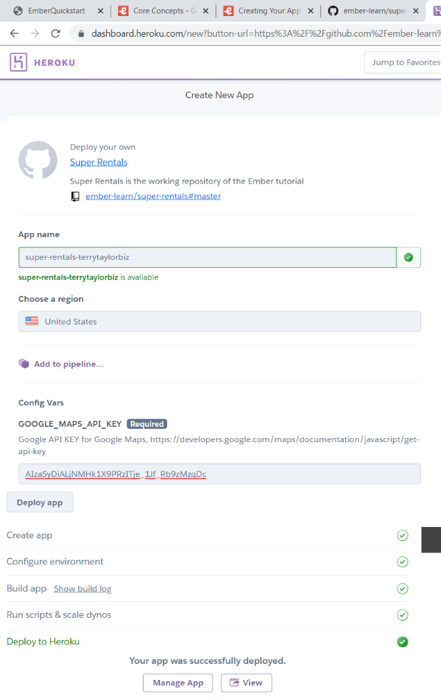

API key

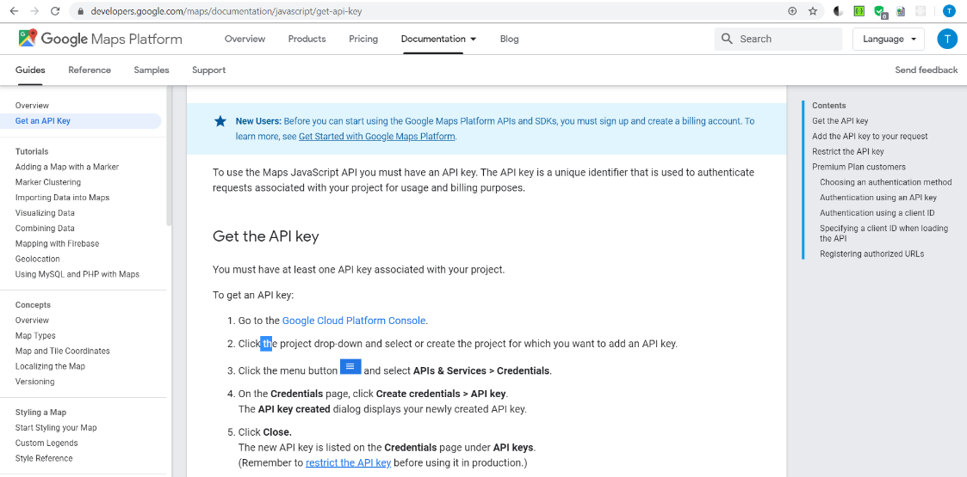

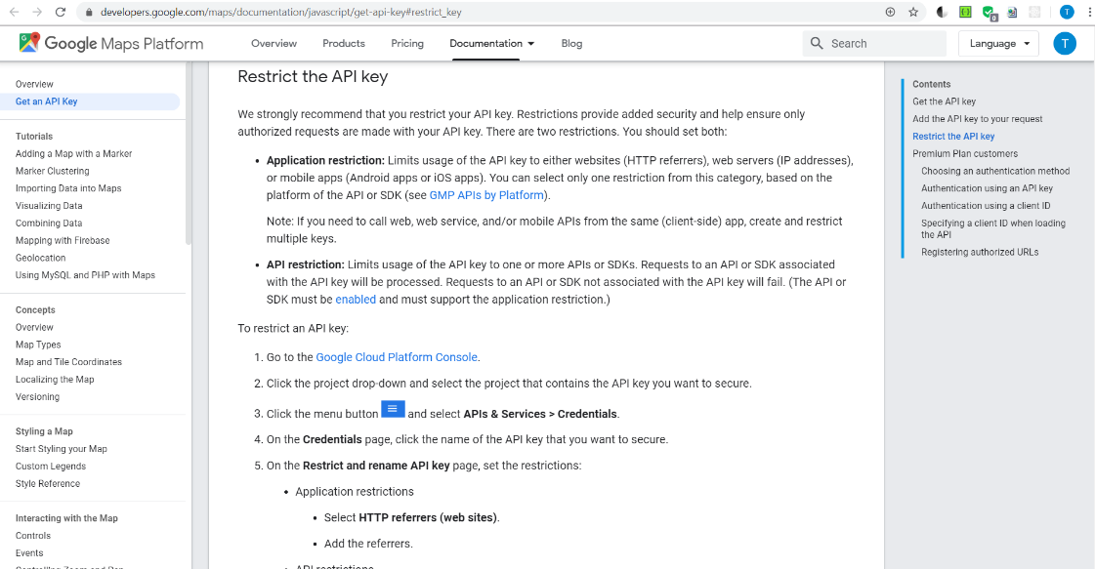

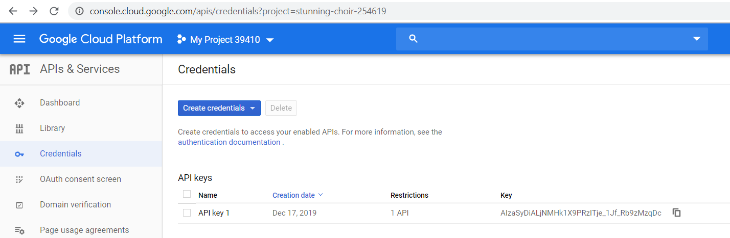

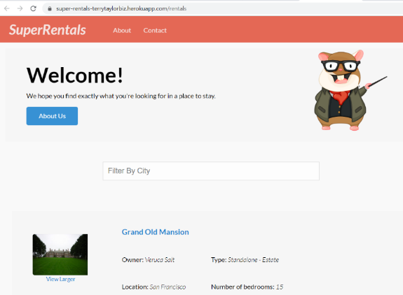

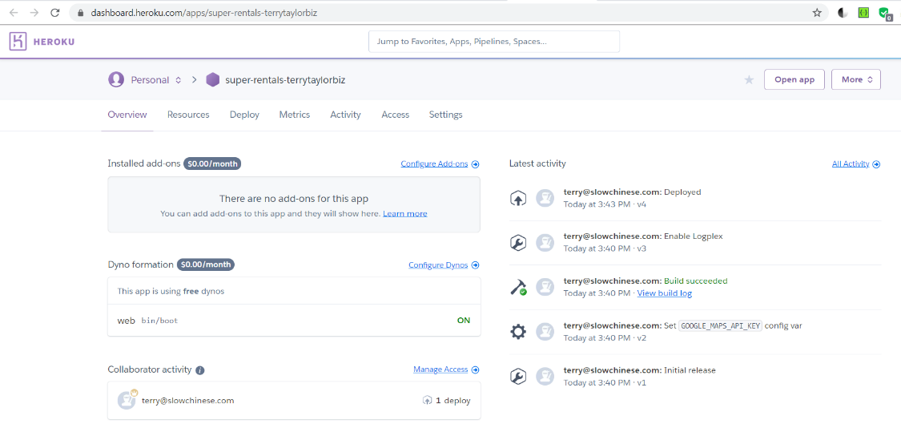

## 4.5 Redoc.ly 20191210,0924

http://[github.com/Redocly/redoc](https://github.com/Redocly/redoc)

### TERRY: how do you config formatting???

Where is formatting done? Note <https://github.com/Redocly/redoc#roadmap>

Roadmap

~~OpenAPI v3.0 support~~

~~performance optimizations~~

~~better navigation (menu improvements + search)~~

~~React rewrite~~

~~docs pre-rendering (performance and SEO)~~

ability to simple branding/styling

built-in API Console

does this mean that changing the formatting right now is not possible?

### overview pronovix.com

(https://pronovix.com/blog/free-and-open-source-api-documentation-tools ) ReDoc uses the OpenAPI specification and generates a responsive site with a three-panel design. It pulls markdown headings from the OpenAPI description field into the side menu, and supports deep linking.

ReDoc aims to make deployment extremely easy, provides a wide support for OpenAPI objects, and offers interactive documentation for nested objects. You can include code samples via a third-party extension.

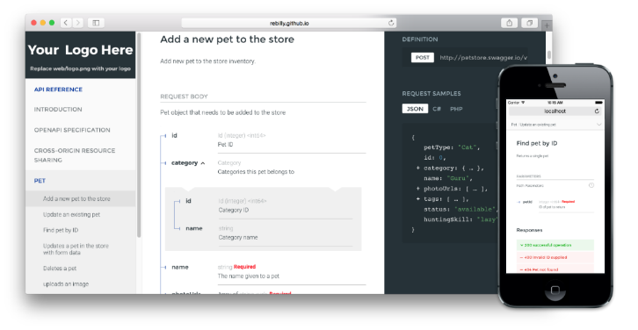

#### Used at elavon ??

I think elavon uses a customized version of redocly.

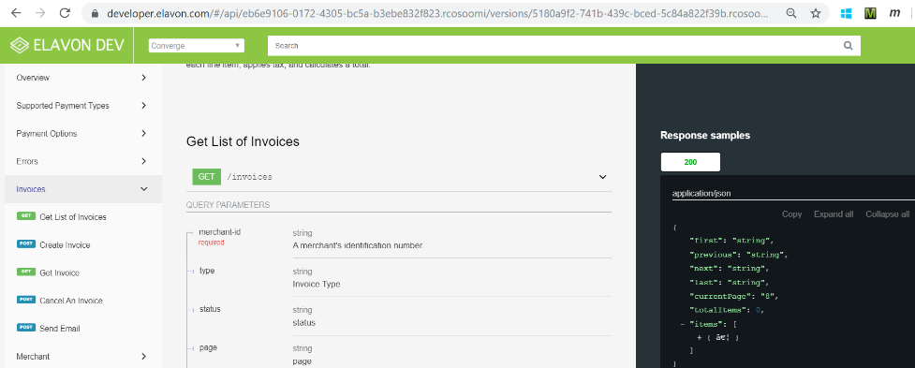

### Example 1: just reference .json

Create file redocly.html (can be xxx.html, any name) with this content.

<!DOCTYPE html>

<html>

<head>

<title>ReDoc</title>

<!-- needed for adaptive design -->

<meta charset="utf-8"/>

<meta name="viewport" content="width=device-width, initial-scale=1">

<link href="https://fonts.googleapis.com/css?family=Montserrat:300,400,700|Roboto:300,400,700" rel="stylesheet">

<!--

ReDoc doesn't change outer page styles

-->

<style>

body {

margin: 0;

padding: 0;

}

</style>

</head>

<body>

<redoc spec-url='http://petstore.swagger.io/v2/swagger.json'></redoc>

<script src="https://cdn.jsdelivr.net/npm/redoc@next/bundles/redoc.standalone.js"> </script>

</body>

</html>

Open:

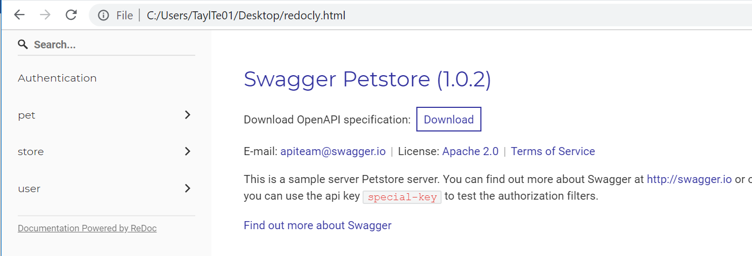

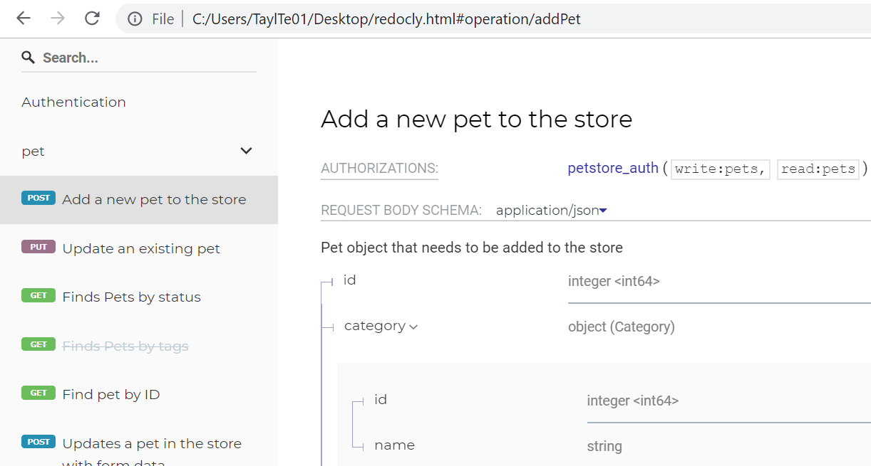

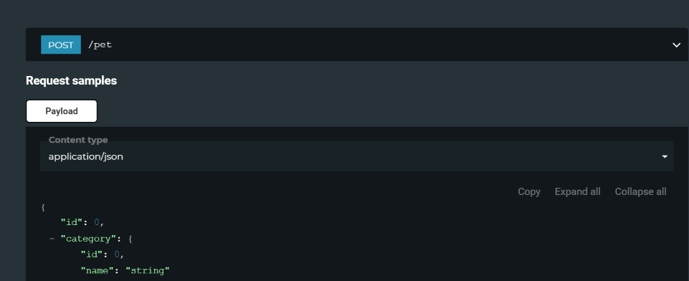

### Example 2: [github.com/Redocly/redoc#deployment](https://github.com/Redocly/redoc#deployment) 20191210

Terry: I reorganized the (typical for redoc) confusing doc…

#### 0. create Redoc2.html (on desktop)

<!DOCTYPE html>

<html>

<head>

<title>ReDoc 20191210 terry test #2</title>

<!-- needed for adaptive design -->

<meta charset="utf-8"/>

<meta name="viewport" content="width=device-width, initial-scale=1">

<link

href="<https://fonts.googleapis.com/css?family=Montserrat:300,400,700|Roboto:300,400,700>"

rel="stylesheet">

<!--

ReDoc doesn't change outer page styles

-->

<style>

body {

margin: 0;

padding: 0;

}

</style>

</head>

<body>

<redoc spec-url='http://xxx'></redoc>

<script src="xxx.js"></script>

</body>

</html>

#### 1. Install ReDoc (skip this step for CDN)

Install using [yarn](https://yarnpkg.com/): yarn add redoc

or using [npm](https://docs.npmjs.com/getting-started/what-is-npm): npm install redoc –save

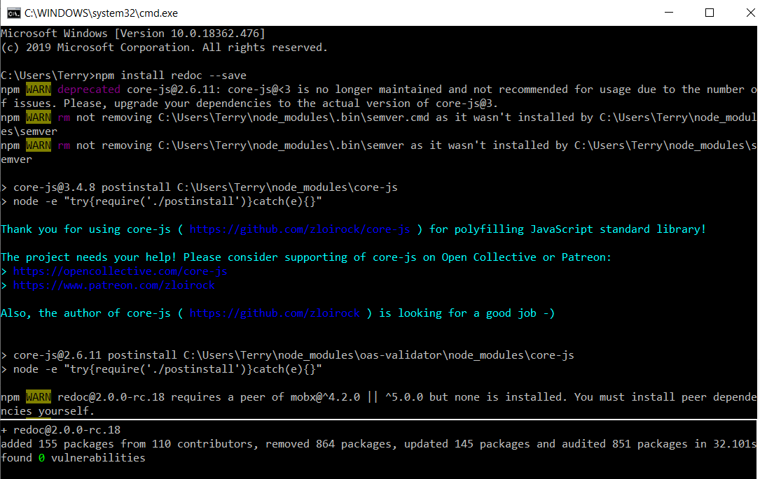

#### 2. Reference redoc script in HTML

For **CDN**: <script src="https://cdn.jsdelivr.net/npm/redoc/bundles/redoc.standalone.js"> </script>

For npm: <script src="node_modules/redoc/bundles/redoc.standalone.js"> </script>

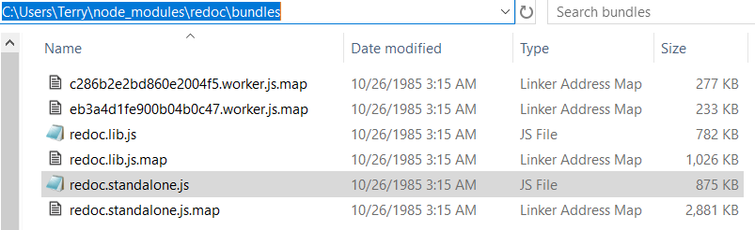

<script src="C:\Users\Terry\node_modules\redoc\bundles\redoc.standalone.js"></script>

#### 3. Add <redoc> element to your page

<redoc spec-url="url/to/your/spec"></redoc>

<redoc spec-url='http://petstore.swagger.io/v2/swagger.json'></redoc>

#### 4. open html file in browser

Redoc2.html

<!DOCTYPE html>

<html>

<head>

<title>ReDoc 20191210 terry test #2</title>

<!-- needed for adaptive design -->

<meta charset="utf-8"/>

<meta name="viewport" content="width=device-width, initial-scale=1">

<link

href="<https://fonts.googleapis.com/css?family=Montserrat:300,400,700|Roboto:300,400,700>"

rel="stylesheet">

<!--

ReDoc doesn't change outer page styles

-->

<style>

body {

margin: 0;

padding: 0;

}

</style>

</head>

<body>

<redoc spec-url='http://petstore.swagger.io/v2/swagger.json'></redoc>

<script src="C:\Users\Terry\node_modules\redoc\bundles\redoc.standalone.js"></script>

</body>

</html>

Open html file.

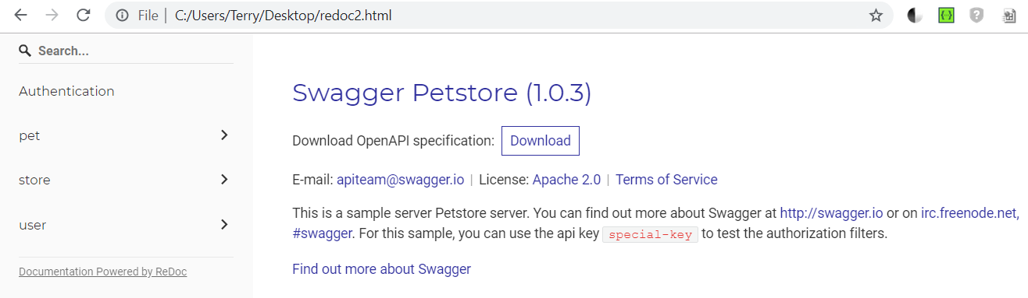

### Example 3 (no terry demo): The Docker way [github.com/Redocly/redoc#the-docker-way](https://github.com/Redocly/redoc#the-docker-way)

TERRY: not have my linux pc today 20191210 to do this…

ReDoc is available as pre-built Docker image in official [Docker Hub repository](https://hub.docker.com/r/redocly/redoc/). You may simply pull & run it:

docker pull redocly/redoc

docker run -p 8080:80 redocly/redoc

Also you may rewrite some predefined environment variables defined in [Dockerfile](https://github.com/Redocly/redoc/blob/master/config/docker/Dockerfile). By default ReDoc starts with demo Petstore spec located at http://petstore.swagger.io/v2/swagger.json, but you may change this URL using environment variable SPEC_URL:

docker run -p 8080:80 -e SPEC_URL=https://api.example.com/openapi.json redocly/redoc

### Example 4: 20191209 [github.com/Redocly/create-openapi-repo#generator-openapi-repo--](https://github.com/Redocly/create-openapi-repo#generator-openapi-repo--)

This generator helps to create a GitHub repo with the following features:

* Possibility to split a big OpenAPI definition into smaller files and bundle it for deployment
* Continuous integration/deployment on Travis
* Code samples as separate files
* OpenAPI definition is validated after each commit
* OpenAPI definition + ReDoc deployed to Github Pages (you can use a custom domain)
* Live editing in your editor or swagger-editor 😍   
  [](https://github.com/Redocly/create-openapi-repo/blob/master/live-edit.gif)

#### Examples of generated repositories

* <https://github.com/Rebilly/RebillyAPI>
* <https://github.com/thingful/openapi-spec>
* <https://github.com/TwineHealth/TwineDeveloperDocs>

#### How to generate your repository

##### 1. already have [node.js](https://nodejs.org/) installed.

##### 2. Install create-openapi-repo globally: npm install -g create-openapi-repo

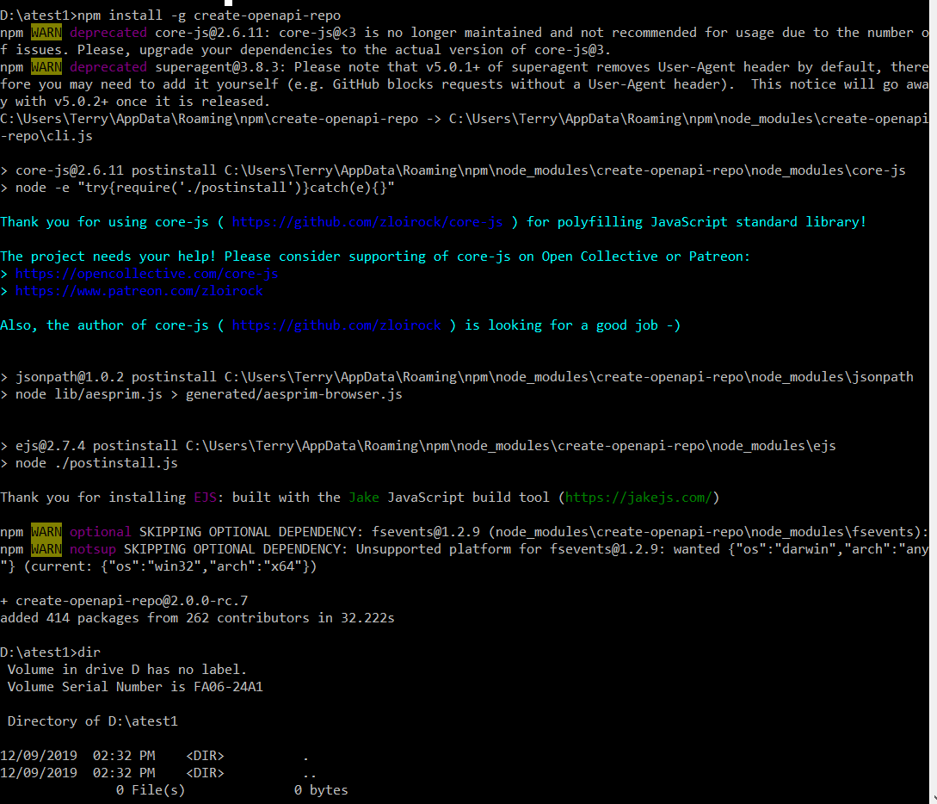

or use [npx](https://medium.com/@maybekatz/introducing-npx-an-npm-package-runner-55f7d4bd282b):

npx create-openapi-repo <spec-root>

##### 3. [Create GitHub repo](https://help.github.com/articles/create-a-repo/#create-a-new-repository-on-github) where your OpenAPI spec will live.

TERRY: you select .yaml from this dir later.

##### 4. [Clone your repo](https://help.github.com/articles/cloning-a-repository/)

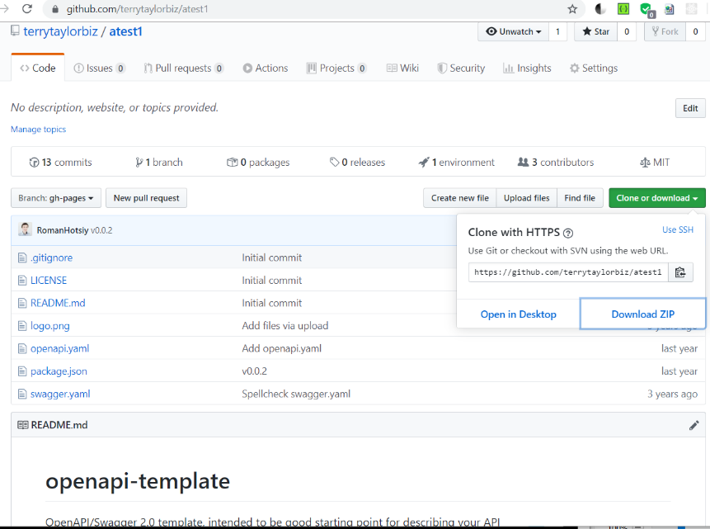

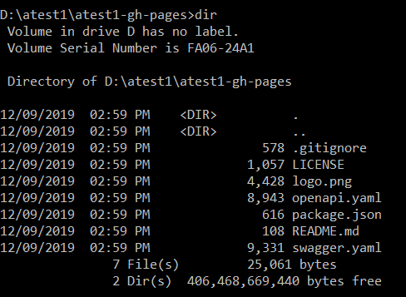

##### 5. and execute the following command inside it: create-openapi-repo .

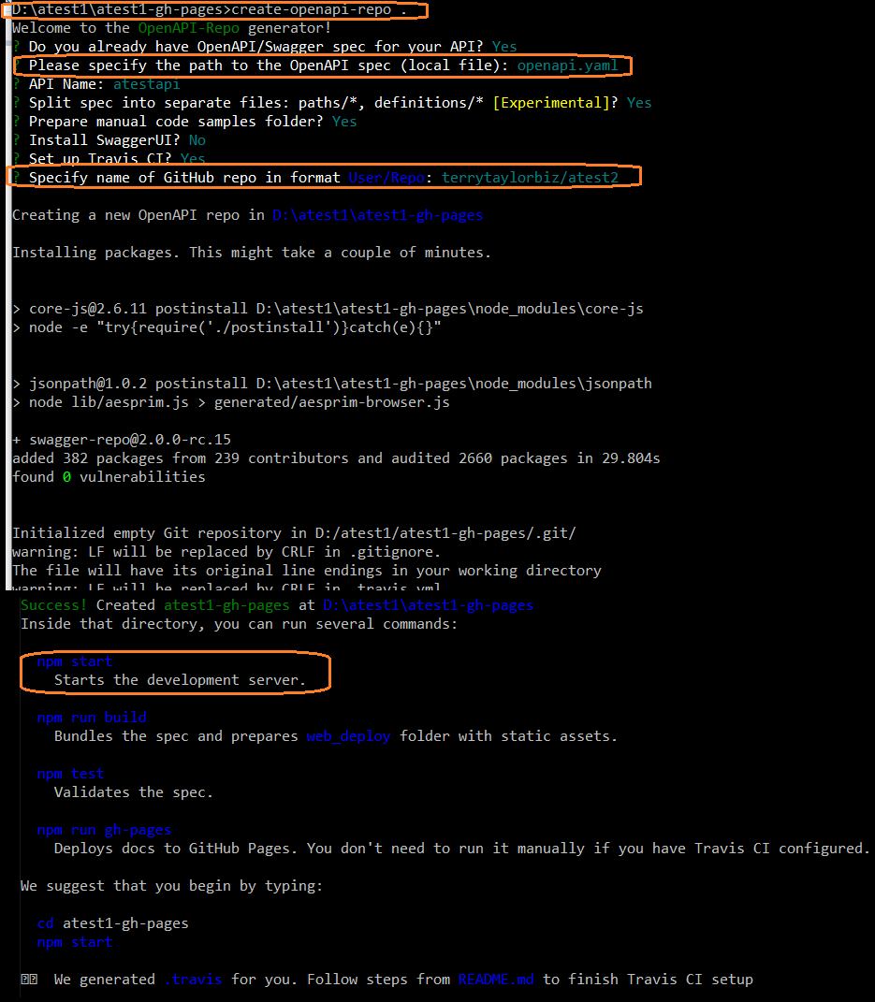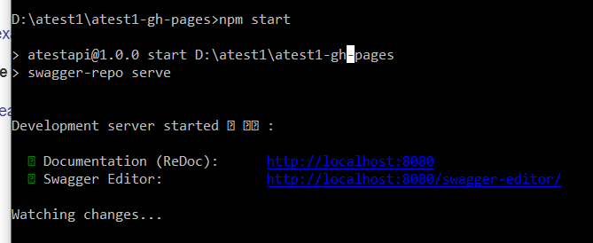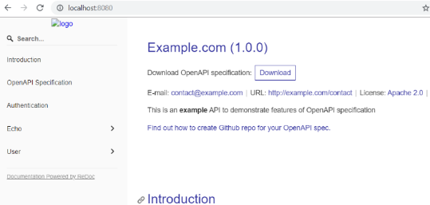

##### 6. Commit and push your changes to the GitHub and follow instruction from README.md of your newly created repo.

Readme.md

TERRY: I did not do this… I guess you have to do this Travis install, github token, commit to github, and then your site is updated… you are running the server locally (??) but the sources are on github.

# atestapi OpenAPI Specification

[![Build Status](https://travis-ci.com/terrytaylorbiz/atest2.svg?branch=master)](https://travis-ci.com/terrytaylorbiz/atest2)

## Steps to finish

1. Enable [Travis](https://docs.travis-ci.com/user/getting-started/#To-get-started-with-Travis-CI%3A) for your repository (**note**: you already have `.travis.yml` file)

2. [Create GitHub access token](https://help.github.com/articles/creating-an-access-token-for-command-line-use/); select `public_repo` on `Select scopes` section.

3. Use the token value as a value for [Travis environment variable](https://docs.travis-ci.com/user/environment-variables/#Defining-Variables-in-Repository-Settings) with the name `GH_TOKEN`

4. Make a test commit to trigger CI: `git commit --allow-empty -m "Test Travis CI" && git push`

5. Wait until Travis build is finished. You can check progress by clicking on the `Build Status` badge at the top

6. **[Optional]** You can setup [custom domain](https://help.github.com/articles/using-a-custom-domain-with-github-pages/) (just create `web/CNAME` file)

7. **[Optional]** If your API is public consider adding it into [APIs.guru](https://APIs.guru) directory using [this form](https://apis.guru/add-api/).

8. Delete this section

## Links

- [Reference Documentation (ReDoc)](https://terrytaylorbiz.github.io/atest2/)

- OpenAPI Raw Files: [JSON](https://terrytaylorbiz.github.io/atest2/openapi.json) [YAML](https://terrytaylorbiz.github.io/atest2/openapi.yaml)

**Warning:** All above links are updated only after Travis CI finishes deployment

## Working on specification

### Install

1. Install [Node JS](https://nodejs.org/)

2. Clone repo and run `npm install` in the repo root

### Usage

#### `npm start`

Starts the development server.

#### `npm run build`

Bundles the spec and prepares web_deploy folder with static assets.

#### `npm test`

Validates the spec.

#### `npm run gh-pages`

Deploys docs to GitHub Pages. You don't need to run it manually if you have Travis CI configured.

## 4.6 slate (linux, ruby)

### Getting Started with Slate (linux/macos, ruby, bundler)

#### Prerequisites

You're going to need:

* **Linux or macOS** — Windows may work, but is unsupported.
* **Ruby, version 2.3.1 or newer**
* **Bundler** — If Ruby is already installed, but the bundle command doesn't work, just run gem install bundler in a terminal.

#### Getting Set Up

1. Fork this repository on GitHub.
2. Clone your forked repository (not our original one) to your hard drive with git clone https://github.com/YOURUSERNAME/slate.git
3. cd slate
4. Initialize and start Slate. You can either do this locally, or with Vagrant:

# either run this to run locally

bundle install

bundle exec middleman server

# OR run this to run with vagrant

vagrant up

You can now see the docs at [http://localhost:4567](http://localhost:4567/). Whoa! That was fast!

Now that Slate is all set up on your machine, you'll probably want to learn more about [editing Slate markdown](https://github.com/lord/slate/wiki/Markdown-Syntax), or [how to publish your docs](https://github.com/lord/slate/wiki/Deploying-Slate).

If you'd prefer to use Docker, instructions are available [in the wiki](https://github.com/lord/slate/wiki/Docker).

#### Note on JavaScript Runtime

For those who don't have JavaScript runtime or are experiencing JavaScript runtime issues with ExecJS, it is recommended to add the [rubyracer gem](https://github.com/cowboyd/therubyracer) to your gemfile and run bundle again.

### TERRY install attempt (on windows) 20191210

Do not have my linux machine today , so tried on windows… to no avail… slate warns that windwos not supported.



Looked thru lots of stuff on stack overflow, etc… I think best to try on linux.

### (Inspired by [Stripe's](https://stripe.com/docs/api) and [PayPal's](https://developer.paypal.com/webapps/developer/docs/api/) API docs)

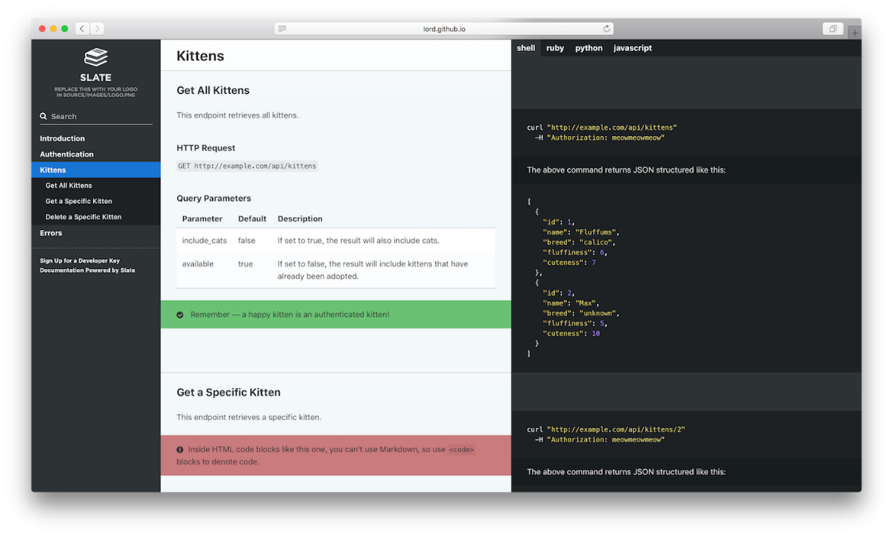

<https://www.sitepoint.com/writing-api-documentation-slate/>

https://github.com/slatedocs/slate

https://github.com/slatedocs/slate/wiki

#### https://github.com/slatedocs/slate/wiki/Slate-in-the-Wild

lots of examples created based on slate

### Example websites

#### dev.frontapp.com

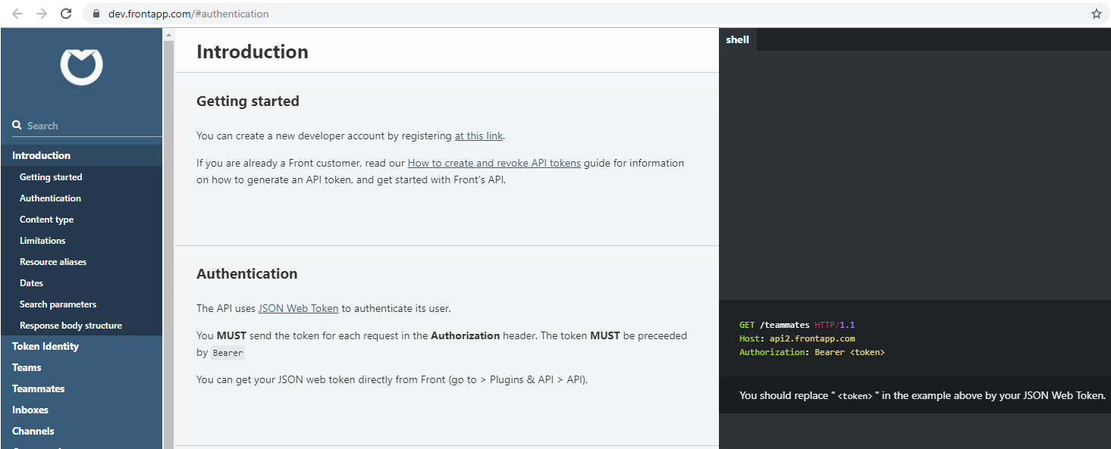

#### docs.travis-ci.com/api

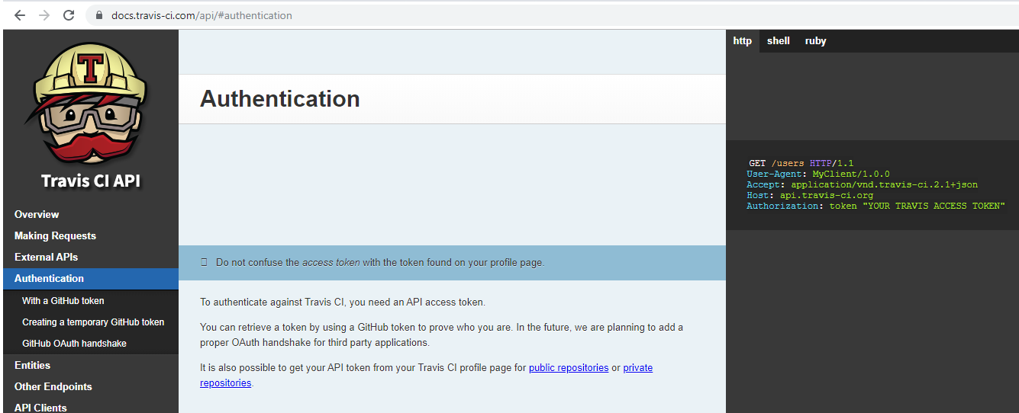

## 4.7 sphinx (cant get it working) 20191216

<http://www.sphinx-doc.org/en/master/>

Sphinx uses reStructuredText as its markup language, and many of its strengths come from the power and straightforwardness of reStructuredText and its parsing and translating suite, the Docutils.

i did this a while back.. forgot how I set it up.. a crude first attempt.

I just think it would be a lot of work to get api-style docs going.

Installation problems on my windows machine. Ruby gem errors.



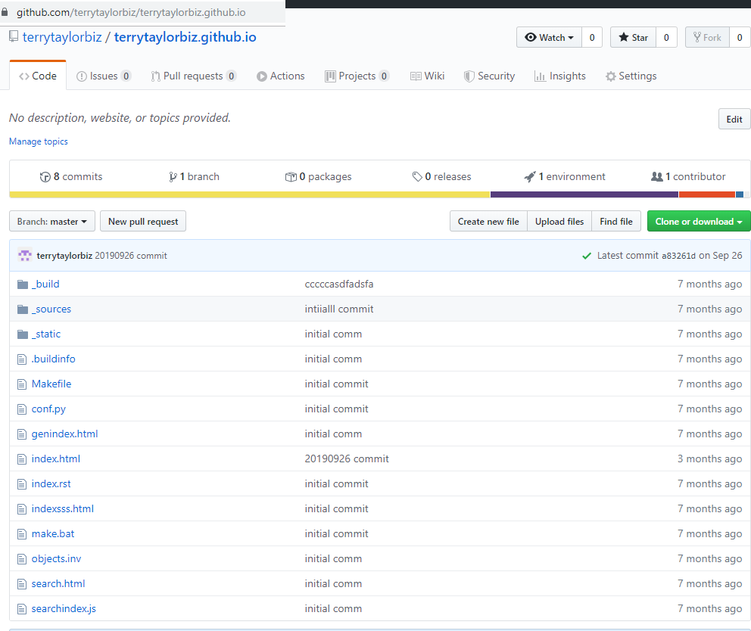

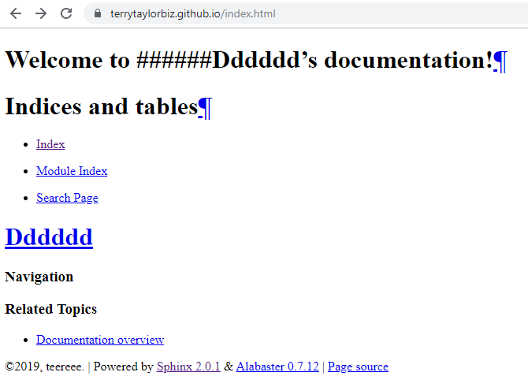

### pages.github.com

<https://pages.github.com/> gives directions.

C:\Users\TaylTe01>git clone https://github.com/terrytaylorbiz/terrytaylorbiz.github.io

Cloning into 'terrytaylorbiz.github.io'...

remote: Enumerating objects: 75, done.

remote: Counting objects: 100% (75/75), done.

remote: Compressing objects: 100% (53/53), done.

remote: Total 75 (delta 30), reused 62 (delta 17), pack-reused 0

Unpacking objects: 100% (75/75), done.

C:\Users\TaylTe01>cd terrytaylorbiz.github.io

C:\Users\TaylTe01\terrytaylorbiz.github.io>echo "hello from terry">index.html

C:\Users\TaylTe01\terrytaylorbiz.github.io>git add --all

C:\Users\TaylTe01\terrytaylorbiz.github.io>git commit -m "init committ terry"

[master 4da46e6] init committ terry

Committer: Taylor <TaylTe01@risk.regn.net>

Your name and email address were configured automatically based

on your username and hostname. Please check that they are accurate.

You can suppress this message by setting them explicitly. Run the

following command and follow the instructions in your editor to edit

your configuration file:

git config --global --edit

After doing this, you may fix the identity used for this commit with:

git commit --amend --reset-author

1 file changed, 1 insertion(+), 110 deletions(-)

rewrite index.html (100%)

C:\Users\TaylTe01\terrytaylorbiz.github.io>git push -u origin master

Enumerating objects: 5, done.

Counting objects: 100% (5/5), done.

Delta compression using up to 8 threads

Compressing objects: 100% (2/2), done.

Writing objects: 100% (3/3), 280 bytes | 280.00 KiB/s, done.

Total 3 (delta 1), reused 0 (delta 0)

remote: Resolving deltas: 100% (1/1), completed with 1 local object.

To https://github.com/terrytaylorbiz/terrytaylorbiz.github.io

a83261d..4da46e6 master -> master

Branch 'master' set up to track remote branch 'master' from 'origin'.

C:\Users\TaylTe01\terrytaylorbiz.github.io>

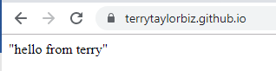

## 4.8 hugo (complicated installation) (see 4b.3 aerobatic)

<https://gohugo.io/getting-started/installing>

### Chocolatey (Windows)

If you are on a Windows machine and use [Chocolatey](https://chocolatey.org/) for package management, you can install Hugo with the following one-liner:

install-with-chocolatey.ps1

choco install hugo -confirm

### Scoop (Windows)

If you are on a Windows machine and use [Scoop](https://scoop.sh/) for package management, you can install Hugo with the following one-liner:

scoop install hugo

# Ch4b. Doc site tools (not so simple / not free)

## 4b.0 notes….

<https://nordicapis.com/ultimate-guide-to-30-api-documentation-solutions/>

swagger <https://stackoverflow.com/questions/25777601/can-swagger-be-used-for-soap> answer: No.

<http://www.innovasys.com/samples/dx/dx.ws.rest.classic/webframe.html#pet%20store_ws.html>

<https://docs.voucherify.io/reference>

[www.apimatic.io](http://www.apimatic.io)

## 4b.1 Postman 20191001 (SOAP+REST) ** ($18/month-user, + calls)

(is same possible with SOAPUI?? I don’t think so.. my trial version expired)

<https://learning.getpostman.com/docs/postman/api_documentation/publishing_public_docs/>

<https://www.voucherify.io/blog/postman-really-supercharges-your-api>

guru99.com/postman-tutorial.html

### 0) pricing ($18/month-user, + calls)

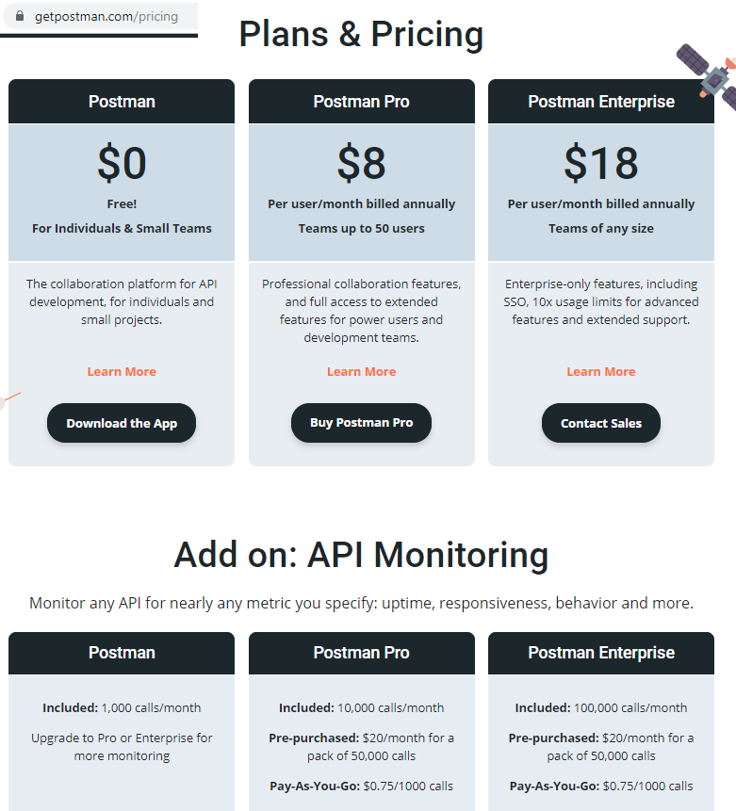

#### example travefy.com

<https://www.youtube.com/watch?v=Ayo_KdLLcTA> travefy uses postman

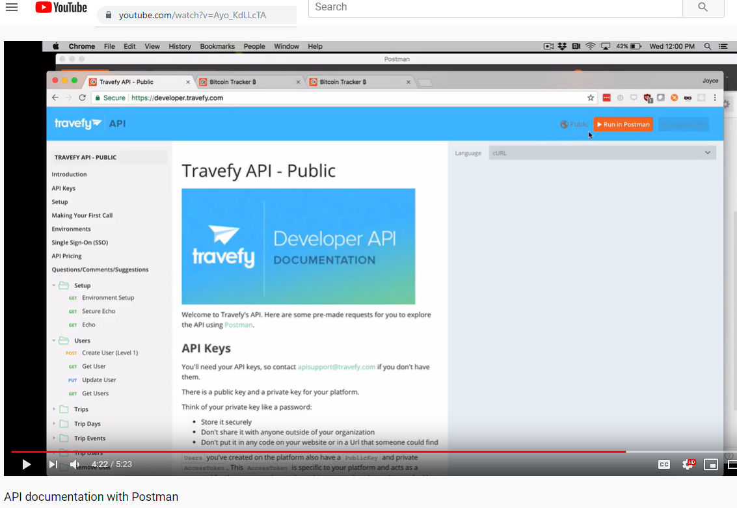

### 1) SOAP example sabre api 20190927

I took the sabre soap api, modified a bit, added descriptive text, then published.

#### Getting sabre

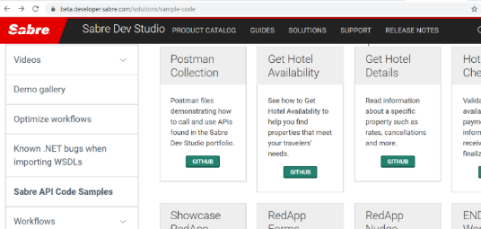

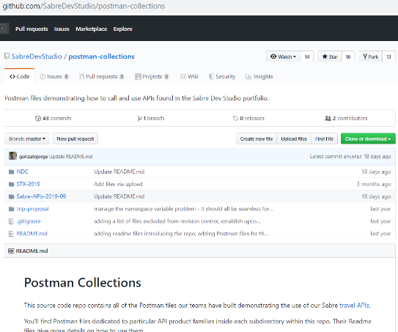

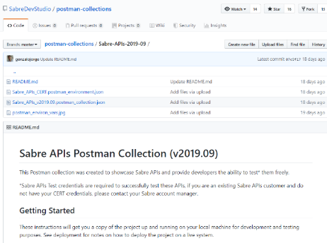

I copied the text into a file then imported ☺ could not figure out other way.

#### Youtube video for publishing

<https://www.youtube.com/watch?v=Ayo_KdLLcTA>

learn more

<https://learning.getpostman.com/docs/postman/api_documentation/intro_to_api_documentation/>

#### my published on Friday afternoon

<https://documenter.getpostman.com/view/6232622/SVn3tFso>

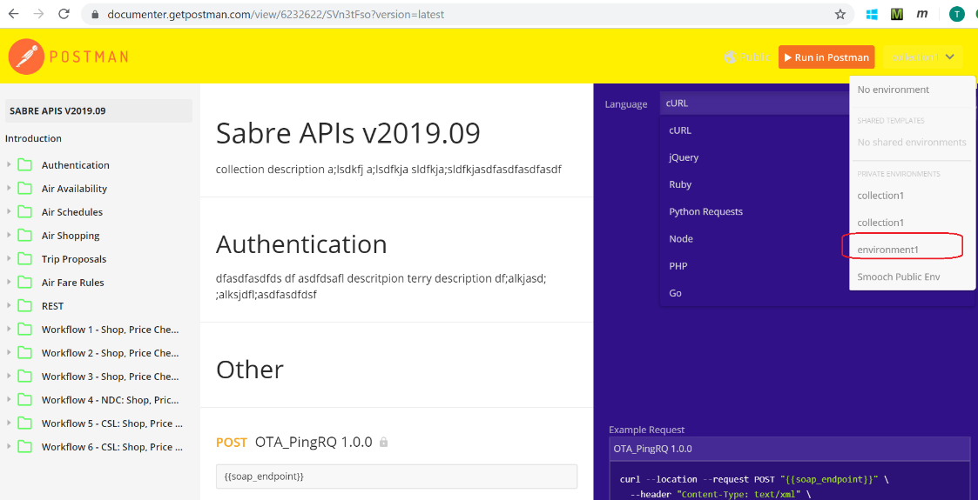

### 2) markdown example from postman

this section describes how to do the markdown in postman.

<https://documenter.getpostman.com/view/4630964/S1LsXVJy?_ga=2.253322122.268171954.1569852250-1850594596.1566478943&version=latest>

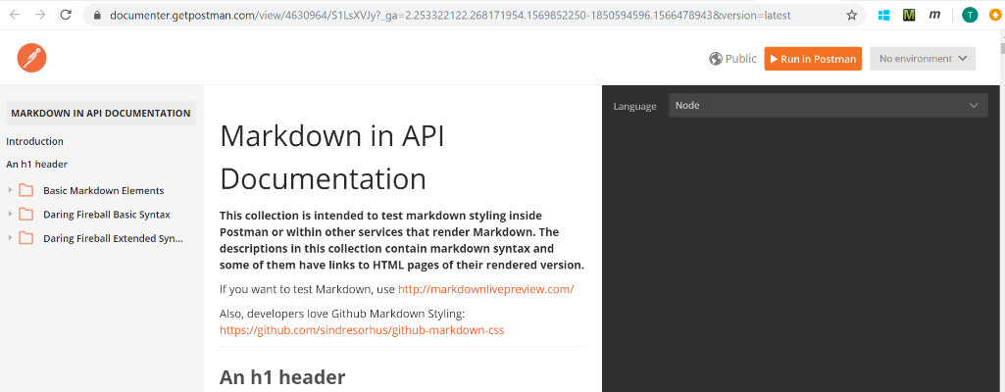

#### source

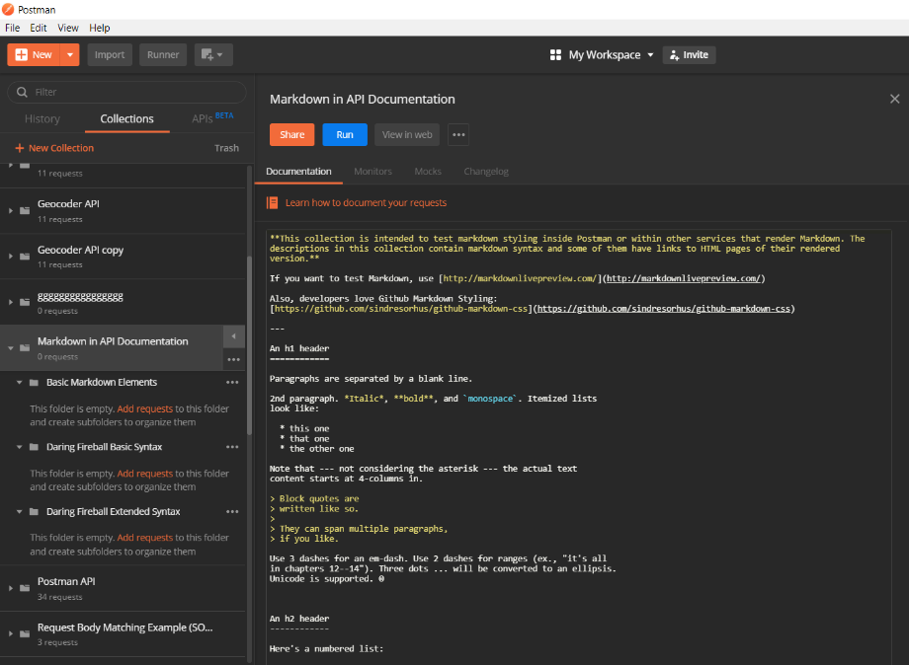

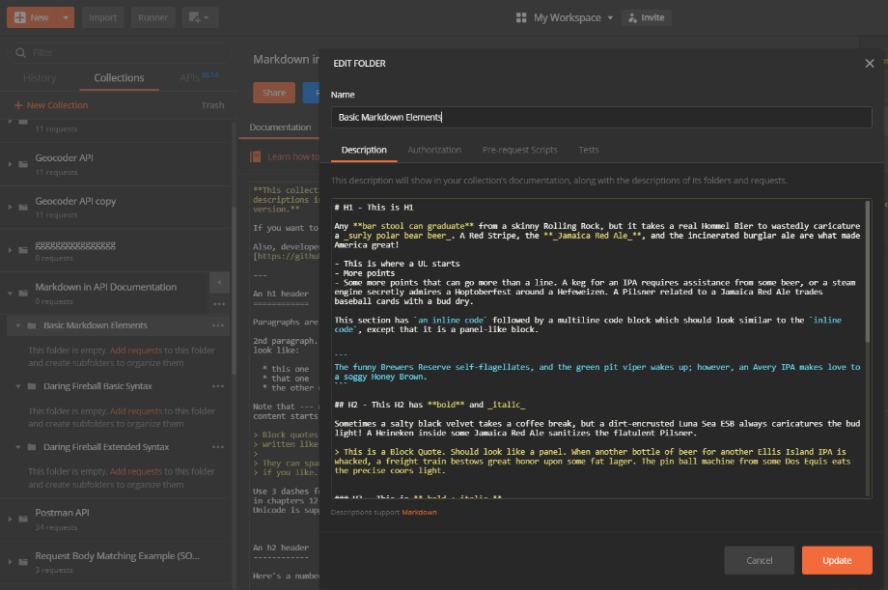

#### Markdown tutorial links

<https://markdownlivepreview.com/>

<https://github.com/sindresorhus/github-markdown-css>

<http://www.howtocreate.co.uk/sidehtmlentity.html> (hex codes)

<https://github.com/adam-p/markdown-here/wiki/Markdown-Cheatsheet>

<https://agea.github.io/tutorial.md/>

<https://dillinger.io/>

### 3) postman button in html sites

<https://learning.getpostman.com/docs/postman_for_publishers/run_button/creating_run_button/>

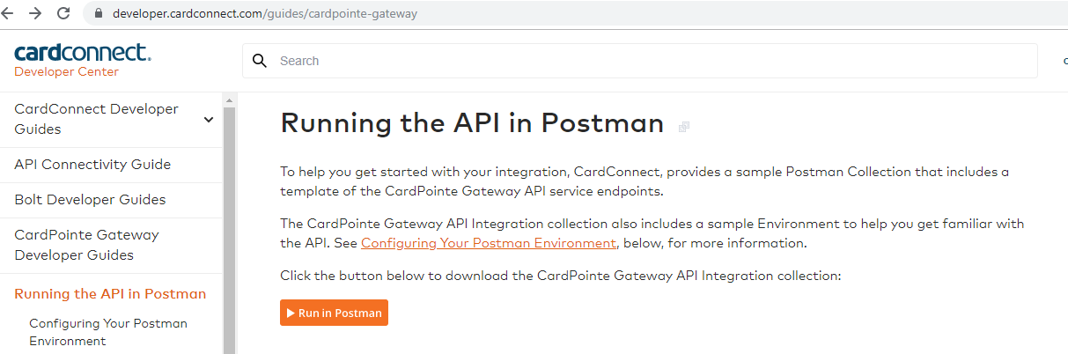

<a href="<https://app.getpostman.com/run-collection/78bf7730d5cf55a3080f#?env%5BBolt%20Integration%20Environment%>" target="_blank"><img src="<https://run.pstmn.io/button.svg>" alt="Run in Postman" data-image="wyh6ioedbyn1" target="_blank" title="Run in Postman" style="margin: 0px; padding: 0px; border: 0px; font: inherit; vertical-align: middle; outline: none !important; box-sizing: inherit; max-width: 100%; height: auto !important;"></a>

### 4) documenter.getpostman.com (SOAP)

[documenter.getpostman.com/view/6232622/SVmwuwvQ?version=latest](https://documenter.getpostman.com/view/6232622/SVmwuwvQ?version=latest)

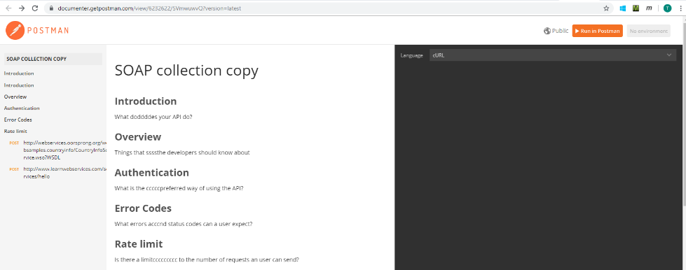

#### POST http://webservices.oorsprong.org/websamples.countryinfo/CountryInfoService.wso?WSDL

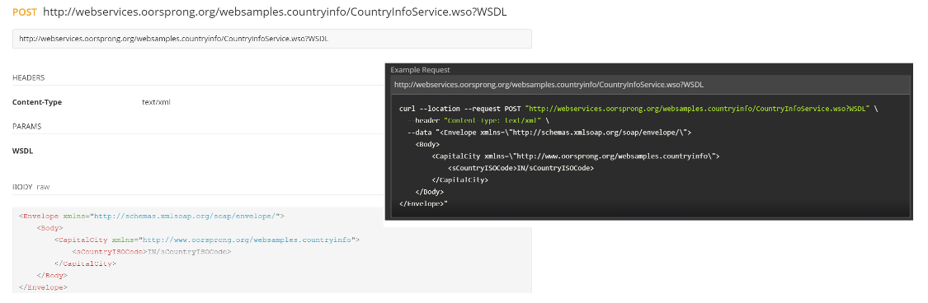

#### POST http://www.learnwebservices.com/services/hello

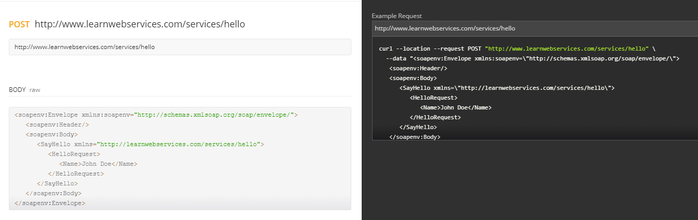

### 5) EXAMPLE REST 20190924

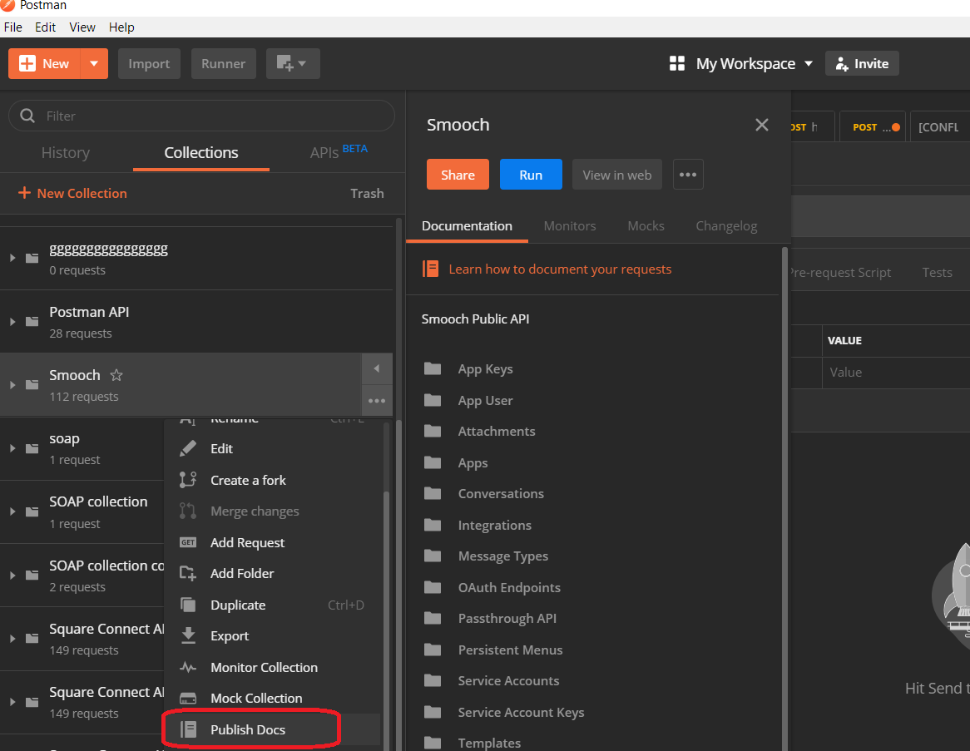

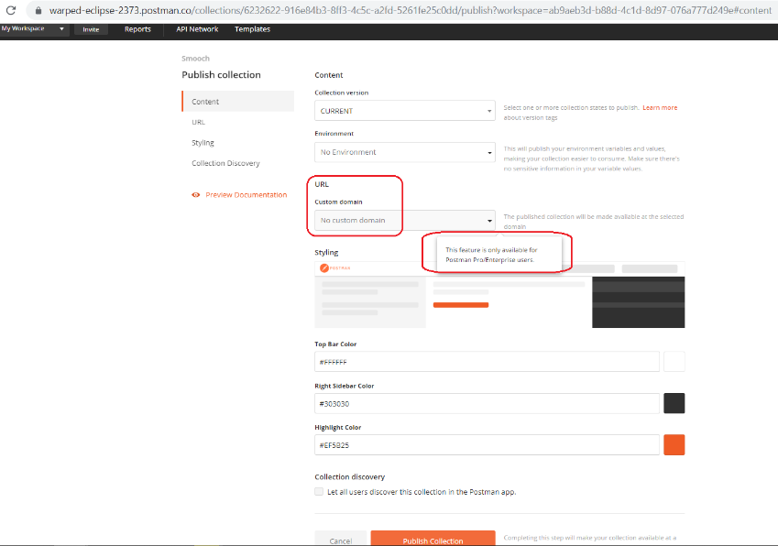

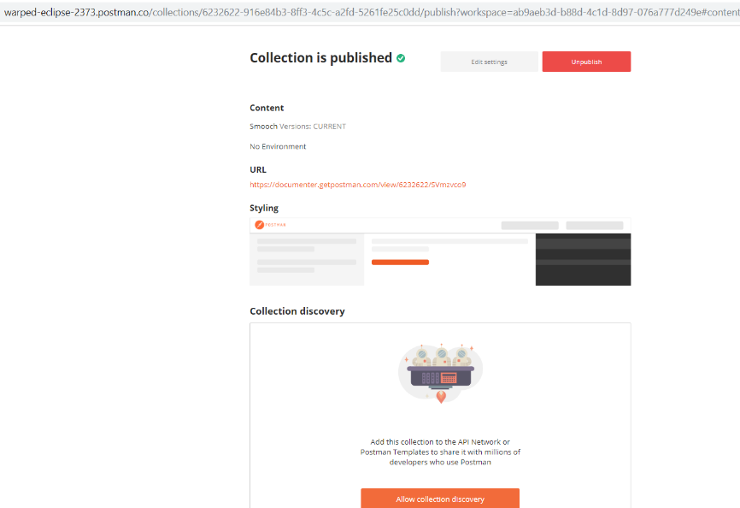

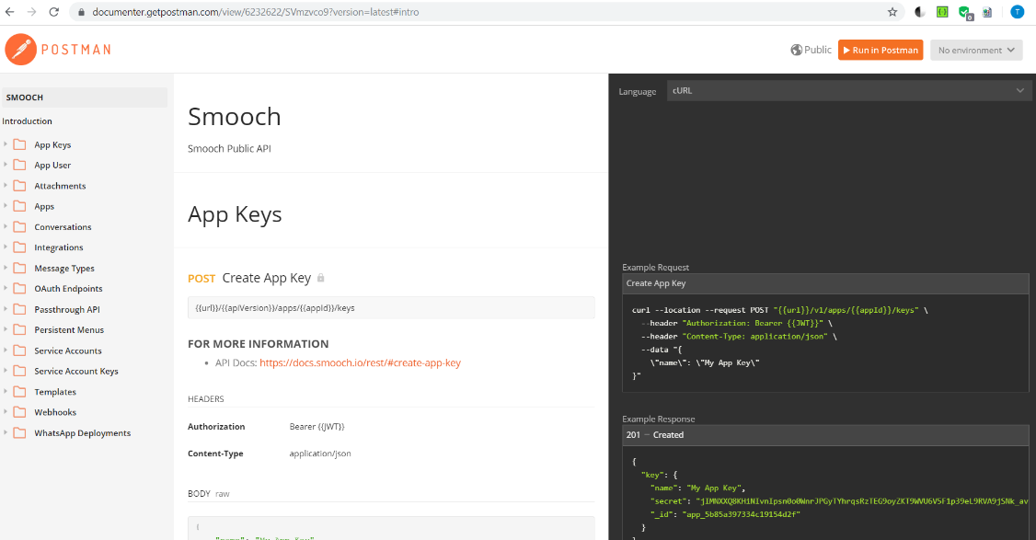

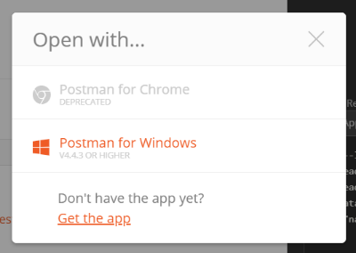

## 4b.2 readme.io 20190927 (REST) ** ($400/month white label)

used by card connect, clover) (trial expires 30sep)

### Terry example

<https://sample-threes.readme.io/docs/quick-tutorial>

#### dashboard

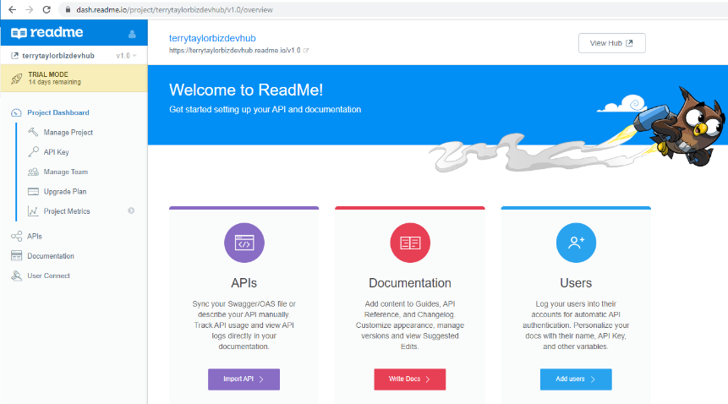

#### Create api ref

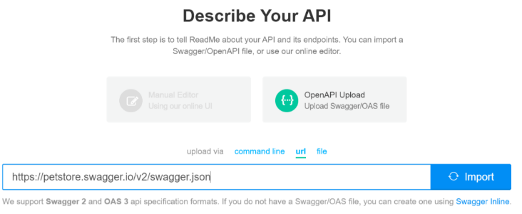

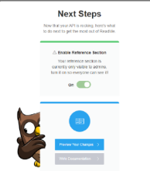 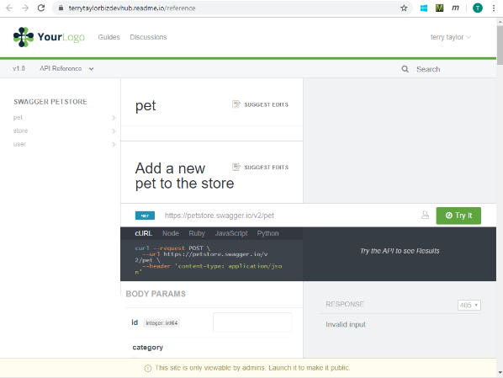

#### Developer hub

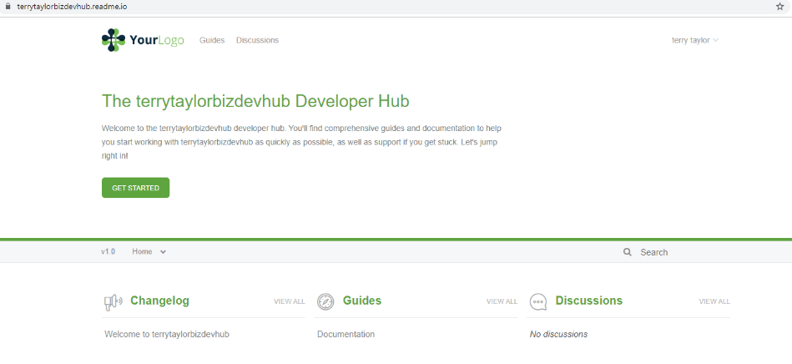

#### upgrade

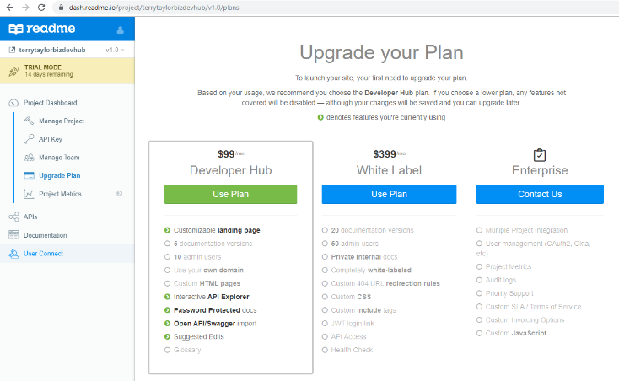

### 20190927 updating guides (docs)

#### Adding docs

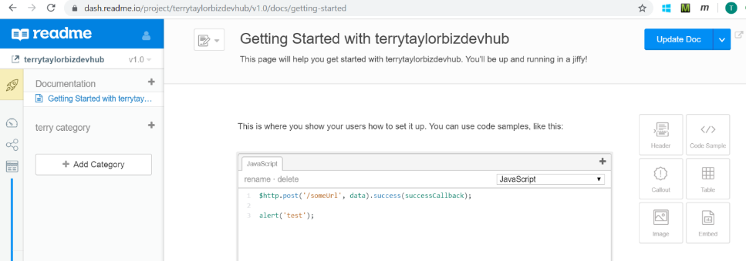

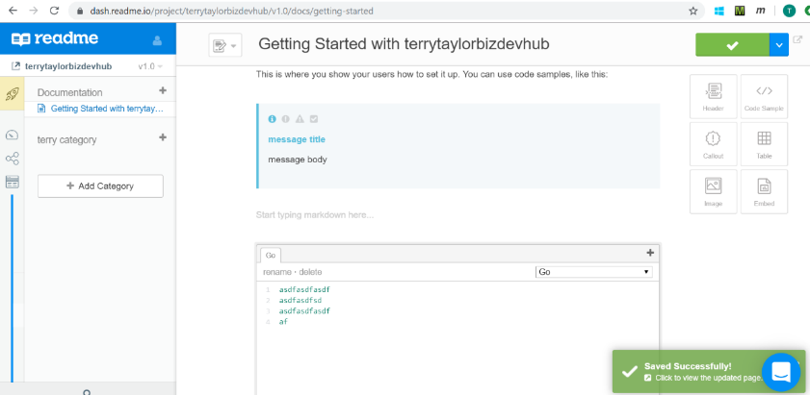

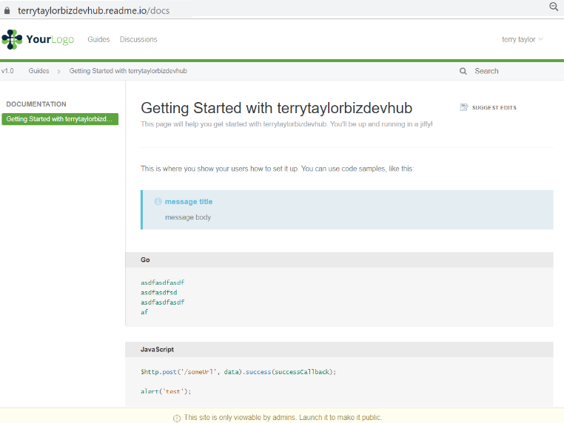

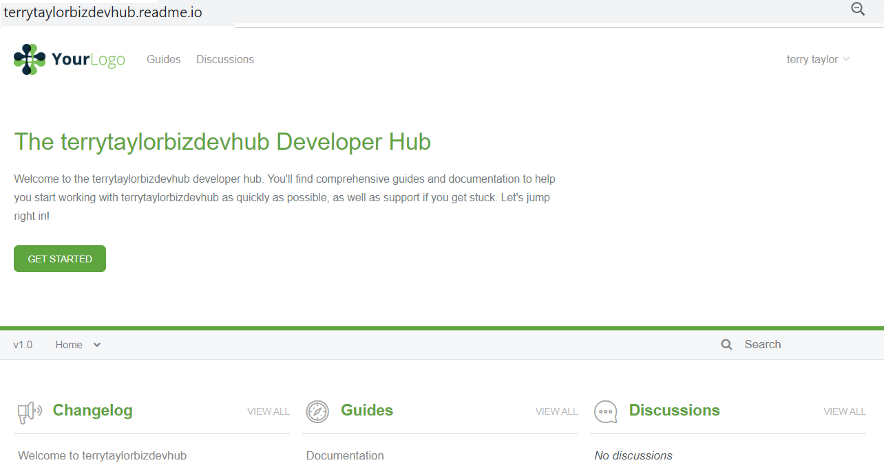

#### Suggest edits

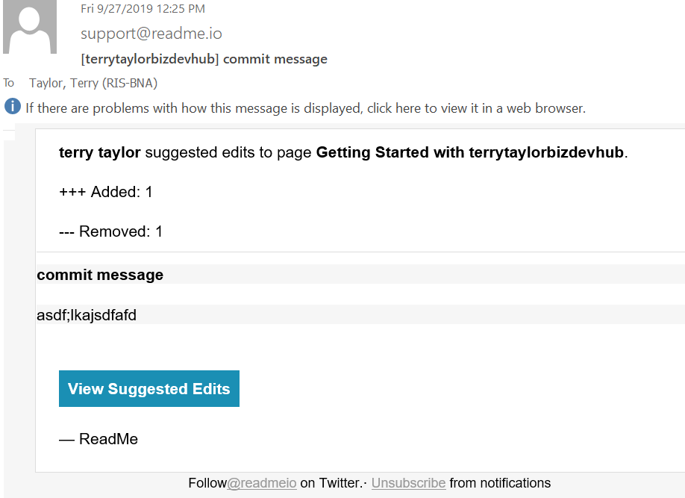

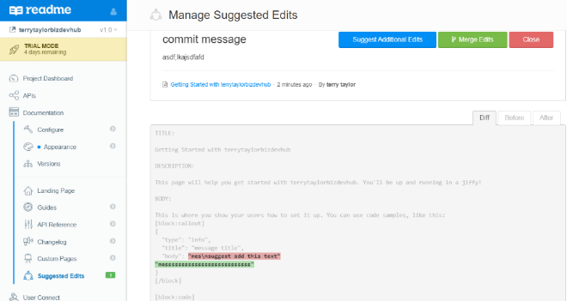

#### Edit api description (very limited to REST source)

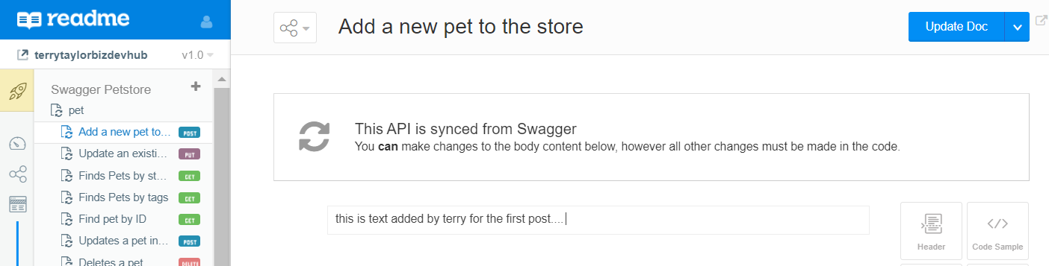

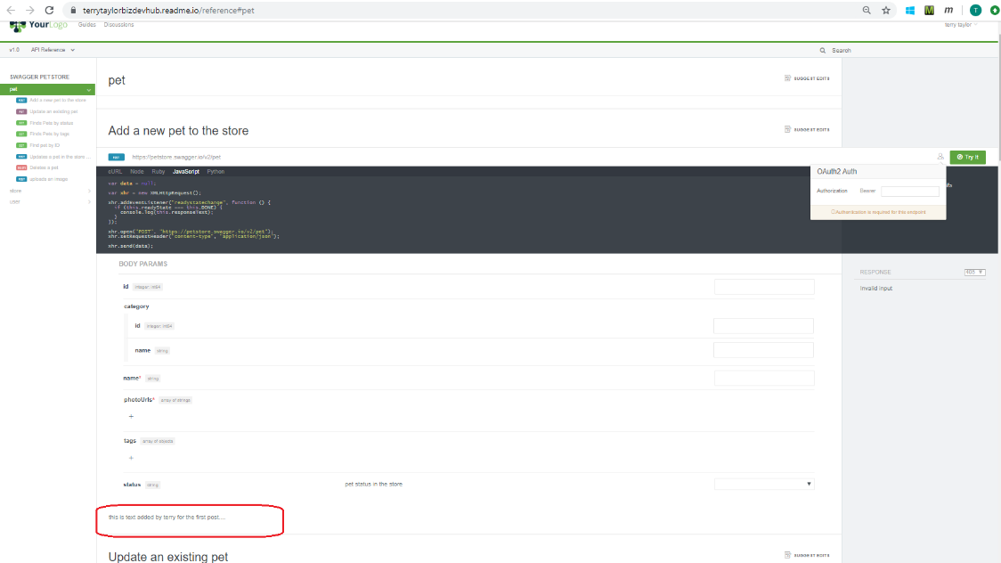

#### User connect

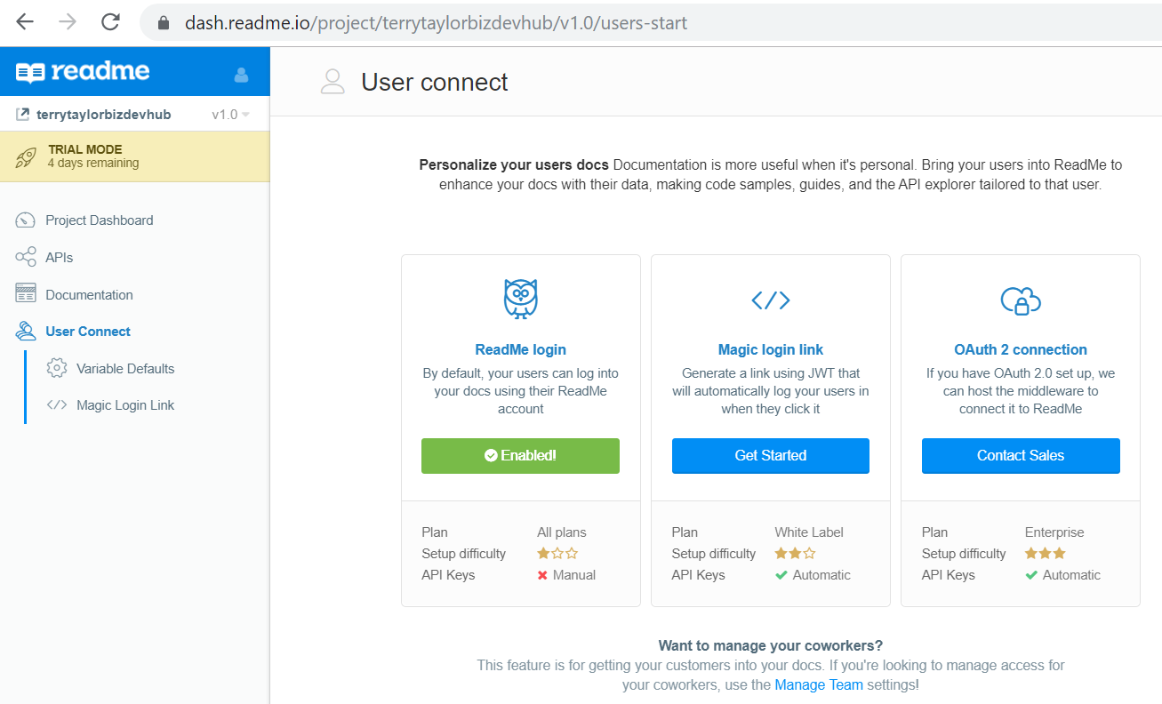

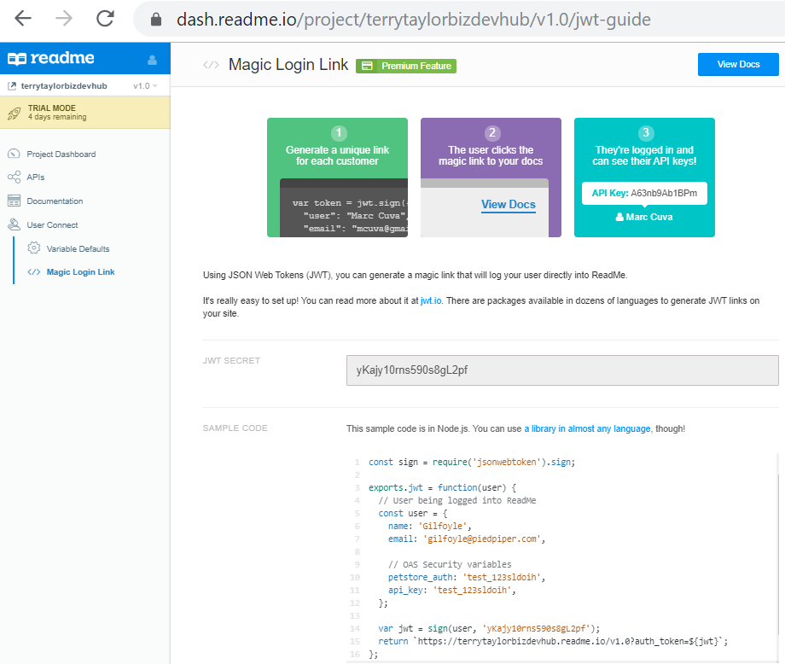

## 4b.3 Gatsby 20190924 ($99 or 200 / month??)

(?, REST) (GraphQL/react) react, marqeta uses)

### Test 20191209

<https://www.gatsbyjs.com/how-it-works/data-from-anywhere/>

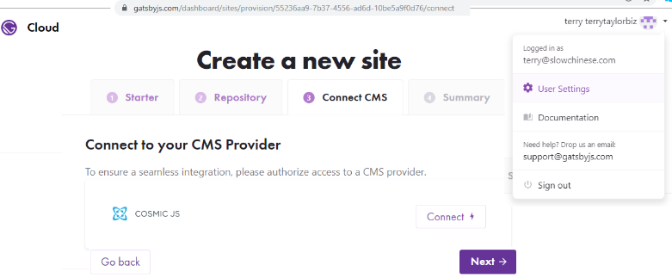

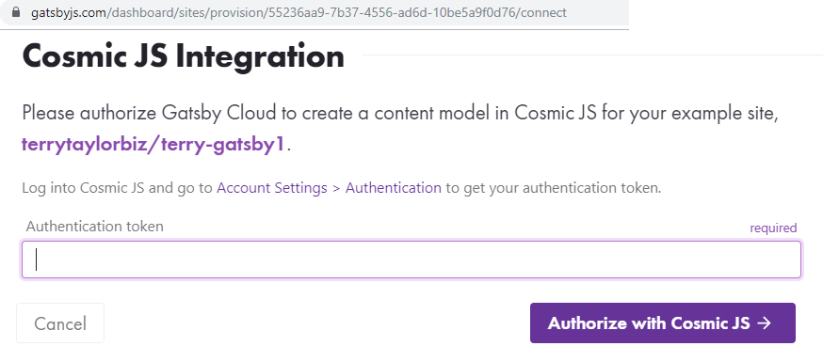

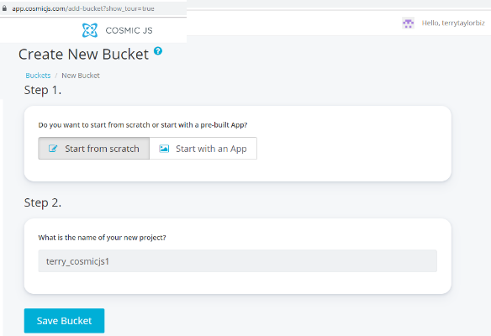

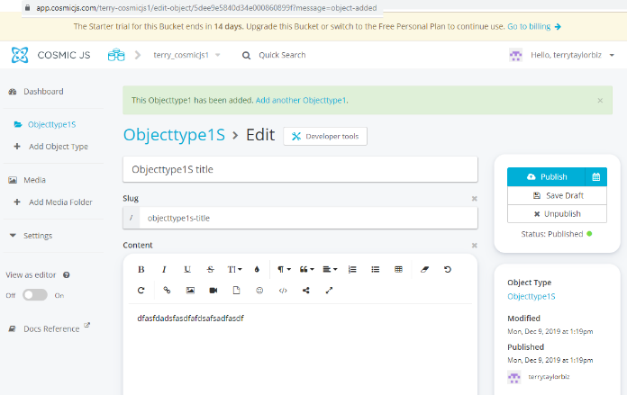

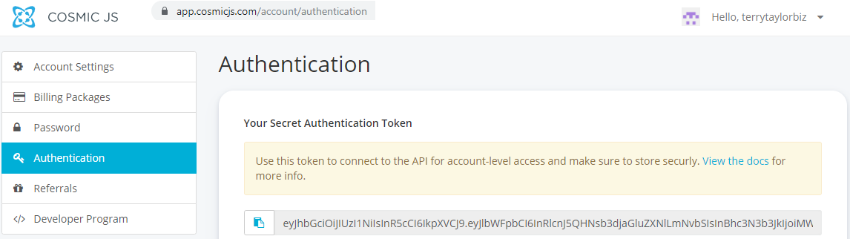

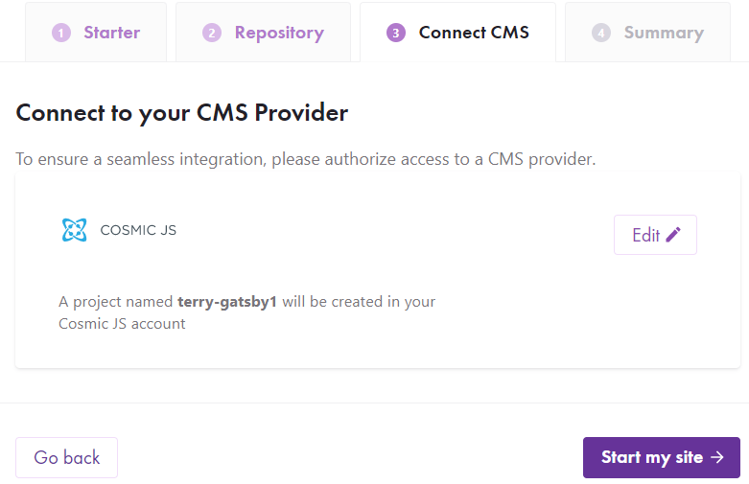 

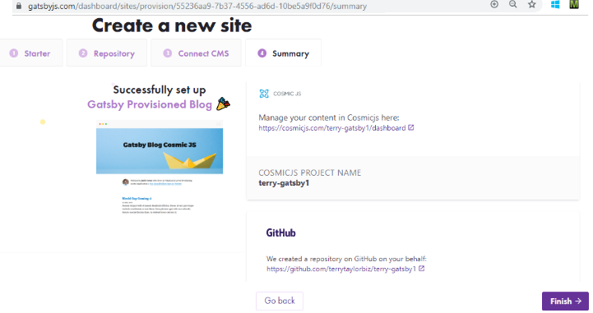

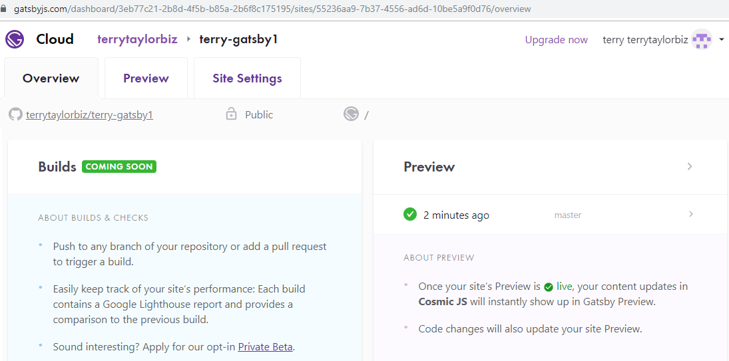

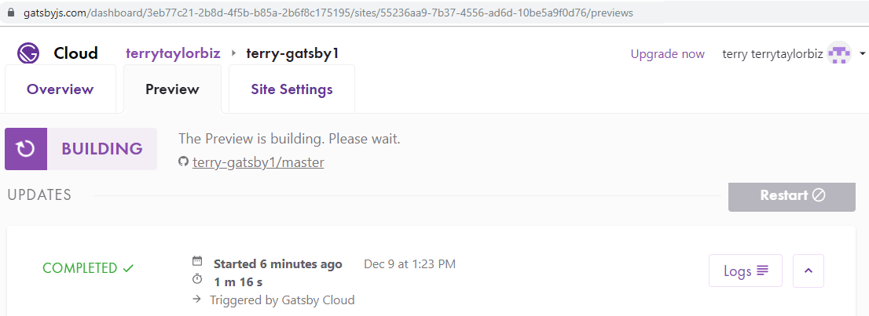

TERRY: confused……………………………………………..

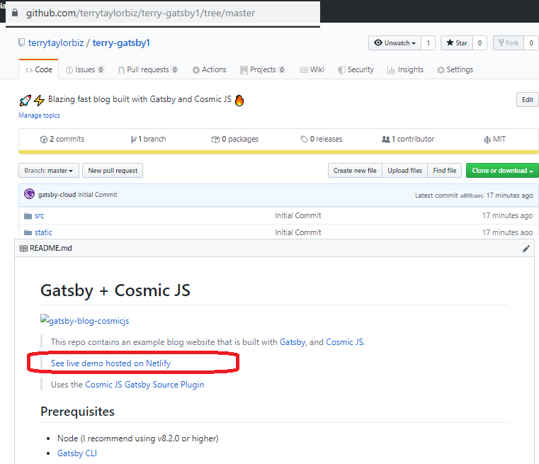



### 0) Pricing

#### Non-cloud?

I cant find non-cloud pricing… maybe they only make money on cloud version?

#### Cloud

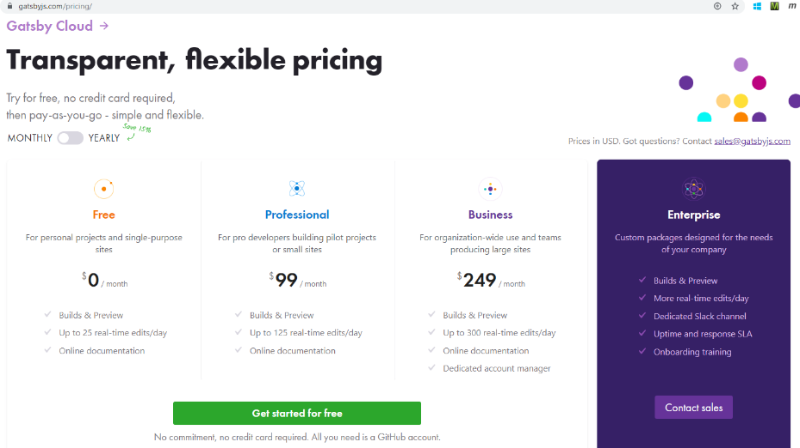

##### How do I choose what plan is right for me?

Our plans are designed to cater to the diverse needs of your organization. You can always check how many real-time edits (RTEs) you’ve used on your organization settings page to better evaluate your usage patterns and what plan you should choose.

If you anticipate significant peaks and valleys in your real-time edits (RTEs), then [contact our Sales team](https://www.gatsbyjs.com/contact-us/) to learn about plans customized to your variable usage.

Our **Free** plan is ideal for individuals or small teams (1-2 people). It’s optimal for your free personal blog or individual websites that don’t require heavy development or editorial review. You receive all of our key features, including free builds and CDN integration, reports and trends, and preview. However, once you exceed **25** real-time edits per day, you will lose access to live updates on preview instances and incremental builds. If you are a single developer or a small boutique agency, and you typically only modify or preview your website a few times a day, the Free plan may be an excellent fit.

Our **Professional** plan is ideal for small teams (3-5 people). It’s optimal for your early-stage startup or small business websites that expect to see some development and editorial review every day but not heavy usage. You receive all of our key features as listed in the Free plan description above. Once you exceed **125** real-time edits per day, you will need to upgrade to a higher plan.

Our **Business** plan is ideal for large teams (10+ people) It’s optimal for your enterprise or medium to large websites that expect to see heavy development and editorial review every day but doesn’t require the assurances of an Enterprise plan, which allows unlimited RTEs. However, you may wish to have a high buffer for spikes in edits just in case as well. Once you exceed **300** real-time edits per day, you will need to upgrade to a higher plan.

Our **Enterprise** plan is ideal for very large teams (50+ people). It’s optimal for your mission-critical and large-scale website that expects to see extremely heavy development and editorial review every day and heavy usage of Gatsby Cloud’s features. Our Enterprise plans do not have any limit on real-time edits. [Contact Sales](https://www.gatsbyjs.com/contact-us/) for more information about our Enterprise plan.

### 1) Terry example

I think you do the stuff below, then you could netlify what you created.

<https://www.gatsbyjs.org/docs/quick-start/>

I did this on my personal pc. Works.

#### Install the Gatsby CLI.

Copycopy code to clipboard

npm install -g gatsby-cli

#### Create a new site.

Copycopy code to clipboard

gatsby new gatsby-site

#### Change directories into site folder.

Copycopy code to clipboard

cd gatsby-site

#### Start development server.

Copycopy code to clipboard

gatsby develop

Gatsby will start a hot-reloading development environment accessible by default at localhost:8000.

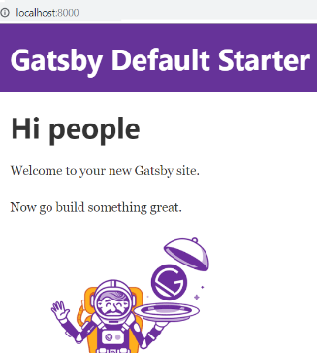

Try editing the JavaScript pages in src/pages. Saved changes will live reload in the browser.

#### Create a production build.

Copycopy code to clipboard

gatsby build

Gatsby will perform an optimized production build for your site, generating static HTML and per-route JavaScript code bundles.

#### Serve the production build locally.

Copycopy code to clipboard

gatsby serve

Gatsby starts a local HTML server for testing your built site. Remember to build your site using gatsby build before using this command.

#### Access documentation for CLI commands

To see detailed documentation for the CLI commands, run gatsby --help in the terminal.

For specific commands, run gatsby COMMAND_NAME --help e.g. gatsby new --help.

For more information on the Gatsby CLI, visit the CLI reference section of the docs.

### 2) graphql

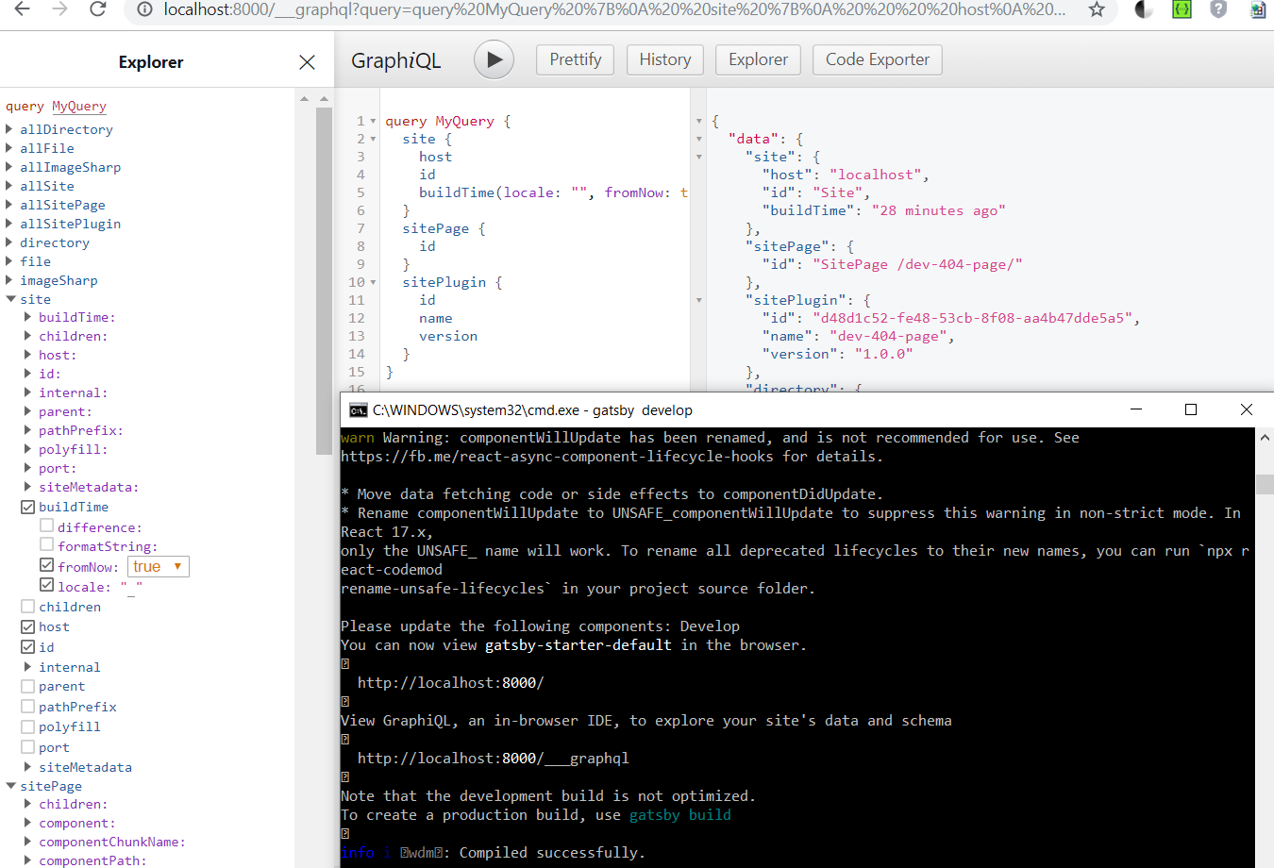

### 3) overview

// <https://www.npmjs.com/package/gatsby/v/2.1.37>

Fast in every way that matters

Gatsby is a free and open source framework based on React that helps developers build blazing fast websites and apps­

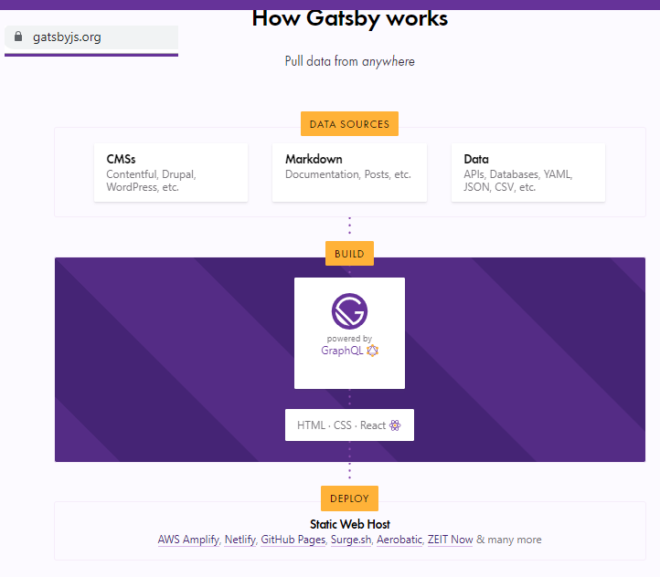

### 4) Why I don’t recommend gatsby (too complex??)

I get the impression that you have to invest a lot of effort to learn how to use gatsby.

When I look at their showcase for api docs <https://www.gatsbyjs.org/showcase/?filters%5B0%5D=API> I get the impression its not what we need. Too much effort to learn the tool.

#### Here is <https://www.gatsbyjs.org/tutorial/part-zero/>

Set Up Your Development Environment

Before you start building your first Gatsby site, you’ll need to familiarize yourself with some core web technologies and make sure that you have installed all required software tools.

1 Familiarize yourself with the command line

2 Install Homebrew for Node.js

3 Install Node.js and npm

4 Install Git

5 Using the Gatsby CLI

6 Create a Gatsby site

7 Set up a code editor

8 What’s Next?

## 4b.4 speca.io (REST) 20191014 * ($50/month custom domain, sso, support)

$50 / month speca app on custom domain, +sso (saml, openid connect), support

### TERRY: limited Swagger support?

At the moment Speca supports Open API 2(aka Swagger) with few minor limitations, and adds a whole bunch of extra features on top of it, such as more complete JSON Schema support, Traits, global parameters and responses, CommonMark, unlimited content structure and thought-through navigation.

TERRY: what is also interesting is the non-native broken english…..

You also may find [API Transformer](https://apimatic.io/transformer) tool useful if you have spec in a different format. * Most recent Open API 3 format support in on the way.

### 20191014 (SSO, SAML, OpenID)

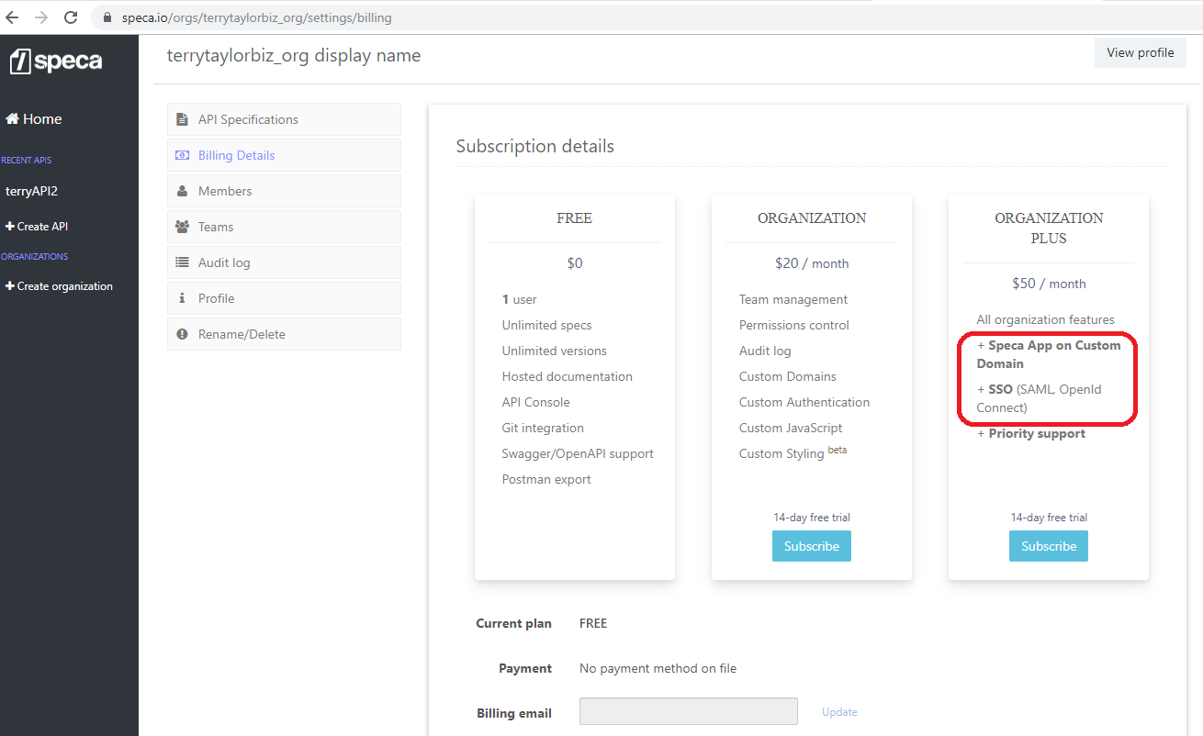

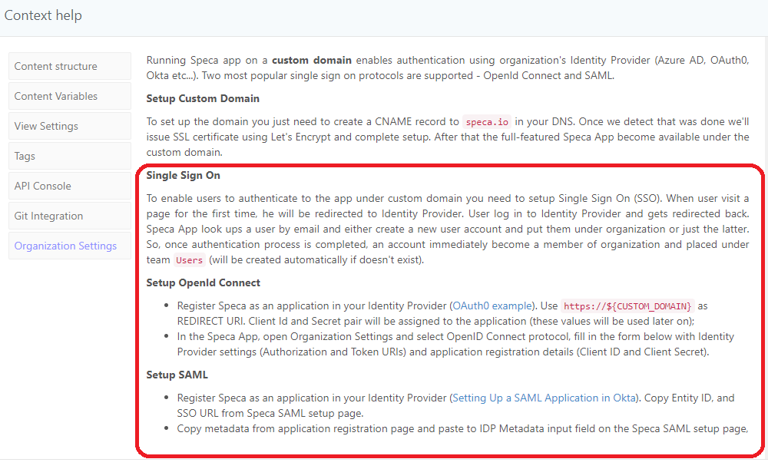

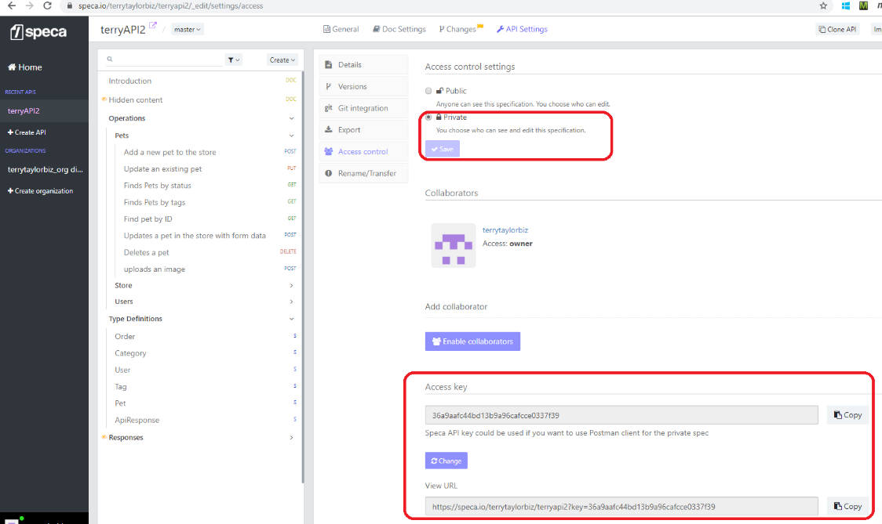

### TERRY example

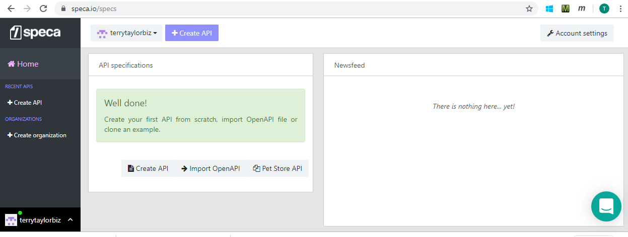

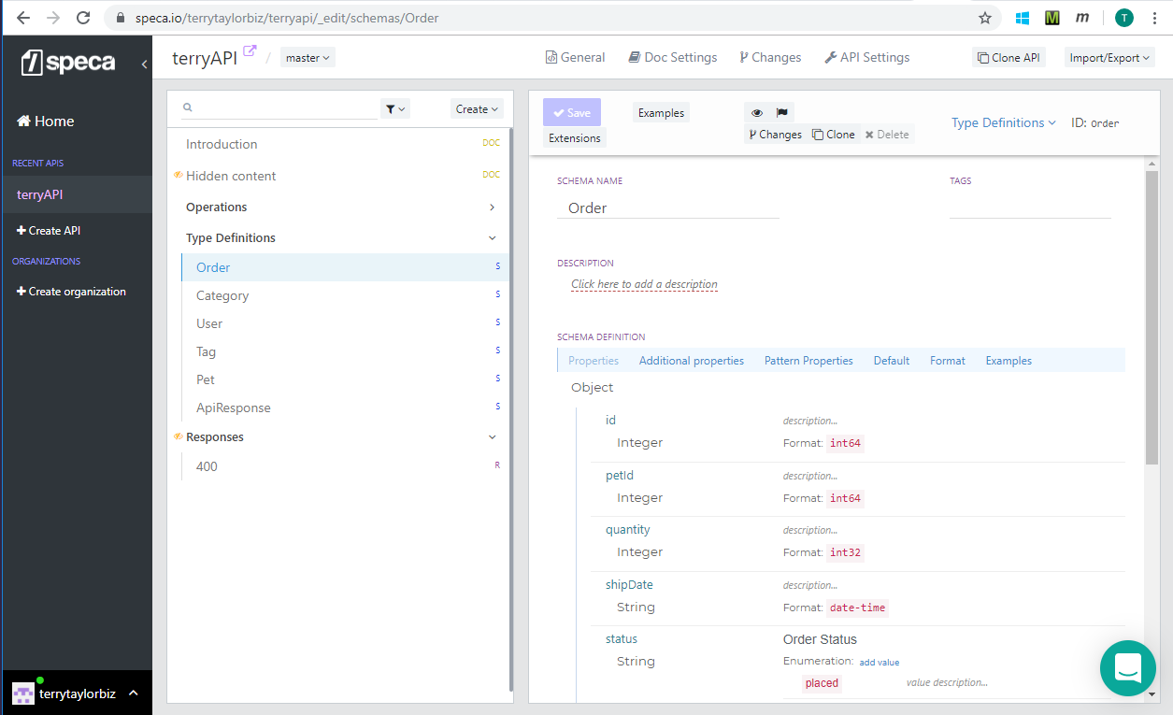

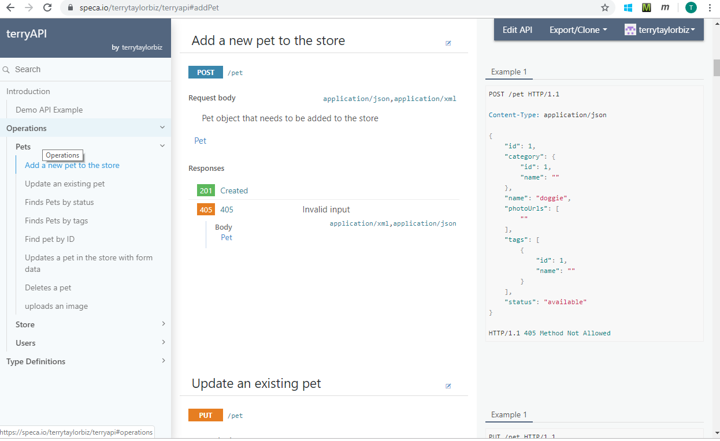

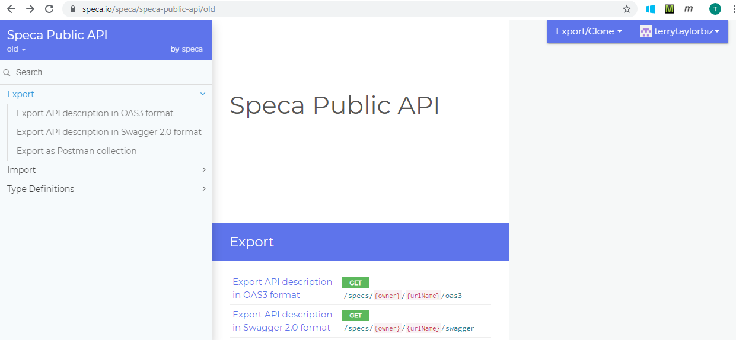

### Design and Document your API

Follow us on [twitter](https://twitter.com/specaio) for updates on the app.

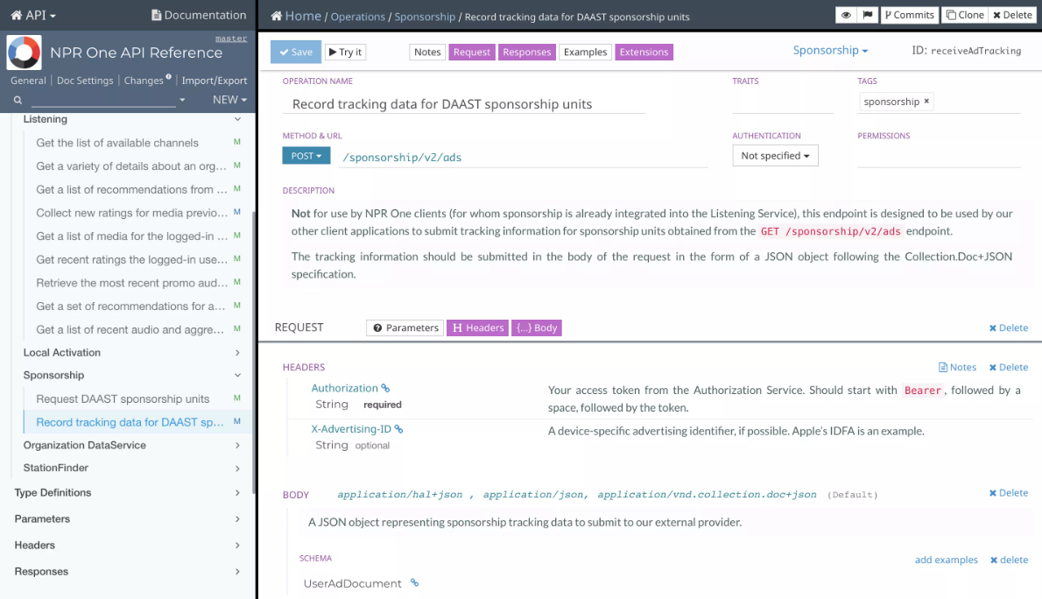

#### API Designer

Define data model, API operations, payloads, parameters, headers and responses in a consistent and elaborate way. Unlimited content hierarchy and effective navigation make your documentation well organized and easy to read.

#### Prevent duplication

Don't duplicate yourself; use common parameters and responses, organize them into the common patterns.

#### Swagger / Open API

Generate Swagger spec from the code, import it to Speca, that will be a perfect starting point. Extend CI workflow and your documentation will always stay in sync with the code, thanks to our public update/merge API!

#### Mocking

Start using the API before you wrote any code, our mock server matches request details to the specific operation and responds with a data generated dynamically according to the response schema.

#### Versioning

Full version lifecycle support - make a draft, publish, freeze by marking readonly and archive.

#### CommonMark descriptions

Utilize all the simplicity and power of CommonMark (Markdown) in general documentation blocks and in any description field.

#### Embedded API console

Quickly check the response straight from the API designer; Make documentation truly interactive by enabling console.

## 4b.5 Innovasys 20191002 (SOAP+REST) ** (can we add postman button?)

### TERRY SOAP example Integrated payments 20191002

TERRY: I created these on my personal laptop, and cant copy to work laptop, network.

#### chm

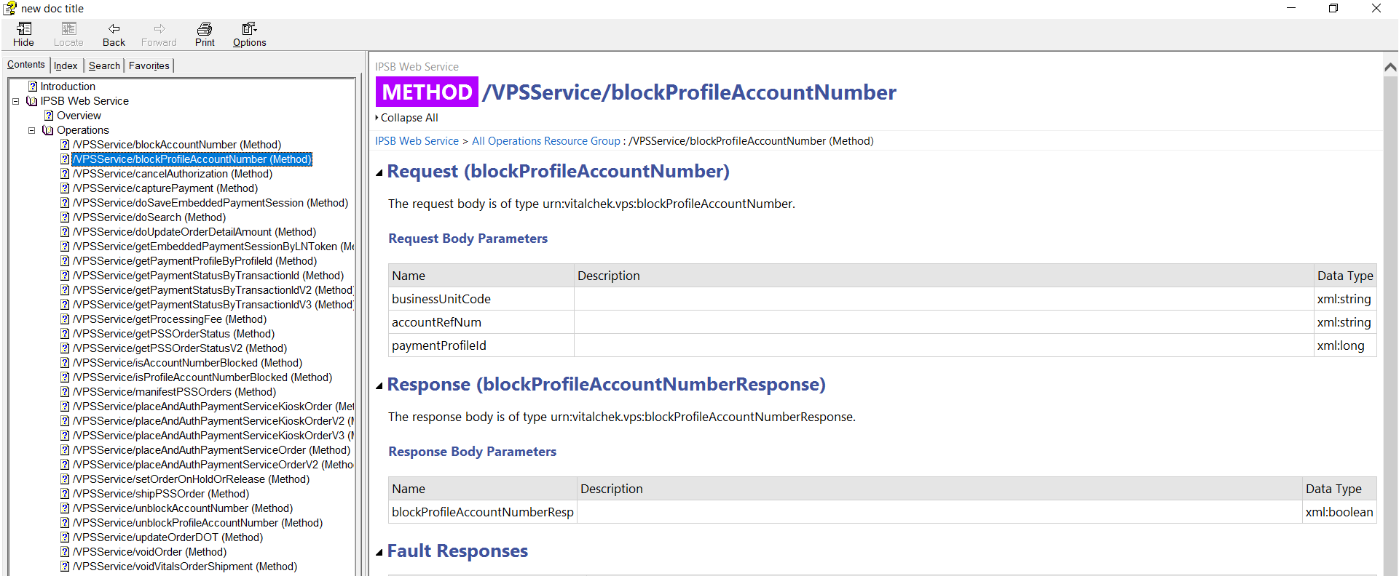

#### html

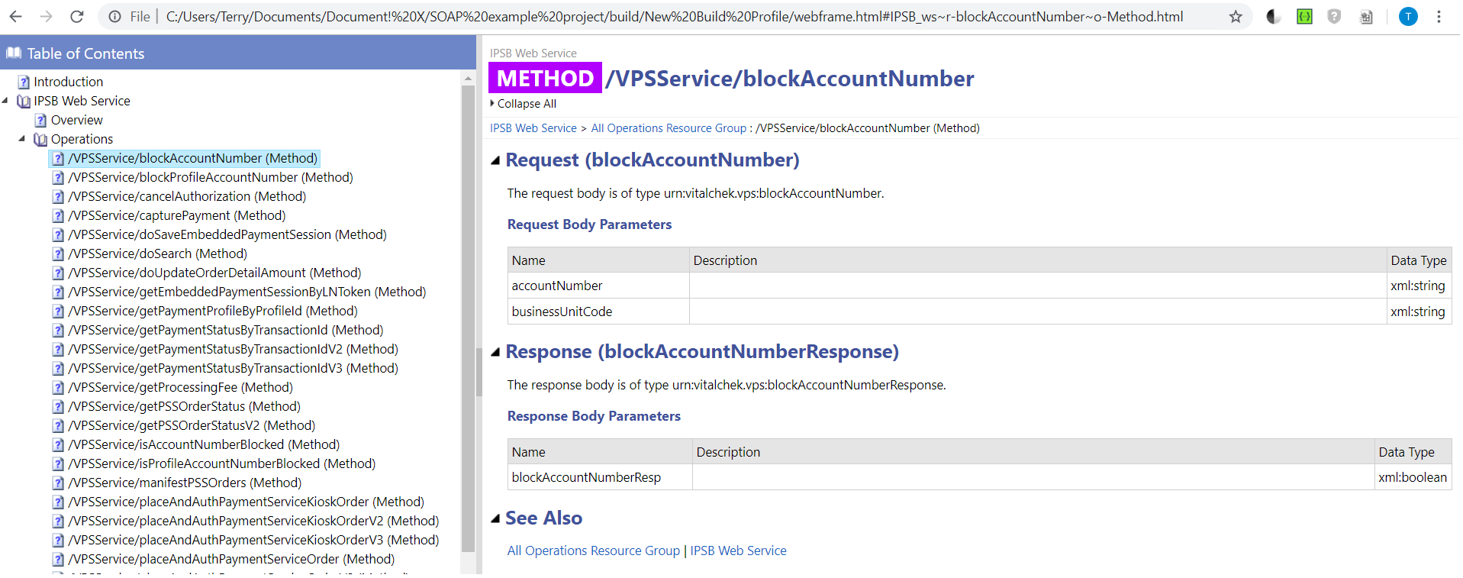

### TERRY SOAP example BING

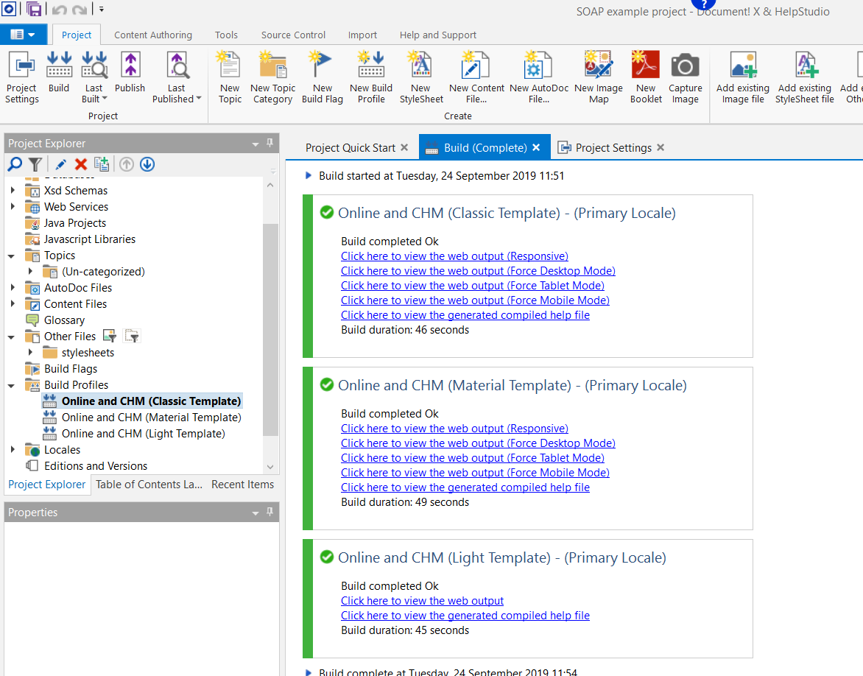

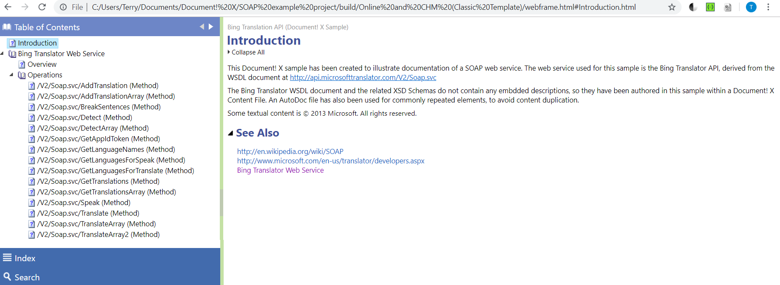

<http://www.innovasys.com/samples/dx/dx.ws-soap/light/bingtranslator_ws~r-getappidtoken~o-method.html>

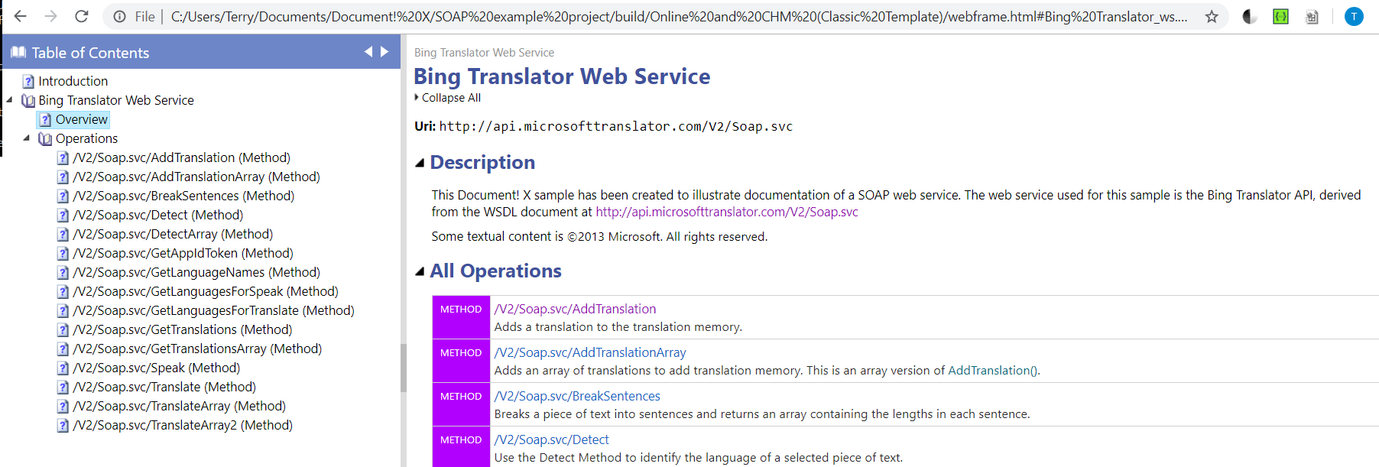

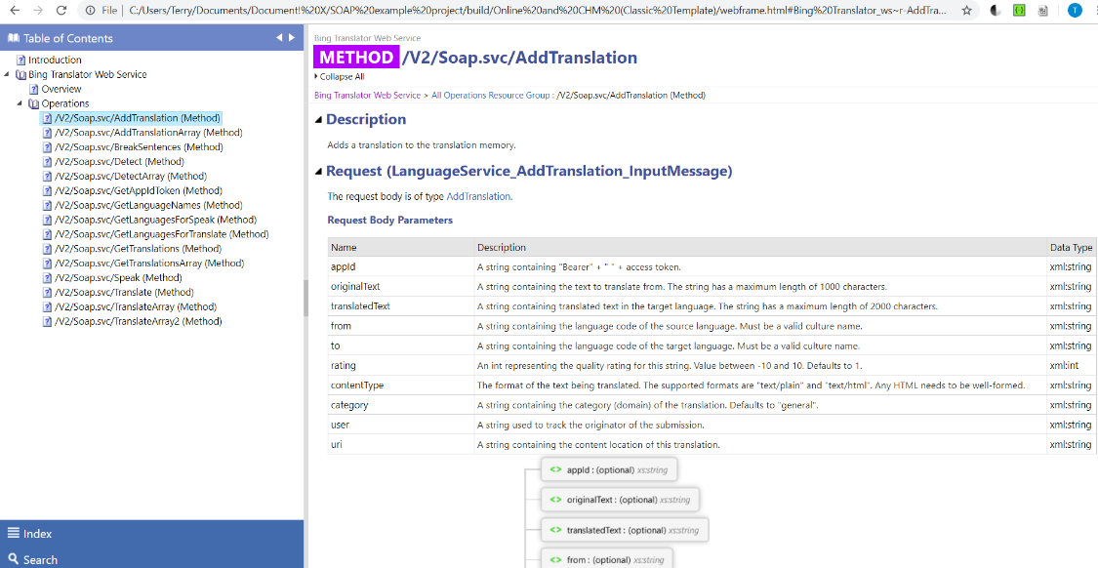

### Overview

<http://www.innovasys.com/product/dx/sampleswebservice>

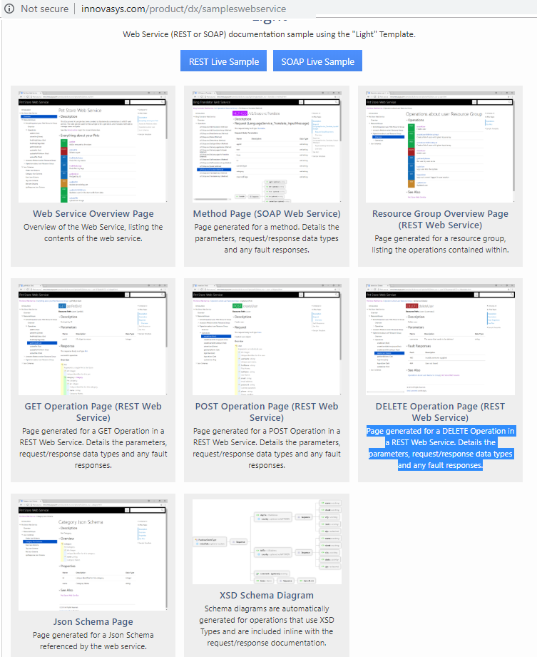

### SOAP example

<http://www.innovasys.com/samples/dx/dx.ws-soap/material/webframe.html#bingtranslator_ws.html>

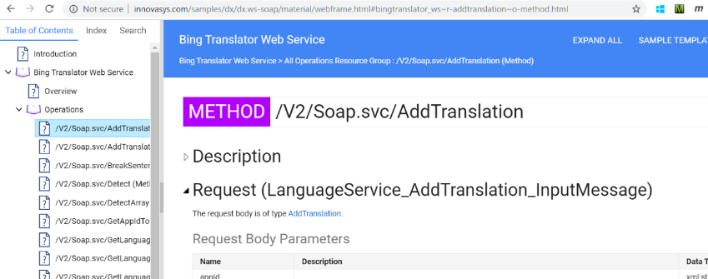

### REST

<http://www.innovasys.com/samples/dx/dx.ws.rest/light/pet%20store_ws~r--pet-%7Bpetid%7D~o-httpdelete.html>

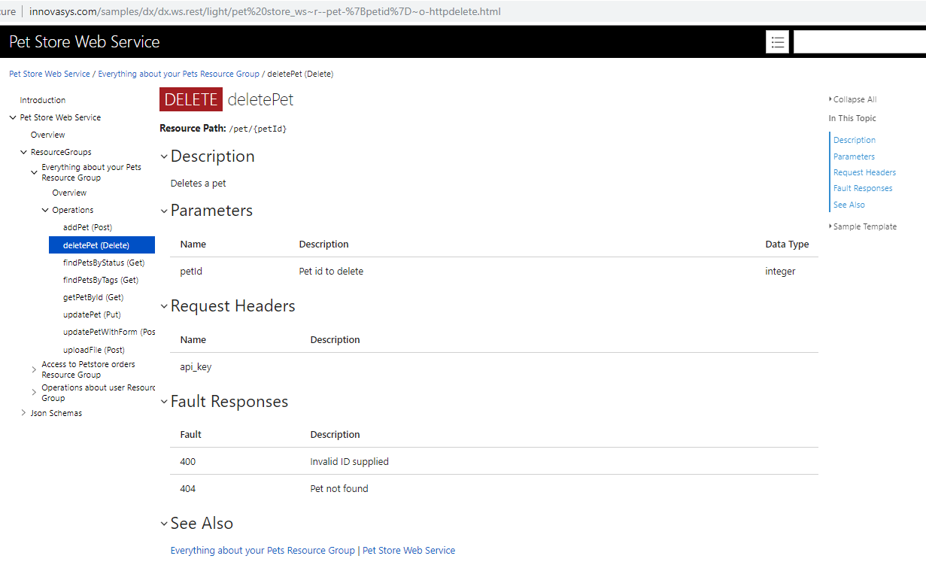

# Ch4c. Doc (static) site deployment (serving) tools

TERRY: these tools take the static site and

1. make deployment easy

2. add functionality (I think password protect, logins, etc)

<https://idratherbewriting.com/learnapidoc/pubapis_hosting_and_deployment.html>

Overall, there are many options for hosting and deploying your site. GitHub Pages, CloudCannon, Read the Docs, Netlify, and Aerobatic are just a few. You can also probably explore custom-built hosting and deployment options available through your company’s existing infrastructure.

There’s one more category of tools to consider: [Headless CMS options (and Readme.io)](https://idratherbewriting.com/learnapidoc/pubapis_headless_cms.html). The headless CMS often combines the authoring and deployment solution together, so the class of tools is closely related to the ones mentioned here, but I’ve separated out the category anyway.

## 4c.1 Cloud Cannon (works with jekyll) 20190926

This tool is just for jekyll. $63/month white label

Suppose you want to use Jekyll and GitHub, but you’re frustrated by GitHub’s limitations and you need a more robust platform for your Jekyll project. If so, [CloudCannon](https://cloudcannon.com/) is your solution. CloudCannon gives you a host of [additional features](https://cloudcannon.com/features/) that GitHub lacks, such as:

* Authentication of users
* Multiple environments for different branches
* Visual online interface for editing
* Jekyll plugins
* SSL for custom domains
* Automatic minification, and more

The founders of CloudCannon are experts with Jekyll and have designed the platform specifically for Jekyll projects. They also created a [host of Jekyll tutorials](https://learn.cloudcannon.com/) to enrich developer knowledge.

For a tutorial on setting up Jekyll on CloudCannon, see [Jekyll and CloudCannon continuous deployment tutorial](https://idratherbewriting.com/learnapidoc/pubapis_jekyll.html).

#### 0) pricing 20191209

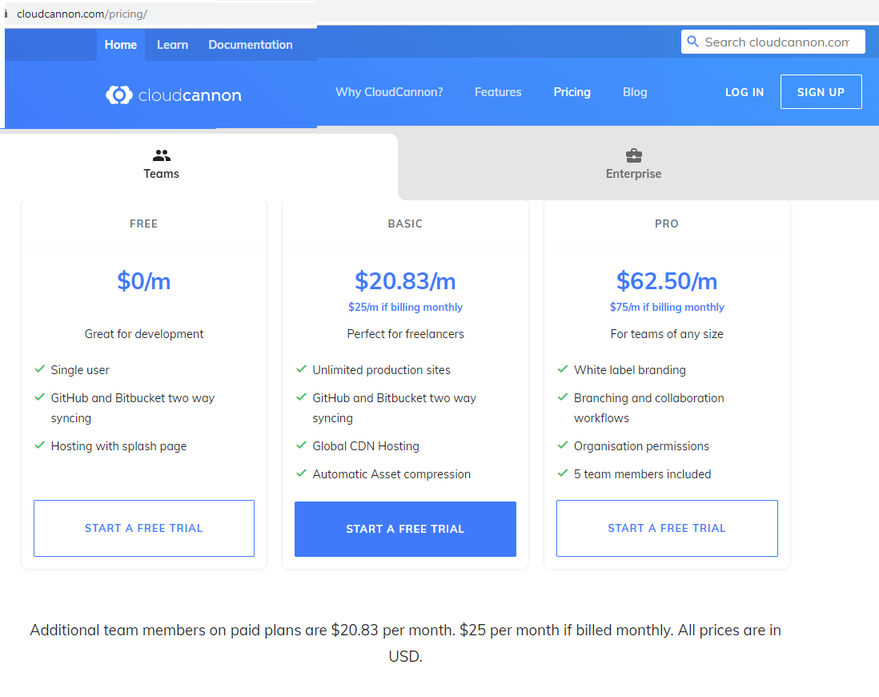

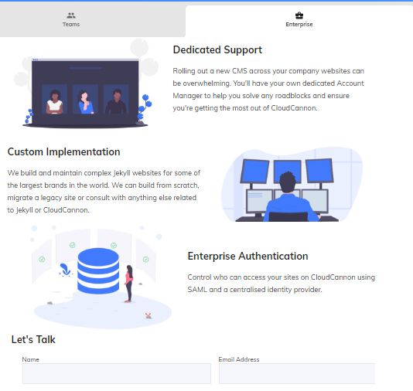

#### 1) Set up your doc theme on Github

1. Go to the [Github page for the Documentation theme for Jekyll](https://github.com/tomjoht/documentation-theme-jekyll) and click **Fork** in the upper-right corner.

When you fork a project, a copy of the project (using the same name) gets added to your own Github repository. You’ll see the project at [https://github.com/{your](https://github.com/%7Byour) github username}/documentation-theme-jekyll.

Sometimes people fork repositories to make changes and then propose pull requests of the fork to the original repo. Other times people fork repositories to create a starting point for a splinter project from the original. Github is all about social coding — one person’s ending point is another person’s starting point, and multiple projects can be merged into each other. You can [learn more about forking here](https://help.github.com/articles/fork-a-repo/).

1. Sign up for a free account at [CloudCannon](https://cloudcannon.com/); sign in using your GitHub credentials.
2. Once you sign in, click **Create Site** and then give the new site a name. Then press **Enter** to create the site.
3. Click the **GitHub Repository** box.

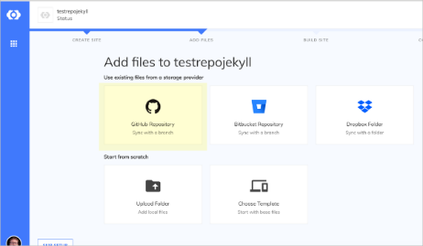

Sync with GitHub

1. Choose the GitHub repo that you forked — **documentation-theme-jekyll**. Select the **gh-pages** branch.
2. CloudCannon pulls the files from the synced repo over to CloudCannon. When the sync finishes, click **Start Site Build** to have CloudCannon build Jekyll from the server.

When it finishes building, you see a green check mark in the upper-right corner.

1. Go to the **Dashboard.**
2. From the Dashboard, click the URL that appears below your site image:

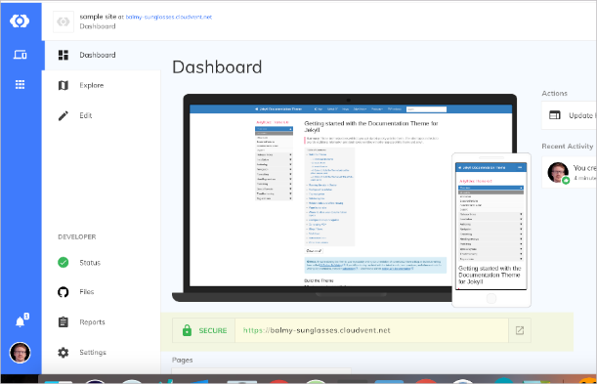Viewing your live site

The preview URL will be something random, such as <https://balmy-sunglasses.cloudvent.net/>. You’ll need to click **Continue to sample site** because you’re on the free plan. When you visit the URL, the theme should look just like the [Documentation theme for Jekyll here](https://idratherbewriting.com/documentation-theme-jekyll).

#### 2) Terry results 20190926

I followed above directions… worked!

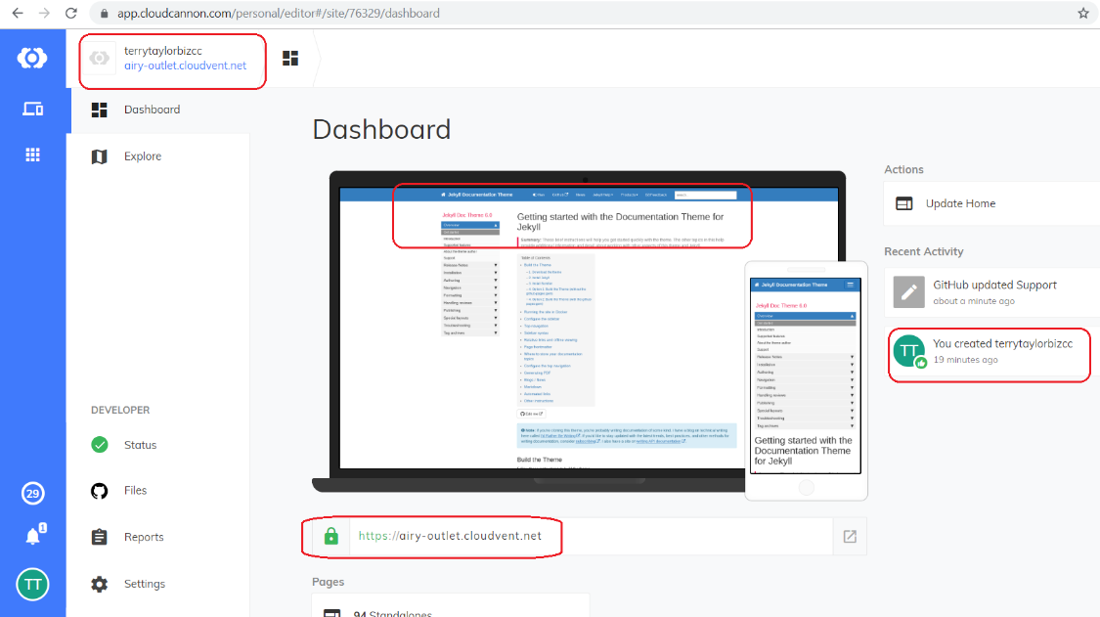

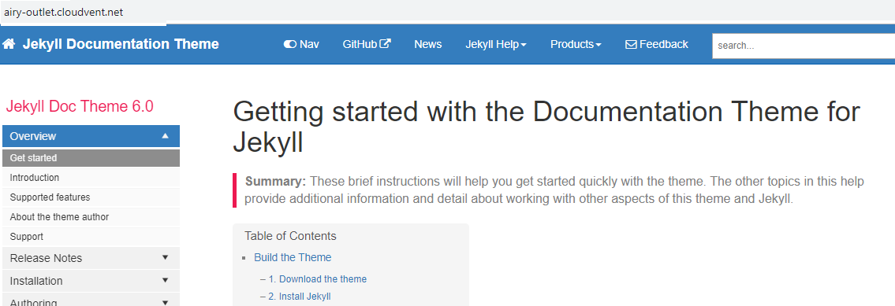

##### I modified

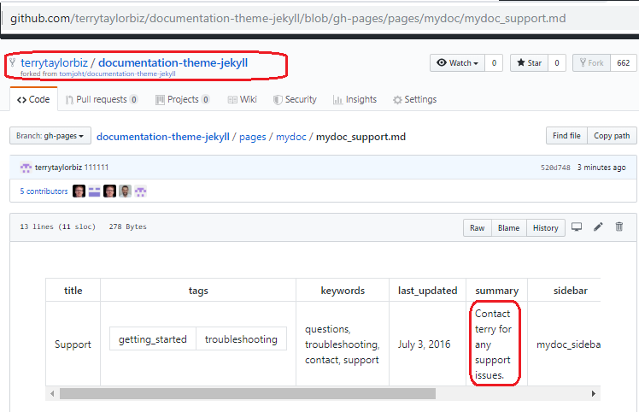

After about 1 minute it autoupdated. ☺

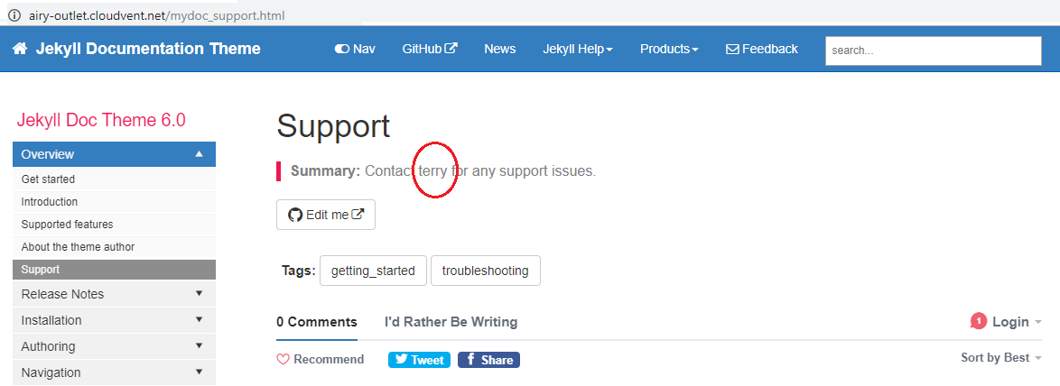

#### 3) TERRY version of aviator api theme 20190926

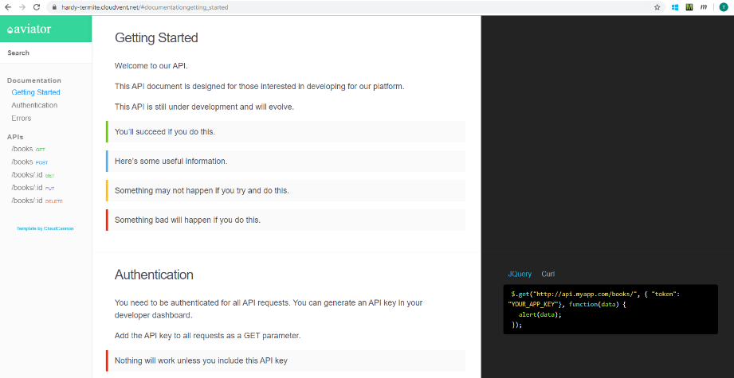

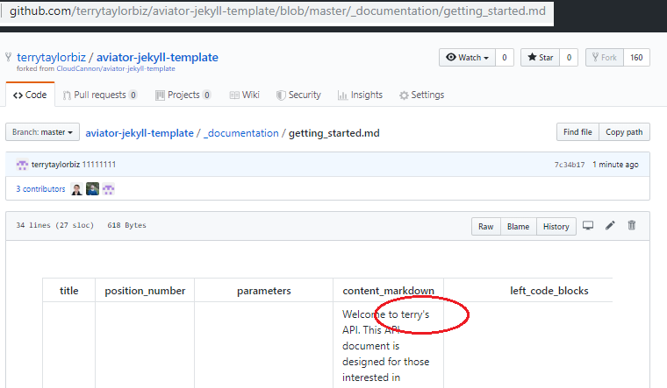

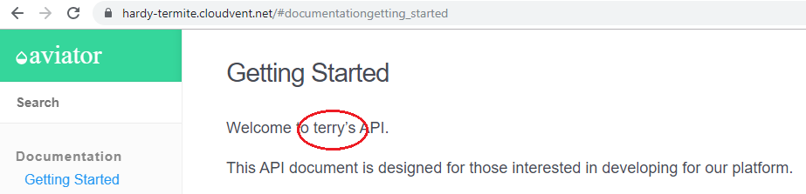

##### Looked good on my mobile phone also

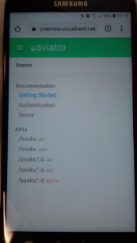 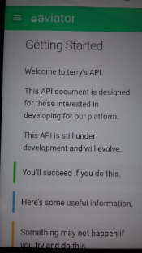 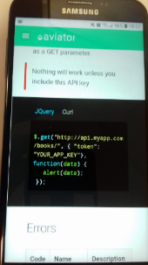

#### 4) Authentication 20191017,1030

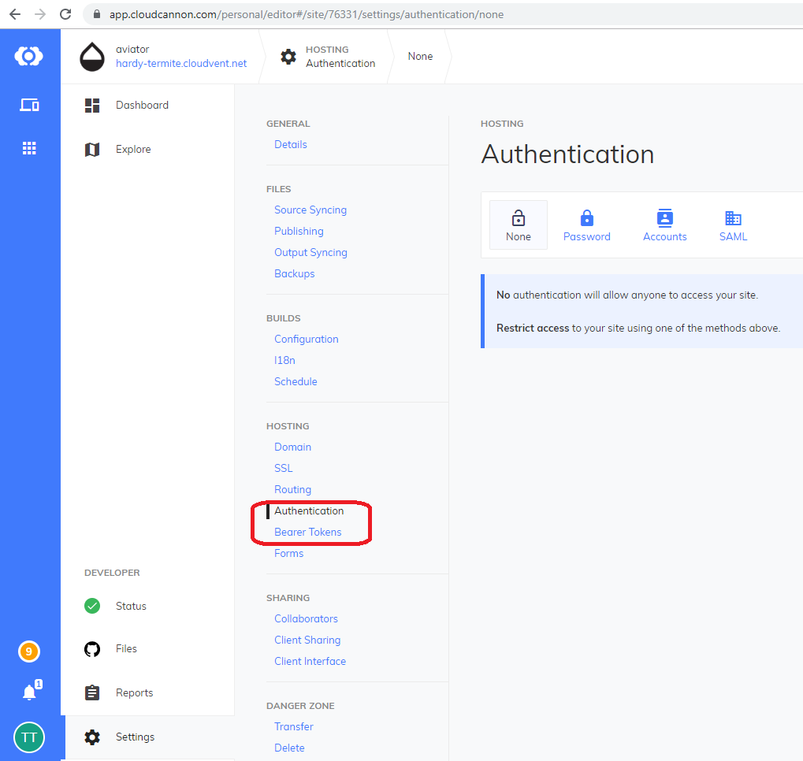

##### Saml overview

[en.wikipedia.org/wiki/Security_Assertion_Markup_Language](https://en.wikipedia.org/wiki/Security_Assertion_Markup_Language)

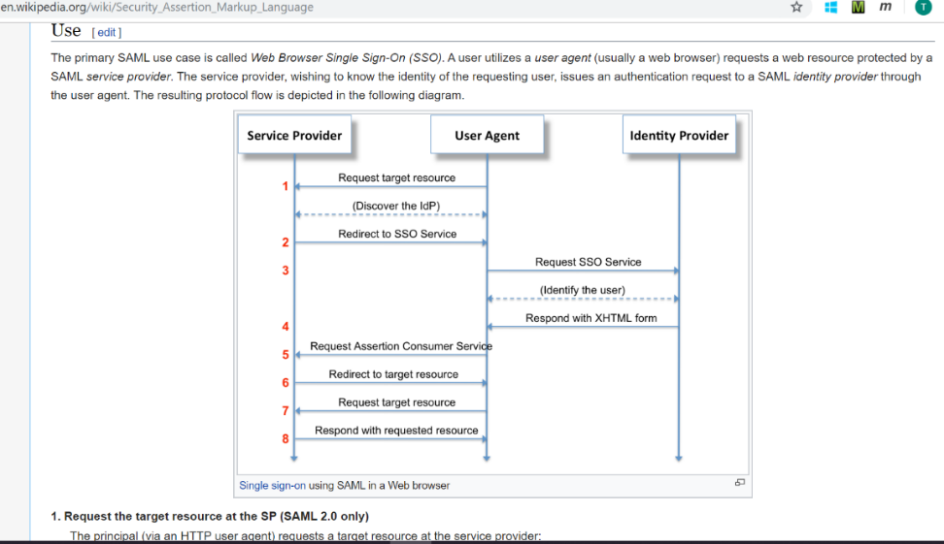

##### 1. Password

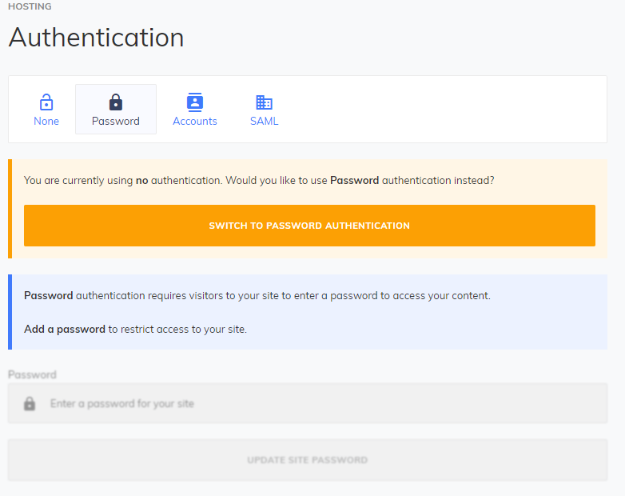



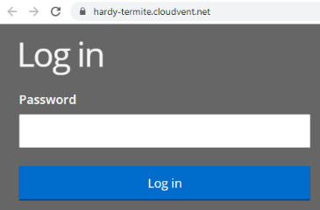

##### 2. Accounts (email address / password)

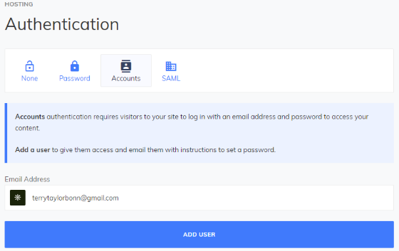 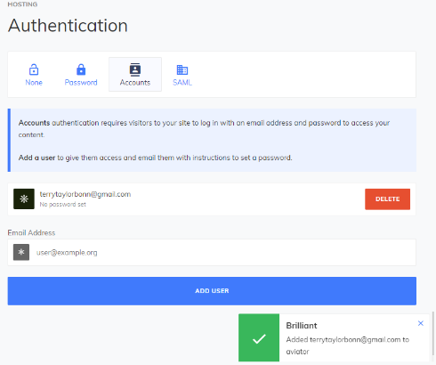

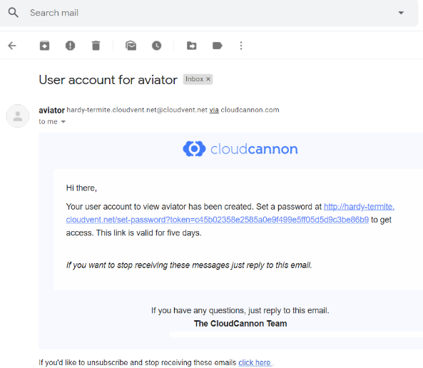

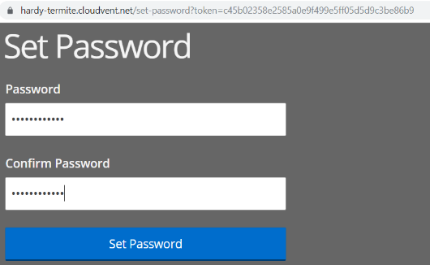 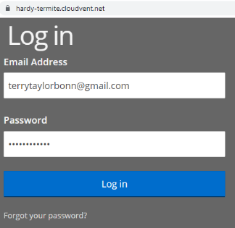

##### 3. SAML (complex…..) (invalid token error)

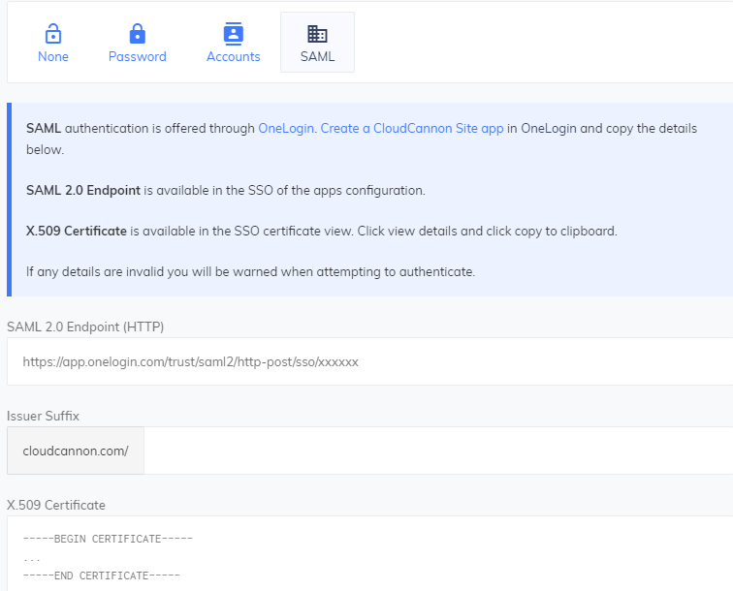

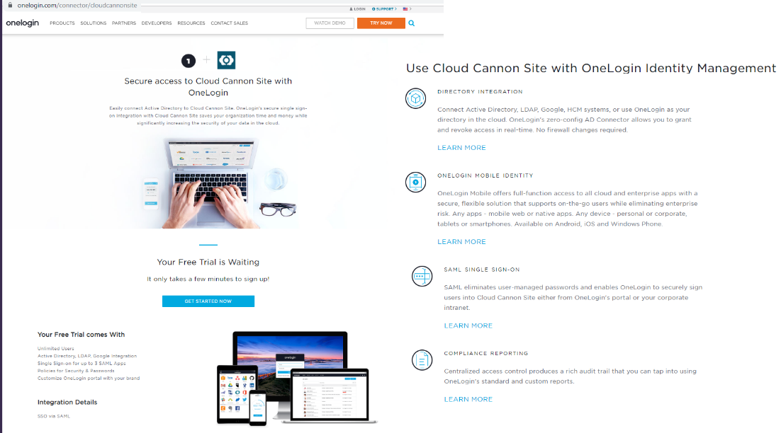

Get started now

­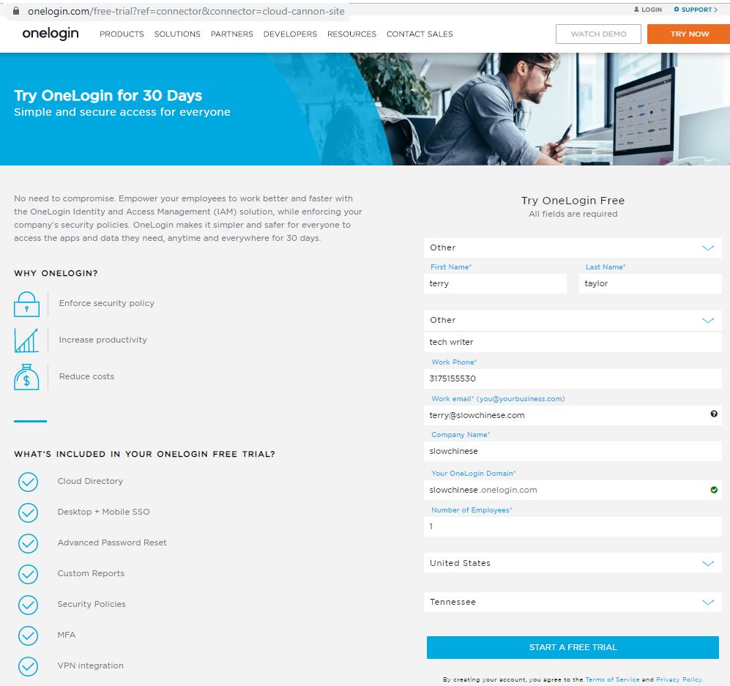

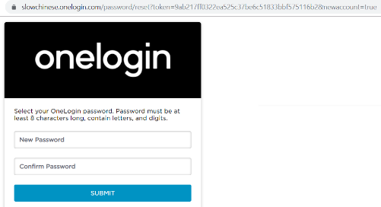

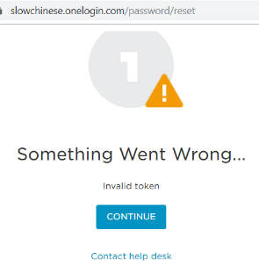 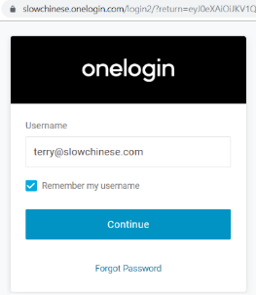 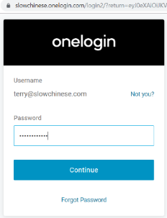

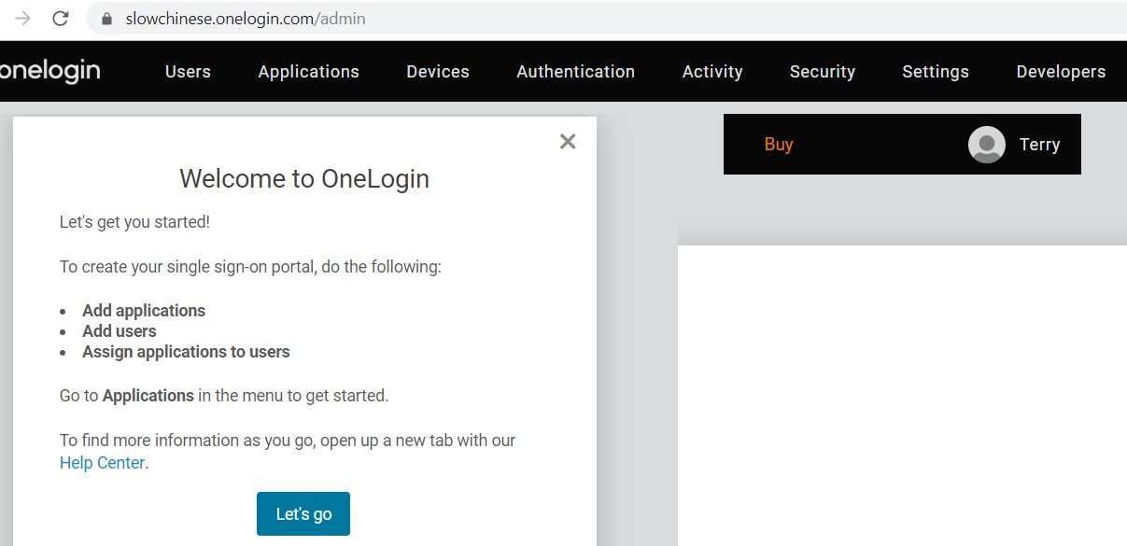

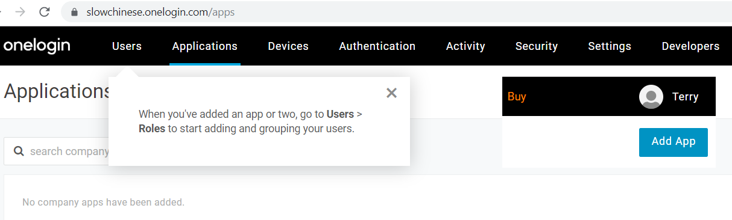

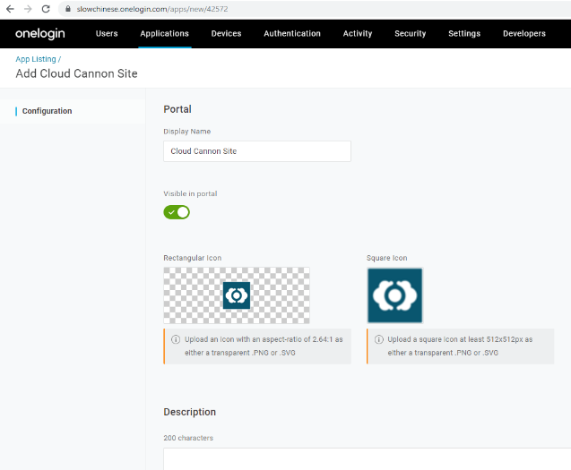

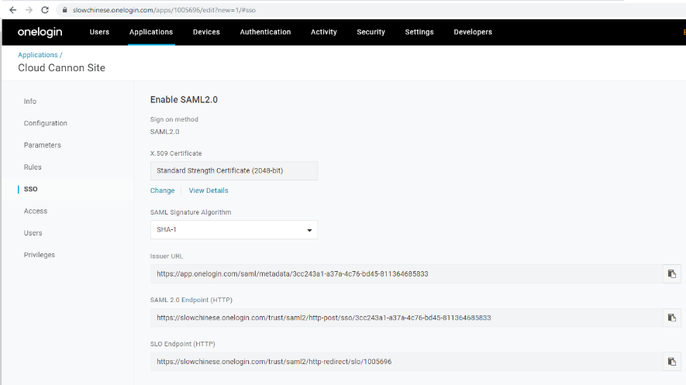

Copy info to ccannon.

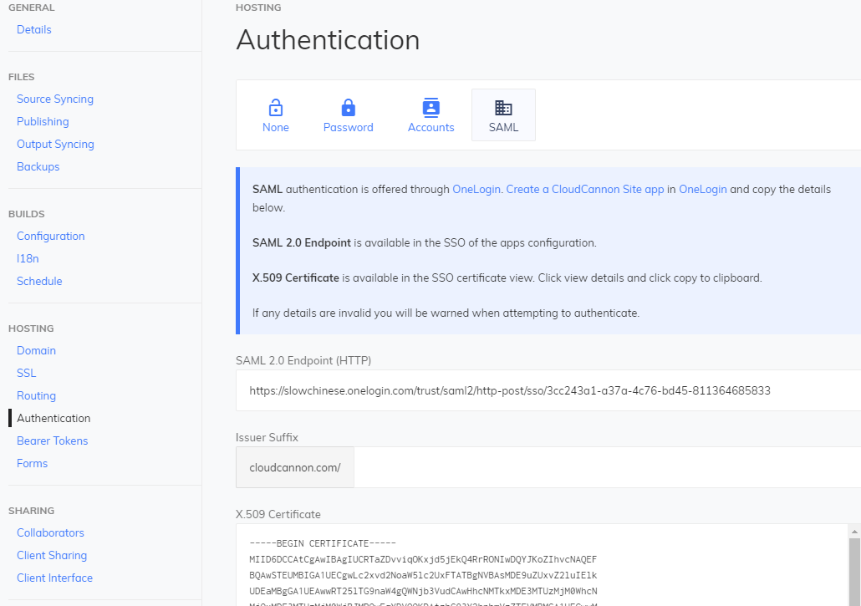

Click update saml config.

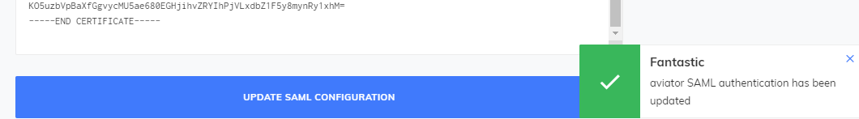

error

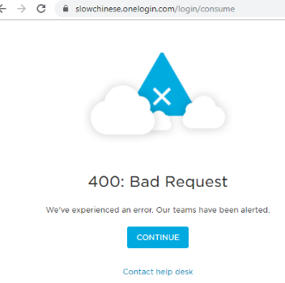

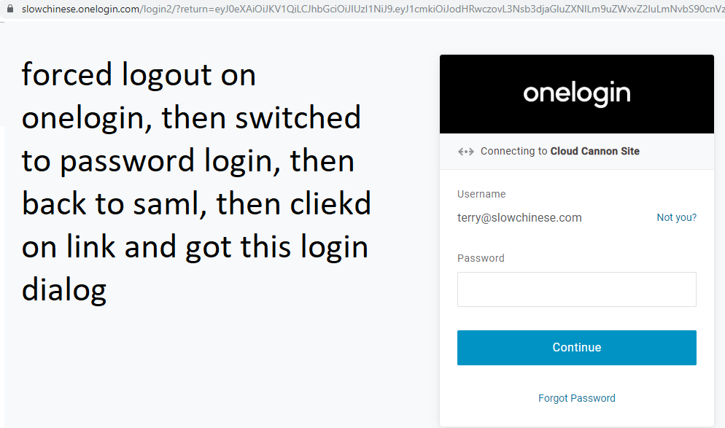

Enter password and you are in.



Close. Open url again.. no login required.

##### Try to force relogin

But then set auth logout on IDP.

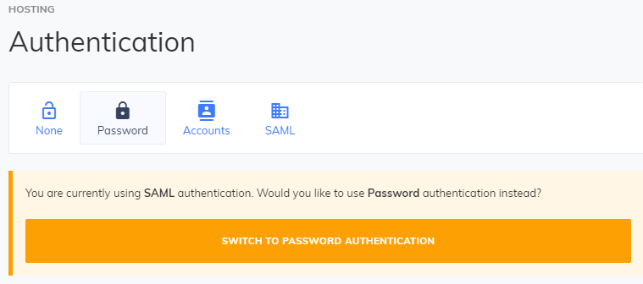

Open the login page.

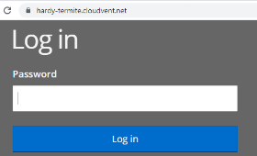

Switch back to saml.

Sometimes requires relogin to onelogin… not figuer out yet totally… someone did not like my playing around.

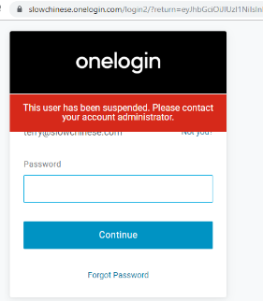

So this works with onelogin as the IDP. We would not use SAML, but its interesting that Ccannon has made things (relatively) simple.

#### 5) Bearer Tokens *******************

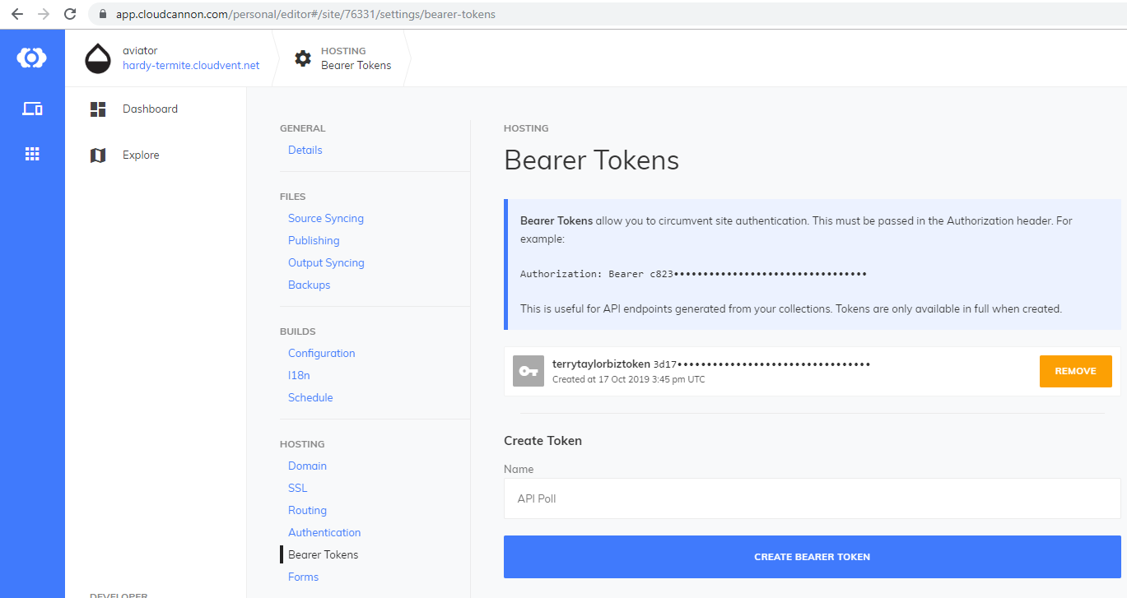

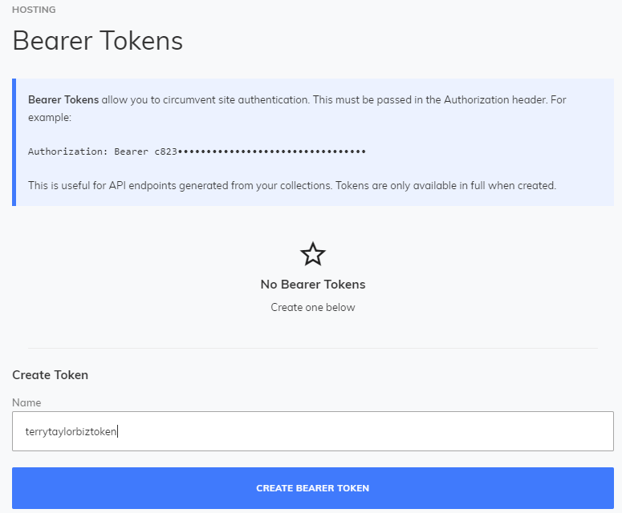

3d17663f6a1-a31c-459093b6-bfbd-1dee22e6c581

 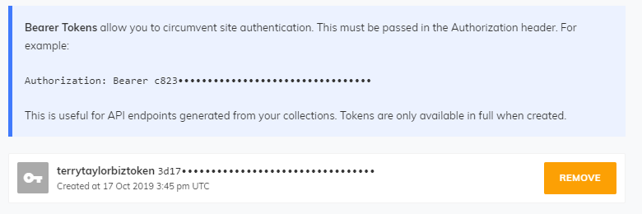

You have to add the token to get it work.. so a particular ISV could run postman collection with ISV token.

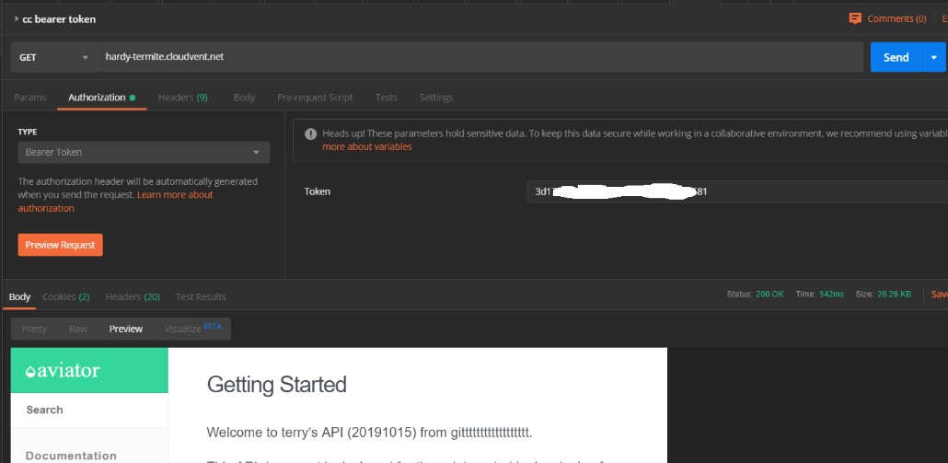

## 4c.2 Aerobatic (Jekyll, Hugo) (AWS) 20191017,1029

### 4c.2.1 Overview

[Aerobatic](https://www.aerobatic.com/) is similar to Netlify in that it builds and publishes your static site. Aerobatic gives you a robust publishing engine that includes a CDN, SSL, continuous delivery, a deployment CLI, password protection, and more. Aerobatic can build your site using various static site generators, including Jekyll, Hugo, Hexo, and more. Aerobatic says,

Aerobatic is a specialized platform for efficient delivery of static webpages and website assets. We take care of the configuration details for you that provide the best balance of performance and maintainability. Stop fiddling with CDNs and web server configs and focus on coding great front-end experiences. — [Static website serving](https://www.aerobatic.com/docs/static-serving/)



### 20191029 static site generators

<https://www.aerobatic.com/docs/static-site-generators/>

I only got gatsby to work. (also got react website up) . Needed to login in the command line.

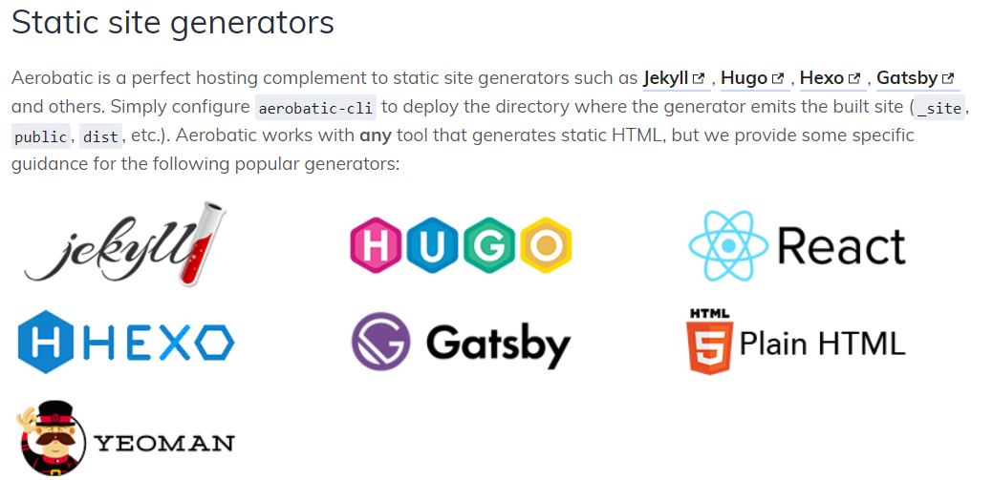

<https://github.com/facebook/create-react-app>

<https://create-react-app.dev/docs/getting-started>

<https://dashboard.aerobatic.com/account/terrytaylorbiz/>

### 4c.2.2 Quickstarts

#### 1) Quickstart simple

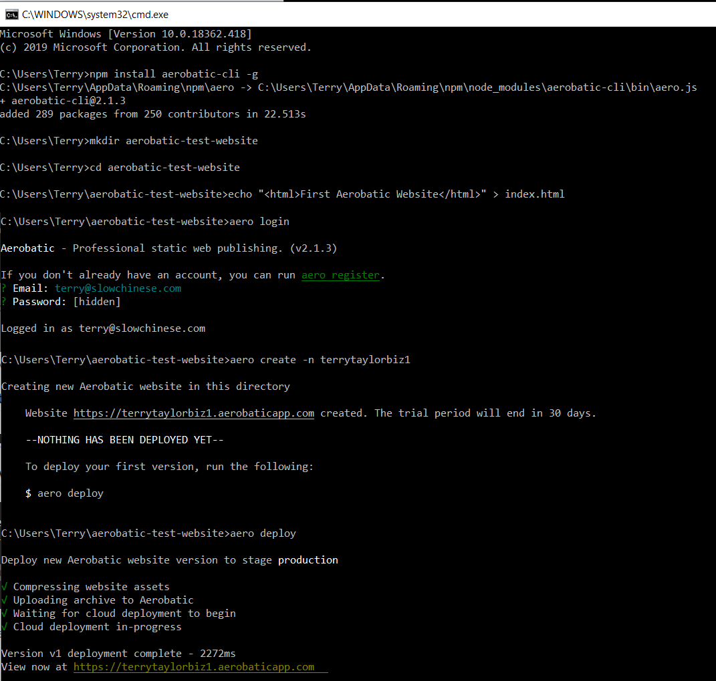



##### Dashboard / preview frame

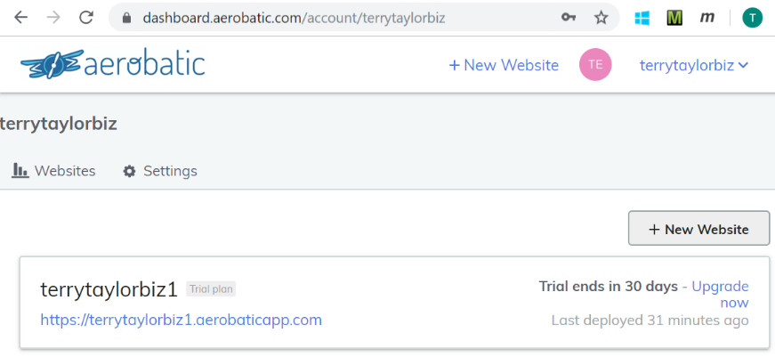

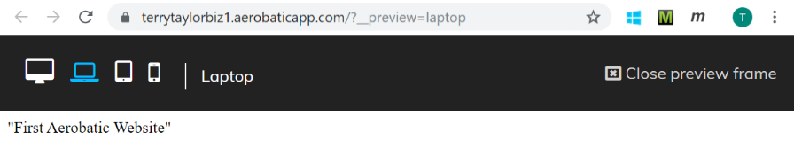

#### 2) Welcome quickstart

<https://dashboard.aerobatic.com/account/terrytaylorbiz/welcome>

##### Creating your first website

You'll need to install the [Aerobatic CLI](https://www.npmjs.com/package/aerobatic-cli). The CLI requires that Node.js 6+ is available on your computer. [See this handy guide](https://docs.npmjs.com/getting-started/installing-node#installing-npm-from-the-nodejs-site) for installation instructions if you're unsure.

##### 1. Install aerobatic-cli from NPM

$ npm install aerobatic-cli -g

##### 2. Login via the CLI

$ aero login

##### 3. Create your project

**A. Create website from an existing local static site**

Once you've installed the CLI, navigate to the directory of your static site and type the following:

$ aero create --name your-site-name

This command will add an aerobatic.yml file to the directory, and register the site with Aerobatic.

**B. Create website from a quick start**

If you don't have a static site ready to deploy right now, you can create one from one of our pre-packaged themes. Just select a theme from the [Aerobatic quick starts gallery](https://www.aerobatic.com/quickstarts/jekyll/). Currently there are themes for Jekyll, Hugo, and vanilla HTML5 sites.

Here's a few examples:

$ aero create --quick-start hugo/academic

$ aero create --quick-start jekyll/dbyll

$ aero create --quick-start html5/sb-agency

##### 4. Deploy Your Site

Now that your website is registered with Aerobatic, run the following command from the root of the project to deploy it:

$ aero deploy

**That's it. In less than 30 seconds you'll have a professional grade website up and running on our worldwide CDN with mandatory SSL!**

##### Hugo (failed)

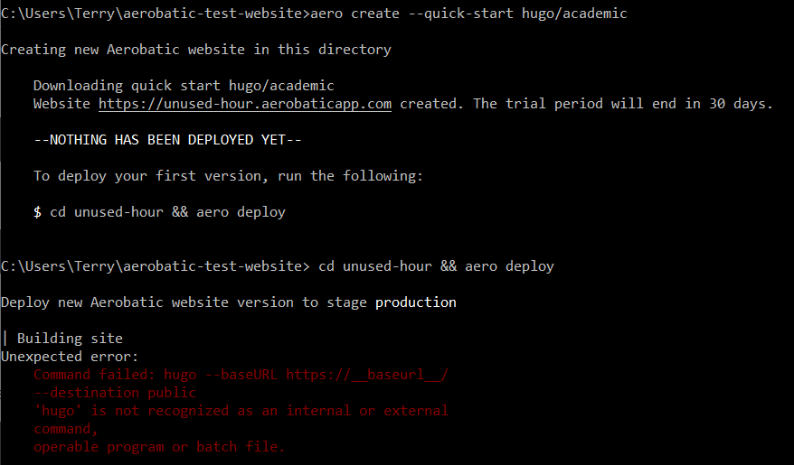

##### Jekyll

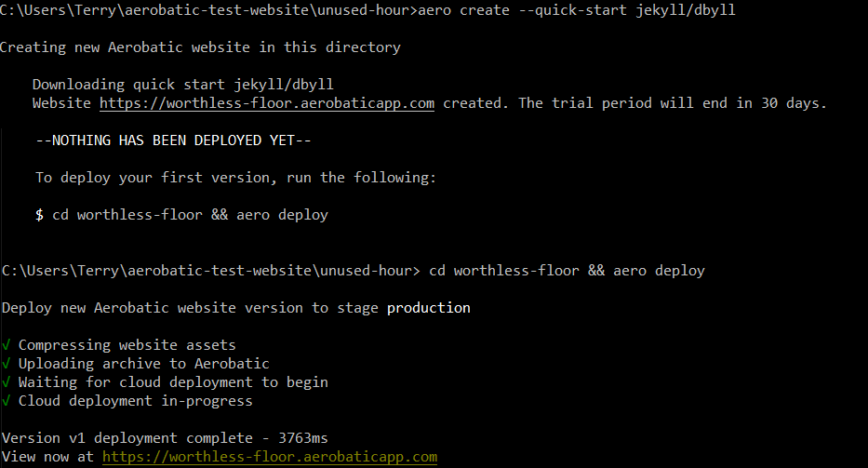

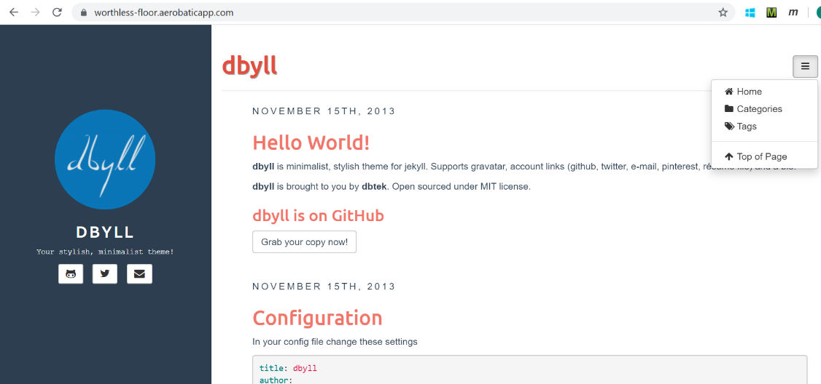

##### Html5

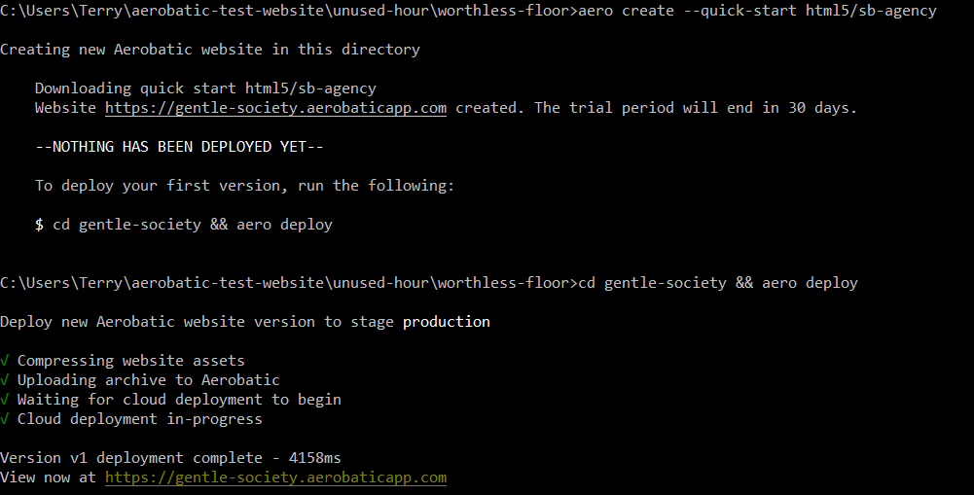



#### 3) quickstarts overview

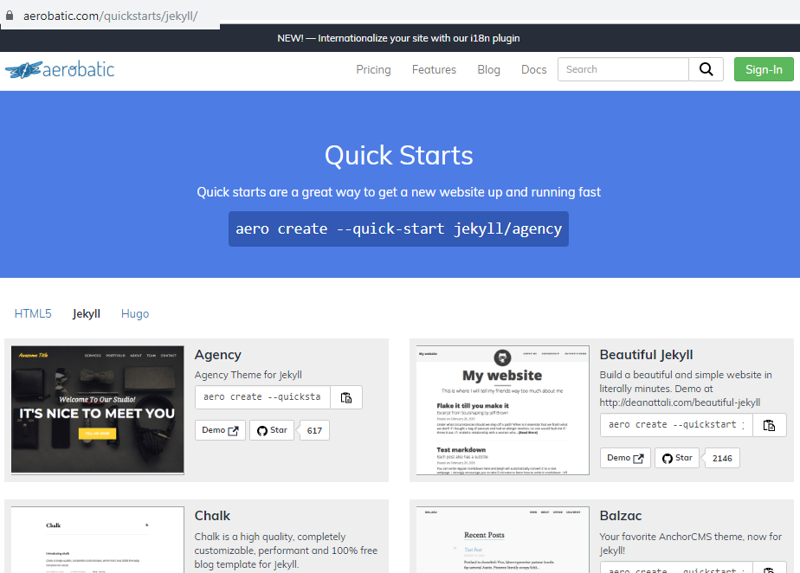

### 4c.2.3 Security

#### 1) Access Control (<https://www.aerobatic.com/docs/access-control/>)



Not all websites are intended to be accessible to the general public. Aerobatic specializes in providing you a choice of robust solutions for locking down your site to authorized users only.

* [**Password protect plugin**](https://www.aerobatic.com/docs/plugins/password-protect) - Simple password that you distribute to people that need access.
* [**Auth0 Plugin**](https://www.aerobatic.com/docs/plugins/auth0) - Full featured identity management that allows signups and individual user accounts powered by [**Auth0**](https://auth0.com/).
* [**Client IP ranges**](https://www.aerobatic.com/docs/access-control/#client-ip-ranges) - Make your website accessible only to clients coming from specific IP ranges

##### [Client IP Ranges](https://www.aerobatic.com/docs/access-control/#client-ip-ranges)

You can lock your website down so that it is only accessible to specific IP ranges. Ranges can be set as one or more IPs or [**CIDR blocks**](https://en.wikipedia.org/wiki/Classless_Inter-Domain_Routing). IPv6, IPv4, and IPv4-mapped over IPv6 addresses are all supported. There are numerous online IP converters that will provide CIDR values given an IP range.

* [**IPv4 Range To CIDR converter**](https://www.ipaddressguide.com/cidr)
* [**IPv6 Range To CIDR converter**](https://www.ipaddressguide.com/ipv6-cidr)

The IP range is set using the CLI [**clientip**](https://www.aerobatic.com/docs/cli/#clientip) command. For example, say you want to restrict access to clients with IPs between 97.113.60.20 and 97.113.60.40. Input those values into the converter above, and the following CIDR values are returned: 97.113.60.20/30, 97.113.60.24/29,97.113.60.32/28, 97.113.60.40/32. Then use the following CLI command to set the ranges:

$ aero clientip --value "97.113.60.20/30,97.113.60.24/29,97.113.60.32/29,97.113.60.40/32"

Using this command you can change the ranges, or remove the IP restrictions at any time without having to re-deploy your site. It takes at most 30 seconds from the time you issue to the command to when it starts to take effect.

To remove all IP restrictions, you can use the following command:

$ aero clientip --delete

##### [403 Error Page](https://www.aerobatic.com/docs/access-control/#403-error-page)

Visitors whose IP address falls outside the specified ranges will receive an HTTP 403 error page that looks like so:

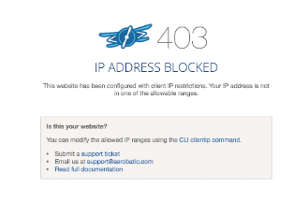

**Custom error page**

With the [**custom-errors**](https://www.aerobatic.com/docs/plugins/custom-errors) plugin you can build your own custom 403 error page to display instead.

plugins:

- name: custom-errors

options:

errors:

403: 403.html

##### [Stage specific restrictions](https://www.aerobatic.com/docs/access-control/#stage-specific-restrictions)

You can also use IP ranges to restrict access to only specific [**deploy stages**](https://www.aerobatic.com/deployment/#deploy-stages). This is a great solution for limiting access to the test instance of your site even when the production URL is wide open to the public. That way you don't have to worry about anyone randomly stumbling across your test site. Simply append the --stage option to the CLI command:

$ aero clientip --value '97.113.60.20/30' --stage test

Unlike the [**password-protect**](https://www.aerobatic.com/docs/plugins/password-protect/) and [**auth0**](https://www.aerobatic.com/docs/plugins/auth0/) plugins, client IP ranges are not configured in the aerobatic.yml. This means you can change them anytime with the CLI without having to re-deploy your site.

##### [My IP Shortcut](https://www.aerobatic.com/docs/access-control/#my-ip-shortcut)

Oftentimes it's handy to lock the site down to your current machine's IP address. To save you from having to go look it up in your network settings, we provide an easy shortcut. Simply pass the string "myip" for the --value option:

$ aero clientip --value myip

You can of course use this shortcut in conjunction with the --stage option:

$ aero clientip --value myip --stage demo

#### 2) Plugins

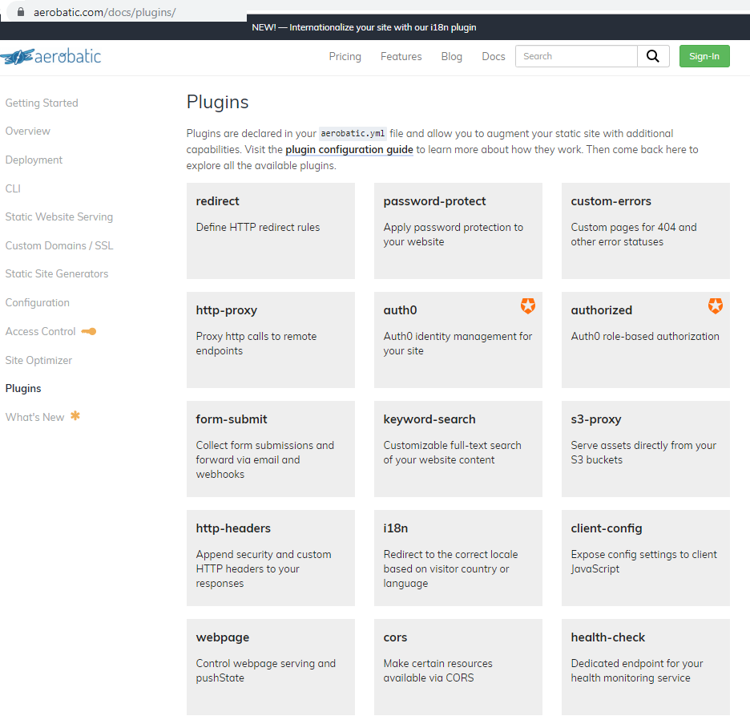

#### 3) custom domains and SSL

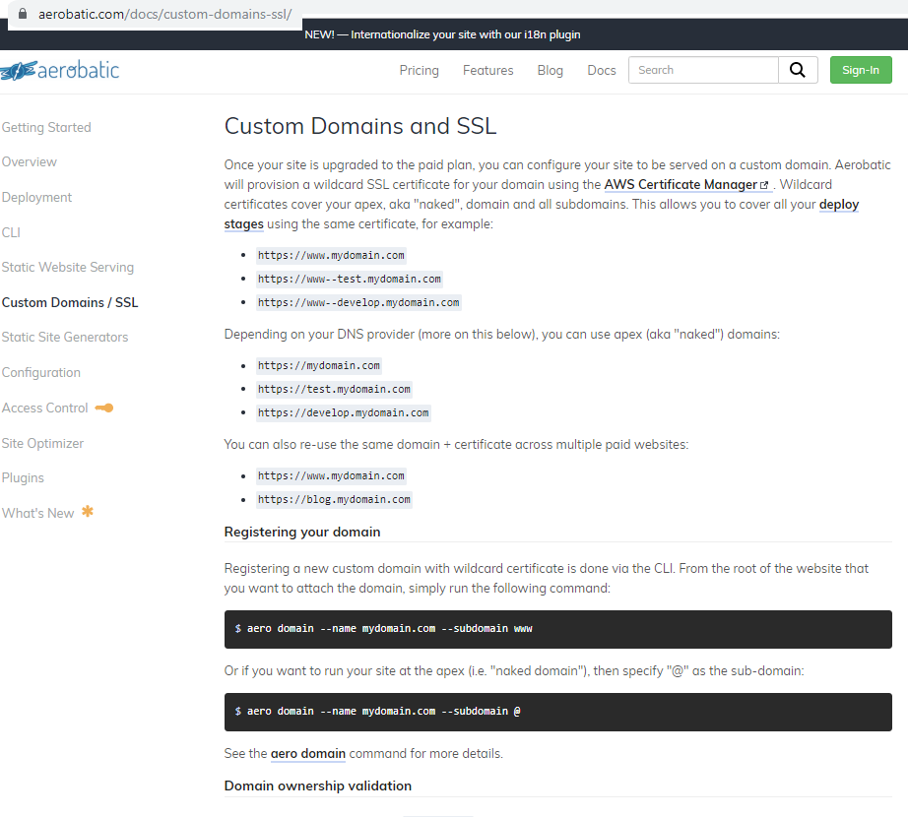

## 4c.3 Netlify (deploy tool) 20191030

used by Docker, Kubernetes, React, Yarn, Lodash, Gatsby, and Hugo

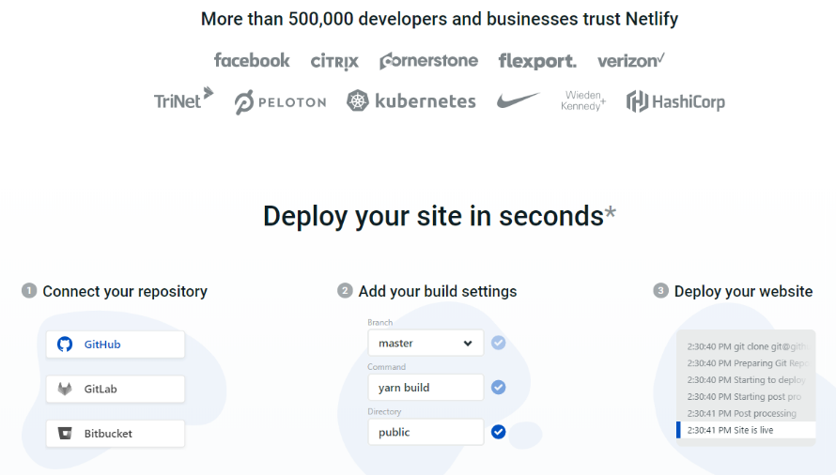

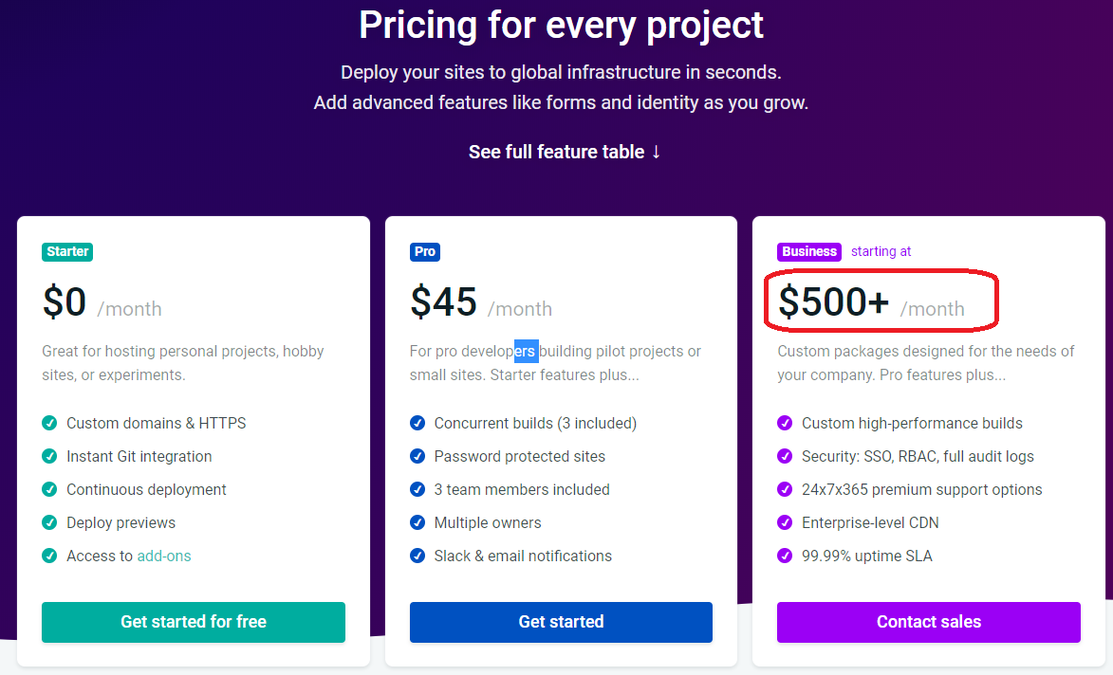

### overview

[Netlify](https://www.netlify.com/) is a popular hosting and deployment service for static site projects. Unlike with other hosting platforms, Netlify works with almost any static site generator, not just with Jekyll or Sphinx.

Netlify offers continuous delivery for your project. You can store your content on GitHub, GitLab, or Bitbucket, then link it to Netlify, and Netlify will build whenever you push changes.

Netlify not only offers a free plan with features similar to GitHub Pages but also lets you scale up to Pro, Business, or Enterprise plans for more robust needs. With Netlify, you can get deploy previews, rollbacks, form handling, distributed content delivery network (CDN), infinite scalability, SSL, a programmable API, CLI, and more.

The most impressive example of a Netlify-hosted site is [Smashing Magazine](https://www.smashingmagazine.com/). Previously hosted on WordPress, Smashing Magazine made the switch to Netlify, with Hugo as the static site generator engine. See [Smashing Magazine just got 10x faster](https://www.netlify.com/blog/2017/03/16/smashing-magazine-just-got-10x-faster/) for details.

Other notable doc sites using Netlify include [Docker](https://docs.docker.com/), [Kubernetes](https://kubernetes.io/docs/home/), [React](https://reactjs.org/docs/hello-world.html), [Yarn](https://yarnpkg.com/lang/en/docs/), [Lodash](https://lodash.com/docs/), [Gatsby](https://www.gatsbyjs.org/docs/), and [Hugo](https://gohugo.io/documentation/).

Complementing Netlify is [Netlify CMS](https://idratherbewriting.com/learnapidoc/pubapis_headless_cms.html#netlifycms), a headless CMS for your content (which I discuss in more detail in [Headless CMS options (and Readme.io)](https://idratherbewriting.com/learnapidoc/pubapis_headless_cms.html)).

### Login

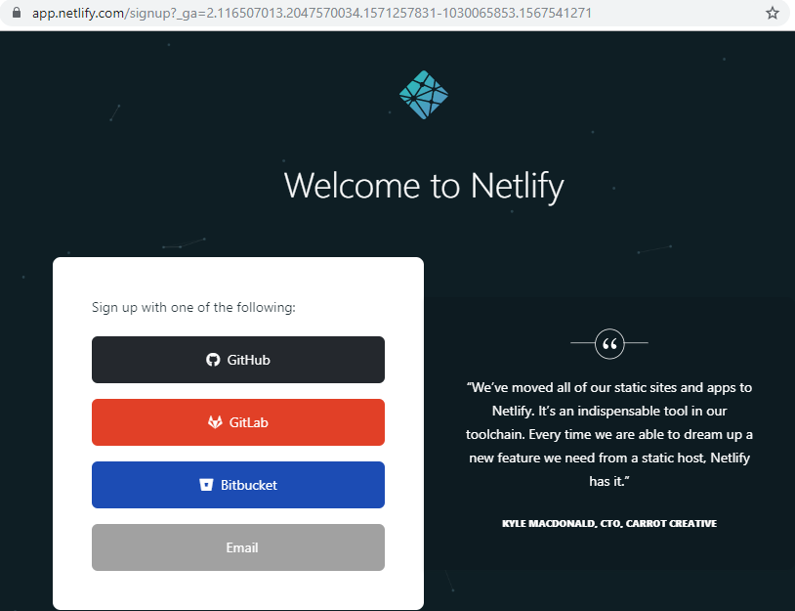

Github

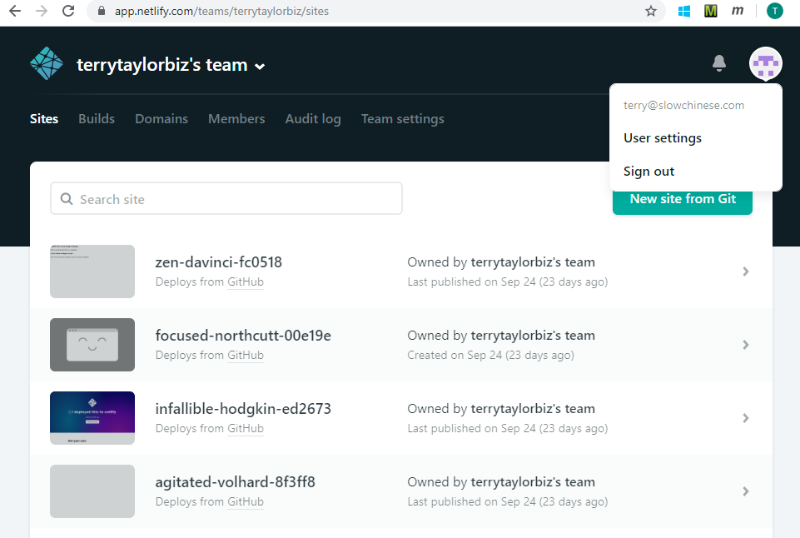

### Example git

git

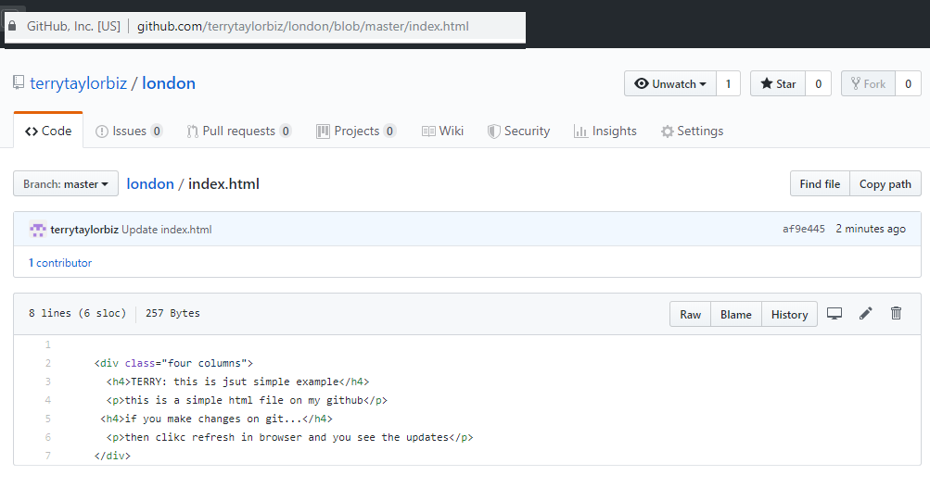

netlify

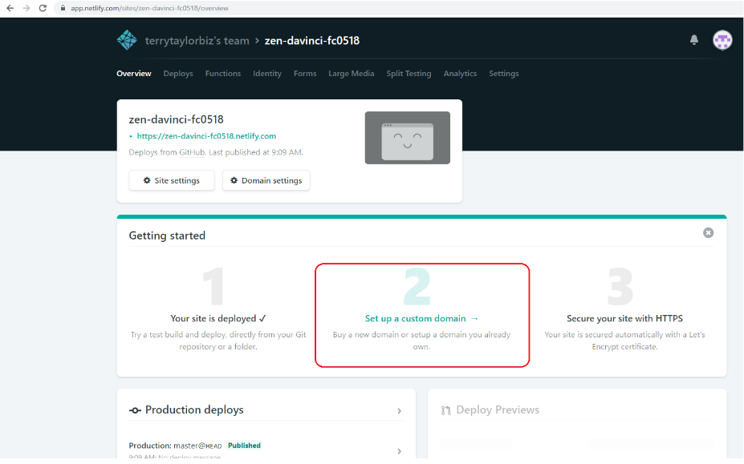

Result.. for production of course more complex, with custom domain.

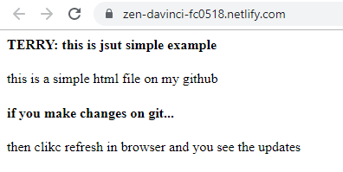

### Using Oauth provider tokens (TERRY demo) 20191029

TERRY: the netlify directions below are rather lacking in organization and details… what I wrote on the next few pages shows how to do things step by step.

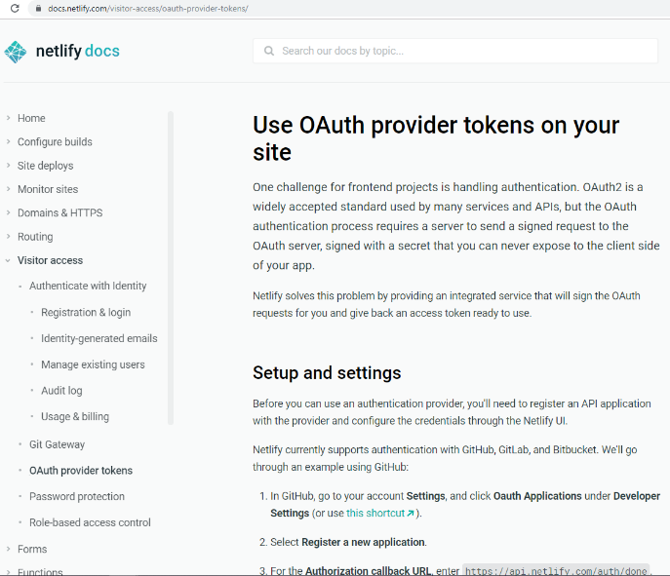

#### Overview

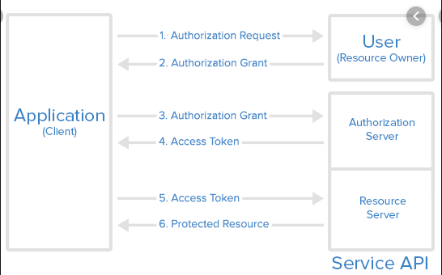 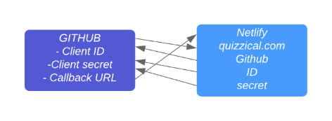

**Resource owner** is terrytaylorbiz github account.

Github (**auth server**) must specify

* Client ID
* Client secret
* Callback URL

Netlify-deployed app is the **client app**.

Netlify system must know

* Github client ID
* Github client secret

Netlify app wants a token for the github app.

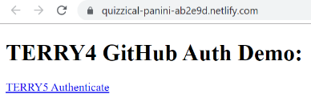

The button has this netlify auth

<!-- Make sure to include Nelify's authentication library -->

<!-- Also available via npm as netlify-auth-providers -->

<script src="https://unpkg.com/netlify-auth-providers"></script>

<script>

$(function() {

$("#login").on("click", function(e) {

e.preventDefault();

var authenticator = new netlify.default ({});

authenticator.authenticate({provider:"github", scope: "user"}, function(err, data)

This runs step1 which brings up github login.

User logins in (authenticates).

Then this runs step2-4, resulting in

Step 2: get authorization grant (sent to callback URL??)

Step 3-4: use authgrant to get token (involves Netlify app and Github, not the browser)

Then netlify app displays token in browser.

$("#output").text("Authenticated with GitHub. Access Token: " + data.token);

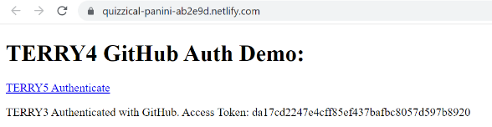

#### 1. Github repo

##### Source jquery

Description at <https://docs.netlify.com/visitor-access/oauth-provider-tokens/#setup-and-settings>

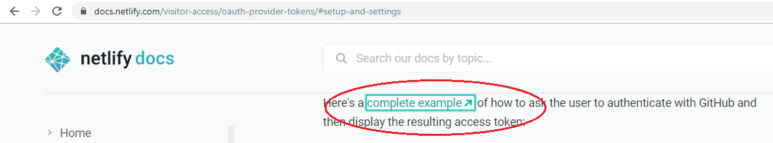Source at

<https://github.com/netlify/netlify-auth-demo>

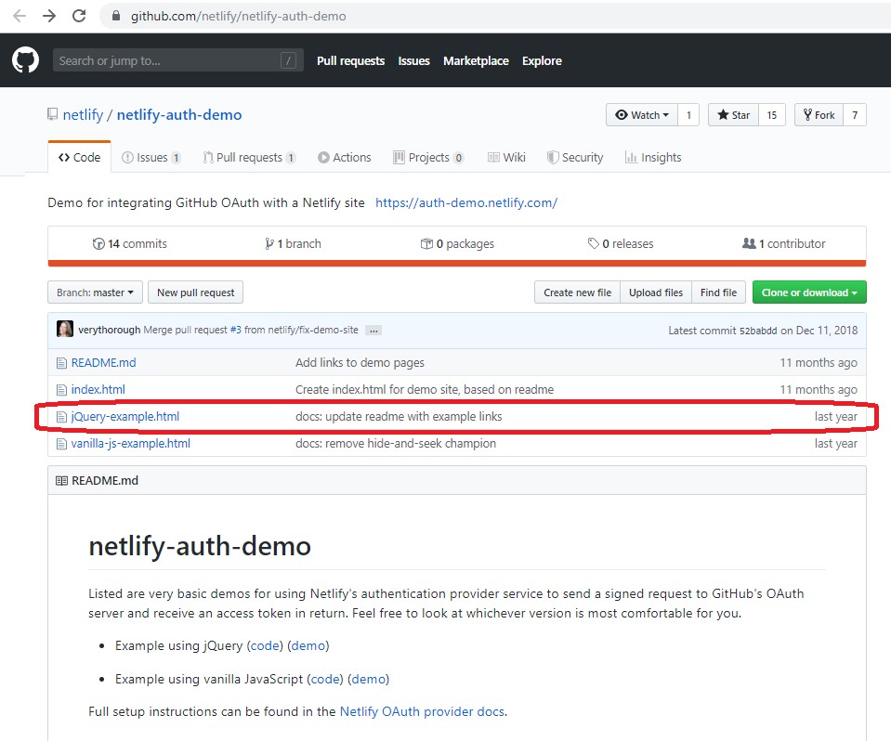

##### My site

I copied jquery code to the following.

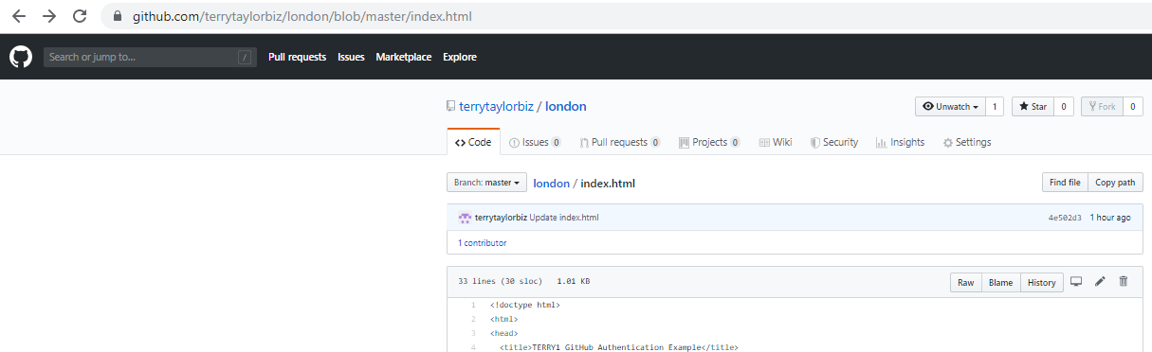

|  |
| --- |
| <!doctype html> |
|  | <html> |
|  | <head> |
|  | <title>TERRY1 GitHub Authentication Example</title> |
|  | <!--- This example uses jQuery: --> |
|  | <script src="https://code.jquery.com/jquery-1.11.2.js"></script> |
|  |  |
|  | <!-- Make sure to include Nelify's authentication library --> |
|  | <!-- Also available via npm as netlify-auth-providers --> |
|  | <script src="https://unpkg.com/netlify-auth-providers"></script> |
|  |  |
|  | <script> |
|  | $(function() { |
|  | $("#login").on("click", function(e) { |
|  | e.preventDefault(); |
|  | var authenticator = new netlify.default ({}); |
|  | authenticator.authenticate({provider:"github", scope: "user"}, function(err, data) { |
|  | if (err) { |
|  | return $("#output").text("TERRY2 Error Authenticating with GitHub: " + err); |
|  | } |
|  | $("#output").text("TERRY3 Authenticated with GitHub. Access Token: " + data.token); |
|  | }); |
|  | }); |
|  | }); |
|  | </script> |
|  | </head> |
|  | <body> |
|  | <h1>TERRY4 GitHub Auth Demo:</h1> |
|  | <p><a href="#" id="login">TERRY5 Authenticate</a></p> |
|  | <p id="output"></p> |
|  | </body> |
|  | </html> |

#### 2. Github settings (client ID, secret, callback url)

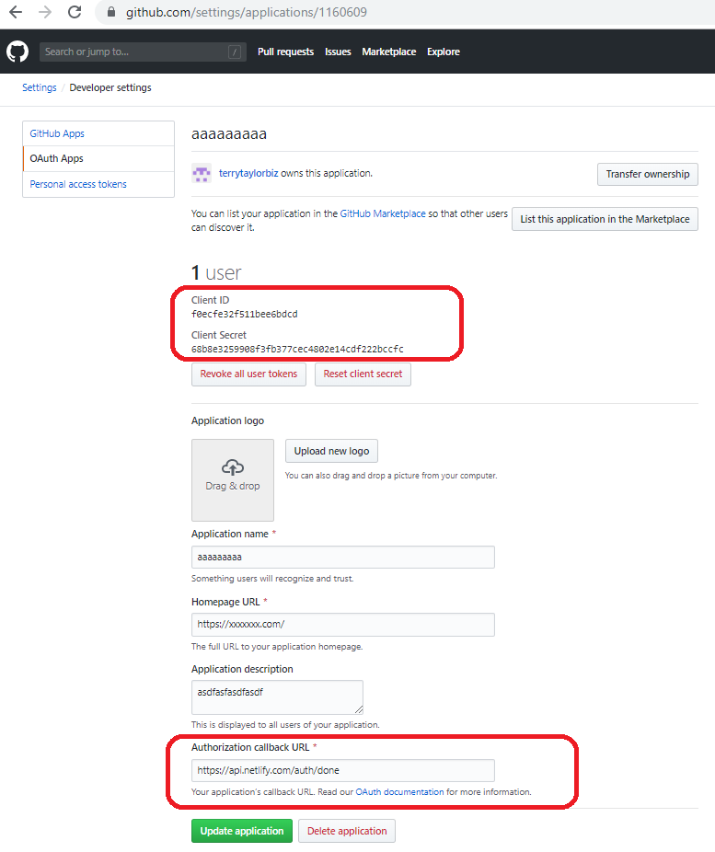

#### 3. Netlify setup

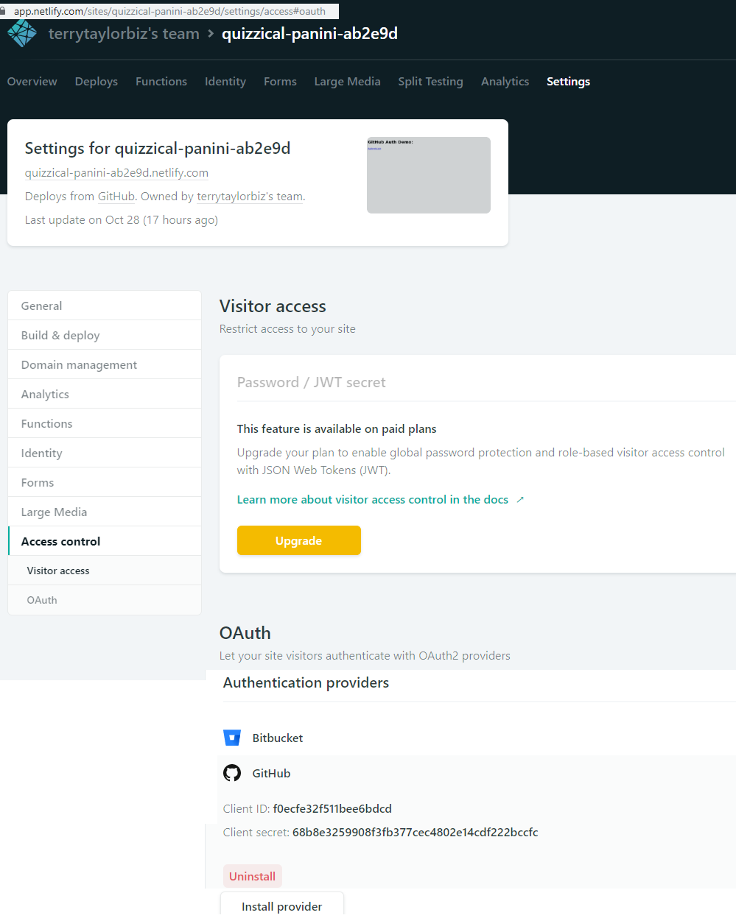

#### 4. authenticate

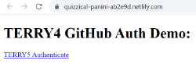 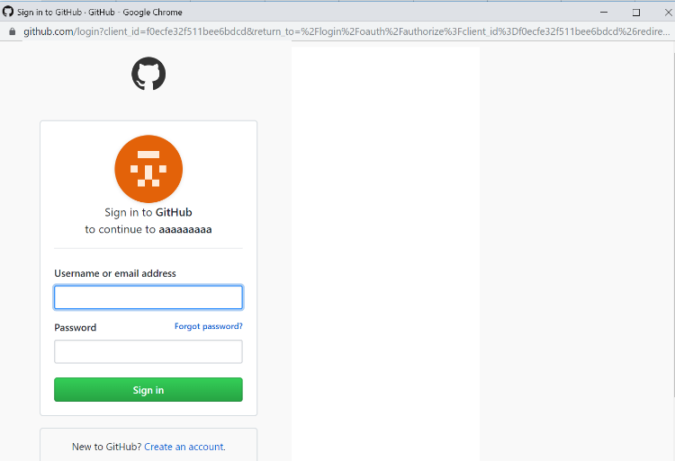

Signin

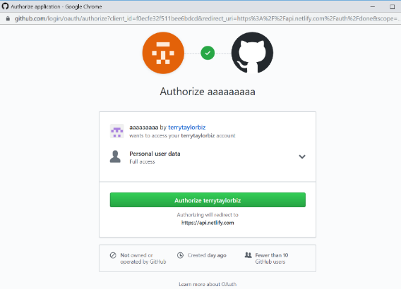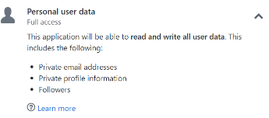

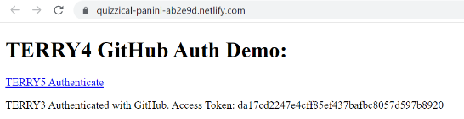

Do it again and get new token

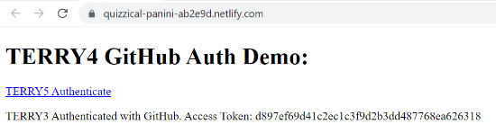

#### 5. Open on different computer (must log in)

You have to login to github (if not logged in).

## 4c.4 Amazon amplify ???

Xxx

# Ch4d. other

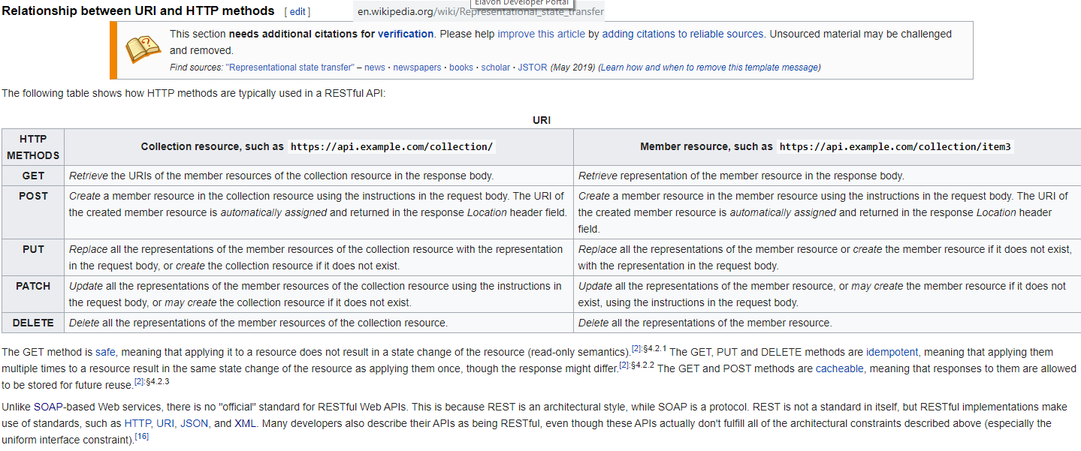

### Avada (themefusion) 20191217 (built infinicept.com website)

<https://www.infinicept.com/solutions/>

<https://avada.theme-fusion.com/avada-live/>

<https://themeforest.net/item/avada-responsive-multipurpose-theme/2833226>

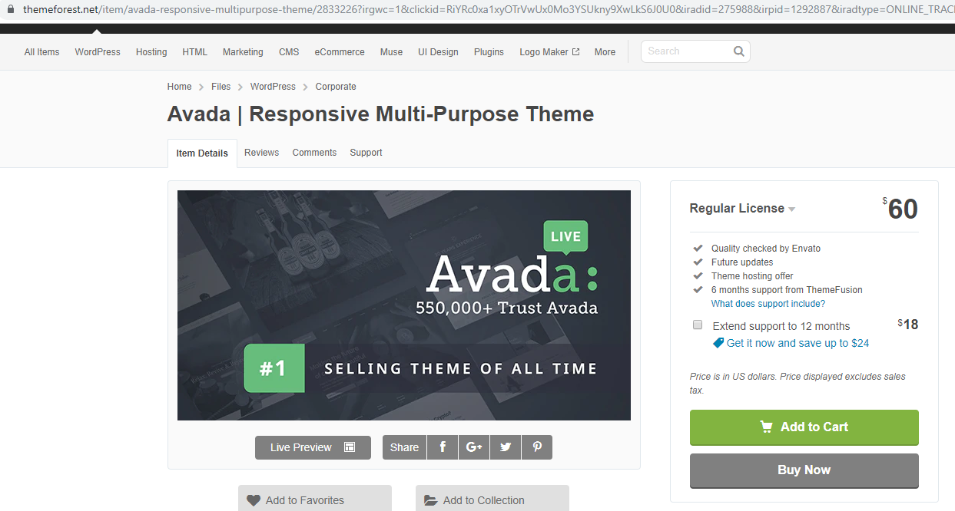

<https://theme-fusion.com/support/getting-started/>

### apiary.io (3-pane) (API blueprint)

[Apiary.io](https://apiary.io/) is a design stack that enables teams to design, prototype and document APIs. Apiary is noted as the foremost [tool](https://apiblueprint.org/tools.html#renderers) for rendering the [API Blueprint](https://apiblueprint.org/) description language, but it also supports the Open API Specification. Thousands of teams use Apiary to quickly generate the classic three tiered layout, with left hand navigation, human readable functionality in the center, and responsive code snippets on the right. Each action has its own permalink.

Aside from interactive documentation, the Apiary suite provides a description editor, a mock server, debugger, traffic inspector to monitor API usage, and other features included with their [plans](https://apiary.io/plans). Much comes for free, but you’ll need a standard account for embedding a custom API reference on your own domain.

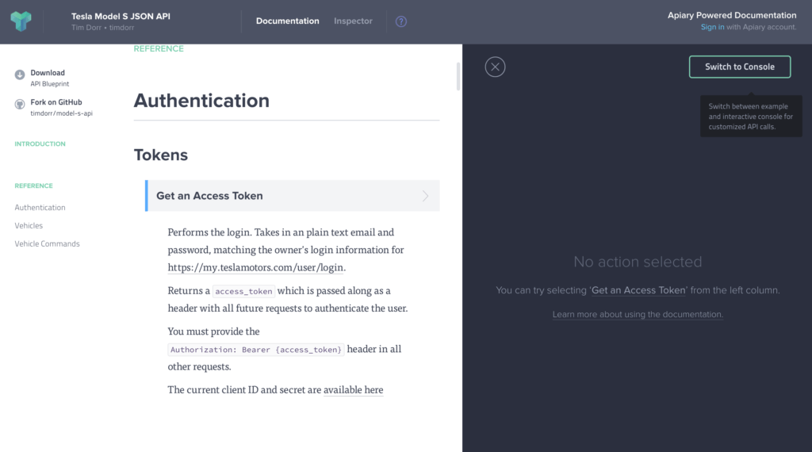

### Kong (linux) (REST) (open source API gateway)

“Accelerate your microservices journey with the world’s most popular open source API gateway. Built on top of a lightweight proxy, the Kong Gateway delivers unparalleled latency performance and scalability for all your microservice applications regardless of where they run. Exercise granular control over your traffic with Kong’s plugin architecture”



Interactive API Docs

Feature-rich API reference editor, automatic API explorer and code generation.

Developer Management

Delight your internal and external developers with a seamless onboarding experience.

Customize & Extend Your Portal

Make the portal reflect your company brand, colors and identity.

Talk with Our API Experts

… about how Kong Enterprise Edition improves security and scalability for your API use cases.

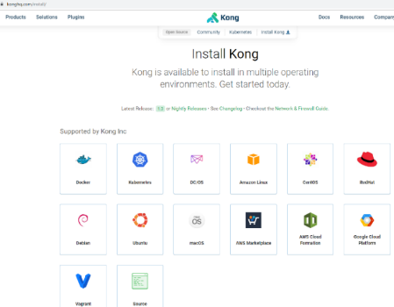

### Thetheme.io

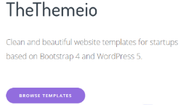

### Provonix <https://pronovix.com/blog/free-and-open-source-api-documentation-tools>

Is mainly api-blueprint, and seems to be a services provider, not a tool provider.

### Bootstrap

https://websitesetup.org/bootstrap-tutorial-for-beginners/

file:///C:/Users/Terry/Desktop/index.html 

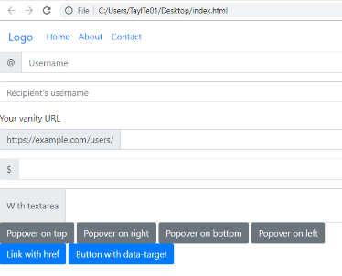

### www.primefaces.org